SQL INJECTION & PREVENTION

ABSTRACT:

SQL injection is a type of cyber-attack where malicious SQL statements are inserted into an application's entry fields, allowing attackers to access sensitive data or control the application's behavior. The aim of a SQL prevention project is to implement measures and strategies to protect a software application from SQL injection attacks. The ultimate goal is to ensure that sensitive data and system resources are protected from unauthorized access, maintaining the confidentiality, integrity, and availability of the application and its data. The project may also involve educating developers and users on the risks of SQL injection and best practices for preventing such attacks.

INTRODUCTION:
SQL injection is a type of attack that occurs when a malicious user inserts code into a web application that uses SQL databases. This code can modify, delete, or retrieve data from the database, depending on the intent of the attacker. SQL injection attacks are typically carried out by entering special characters or commands into the application's input fields, such as login forms or search bars.
The main reason why SQL injection attacks are so prevalent is that many web applications do not properly sanitize user input. This means that when a user enters a value into an input field, the application does not check to ensure that it is valid or safe. If the input is not validated properly, the attacker can use it to insert their own SQL code into the application's database query.
For example, suppose a web application allows users to search for products by entering a product name in a search bar. If the application does not validate the user's input.
This input might look like a legitimate product name, but it is actually an SQL command that tells the application to retrieve all data from the database, regardless of any filters or restrictions. The semicolon terminates the current SQL command, and the double dash indicates that the rest of the line should be treated as a comment, effectively nullifying any subsequent SQL code.
Once an attacker has successfully executed an SQL injection attack, they can gain access to sensitive data, such as usernames, passwords, or credit card numbers. They can also modify or delete data, potentially causing irreparable harm to the application and its users.
To prevent SQL injection attacks, web application developers need to ensure that all user input is properly sanitized and validated. This involves checking input values for special characters or commands that might indicate an SQL injection attack, such as apostrophes, semicolons, or double dashes. Developers can also use parameterized queries or prepared statements to separate user input from the SQL code and prevent attacks.
In conclusion, SQL injection attacks are a serious threat to the security of web applications that use SQL databases. They can result in the theft or modification of sensitive data and can cause significant damage to the application and its users. By following best practices for input validation and SQL query construction, developers can help prevent SQL injection attacks and ensure the safety of their applications.

OBJECTIVES:

Identifying vulnerabilities: The project should aim to identify any existing SQL injection vulnerabilities in the application's code and database structure.
Developing prevention measures: The project should involve developing and implementing effective prevention measures, such as input validation and parameterized queries.
Testing and validation: The project should include thorough testing and validation to ensure that the prevention measures are effective and do not cause any unintended consequences or performance issues.
Education and awareness: The project should aim to educate developers and other stakeholders about the importance of SQL injection prevention and the potential consequences of an attack.
Compliance: If the project is being undertaken to comply with data protection regulations, the objective should be to ensure that the prevention measures meet the relevant standards and requirements.
Ongoing maintenance: The project should include a plan for ongoing maintenance and monitoring to ensure that the prevention measures remain effective and up-to-date with emerging threats and best practices.

LITERATURE SURVEY:

SQL injection is a well-known and prevalent attack vector that targets web applications. This attack involves injecting malicious SQL code into an application's database, potentially allowing an attacker to access sensitive data, modify or delete data, or even take over the entire system. The following literature survey provides an overview of the research on SQL injection, including its prevalence, detection, prevention, and mitigation techniques.
Prevalence of SQL Injection:
Various studies have demonstrated the prevalence of SQL injection attacks. A study by Verizon revealed that SQL injection was one of the most common attack vectors in data breaches. Similarly, a report by Imperva found that SQL injection was the most common technique used by hackers to exploit web applications.
Detection of SQL Injection:
Several approaches have been proposed for detecting SQL injection attacks. These include static analysis, dynamic analysis, and hybrid approaches. Static analysis involves analysing the application's source code to detect vulnerable code patterns. Dynamic analysis involves monitoring the application's runtime behaviour to detect anomalies that could indicate an attack. Hybrid approaches combine both static and dynamic analysis techniques to improve detection accuracy.
Prevention of SQL Injection:
Preventing SQL injection attacks involves a combination of techniques, including input validation, parameterized queries, stored procedures, and web application firewalls. Input validation involves checking user input for potential SQL injection attacks. Parameterized queries involve using parameter placeholders to separate user input from the SQL query. Stored procedures involve predefining SQL queries that are called by the application. Web application firewalls sit between the application and the database and can detect and block SQL injection attacks.
Mitigation of SQL Injection:
In addition to prevention, mitigation techniques are also necessary to handle SQL injection attacks that bypass prevention measures. These techniques include log analysis, intrusion detection, and incident response. Log analysis involves analysing application and database logs to detect and investigate potential SQL injection attacks. Intrusion detection involves monitoring the network and application for signs of SQL injection attacks. Incident response involves developing a plan of action for responding to SQL injection attacks, including isolating affected systems, removing the attacker's access, and patching vulnerabilities.

EXISTING SYSTEM:
There are several projects and tools available for preventing SQL injection attacks. Here are some examples:
Parameterized queries: One of the most effective ways to prevent SQL injection attacks is to use parameterized queries in your code. Parameterized queries use placeholders for user input, which are then bound to variables before the query is executed. This prevents malicious input from being executed as part of the SQL statement.

Input validation: Another approach is to validate user input before it is used in a SQL query. This can include checking the data type, length, and format of user input, as well as using regex to filter out malicious input.
ORM frameworks: Object-Relational Mapping (ORM) frameworks can also help prevent SQL injection attacks. ORM frameworks like Hibernate and Entity Framework use prepared statements and parameterized queries behind the scenes to prevent SQL injection.
Web Application Firewalls (WAFs): WAFs can also help prevent SQL injection attacks by filtering out malicious input before it reaches your application. They do this by analysing incoming traffic and blocking requests that contain known SQL injection attack patterns.
Code analysis tools: There are several code analysis tools available that can scan your code for SQL injection vulnerabilities. These tools can help identify potential vulnerabilities and provide suggestions for how to fix them.

PROPOSED SYSTEM:
A web application is vulnerable to an SQL injection attack if an attacker is able to insert SQL statements into an existing SQL query of the application. This is usually achieved by injecting malicious input into user fields that are used to compose the query, login page prompts the user to enter their username and password into a form typically used for checking the user login credentials therefore, are prime targets for an attacker. In this example, if the login application does not perform correct input validation of the form fields, the attacker can inject strings into the query that alter its semantics. For example, consider a hacker entering “OR 1=1” -- one of SQL injection string as in the table(1), the “--” command indicates a comment in Transact-SQL. Hence, everything after the first “--” is ignored by the SQL database engine with the help of the first quote in the input string, the user’s name string is closed, while the “OR 1=1” adds a clause to the query which evaluates to true for every row in the table. When executing this query, the database returns all user rows, which applications often interpret as a valid login. So, in the proposed system all client-supplied data needs to be cleansed of any characters or strings that could possibly be used maliciously.
In this section list proposed methods can be applied to minimize the risk of a SQL injection attack .
Validation Input:
The first step in any form processing script should check the syntax of input for validity to verify that the input is a valid input in the language. The validation could be anything such as checking whether the entered value for “password" is a number, and is 16 or over, or making sure the username column has only valid characters such as A to Z, a to z and many classes of input have fixed languages such Email addresses, dates etc.
Encoding Input:
Sometimes input might contain some illegal characters, or it might not always be viable to validate all user input for example, in a search field the user could type anything that they are searching for, including script tags such as < script>, encoding is the best way to neutralize harmful data from user input, since encoding translates the harmful characters into their display equivalents for example the < character will be translated into < character. The HTML Encode method of the server object can be used to encode the harmful characters.
Filtering Input:
If an application does not filter user input before it is used in a SQL query, then SQL injection vulnerability occurs because server received incorrect input from an untrusted client. So proposed system prevent SQL injection attacks by filtering user input using language-supplied input filtering functions before using untrusted input in a SQL query. For example, let's suppose to filter out special characters such as the following: [] { } ; &. to achieve this functionality, use the Replace method of the String object this code will replace all the unwanted characters from the user’s input.
Low privilege:
Limit database permissions and segregate users and never allows to connect as a database administrator in web application will limit the damage potential. The proposed system has three pages, the code of first page shown an HTML page with a form element. The form asks the visitor to enter his MySQL user name and password. The name of this page is login.html, when user full the data and click login button the data will send by post method to the second page that called login.php

SYSTEM REQUIREMENTS:
- HTML
- CSS
- BOOTSTRAP
- PHP
- SQL
- Windows 10 or higher
- XAMPP Apache tomcat server
- MySQL database

USERS:
- Developers: Developers are responsible for writing and testing code that prevents SQL injection attacks. They may use input validation, parameterized queries, and other security techniques to protect against SQL injection attacks.

- Database administrators: Database administrators are responsible for configuring and maintaining databases to prevent SQL injection attacks. They may configure access controls, monitor database activity, and implement security measures such as WAFs and intrusion detection systems.

- Security professionals: Security professionals are responsible for monitoring and managing overall system security. They may use tools such as vulnerability scanners, penetration testing, and code analysis to identify and prevent SQL injection attacks.

- System administrators: System administrators are responsible for configuring and maintaining server infrastructure to prevent SQL injection attacks. They may implement security measures such as firewalls, load balancers, and network segmentation to protect against SQL injection attacks.

DATA MODELLING DIAGRAMS:

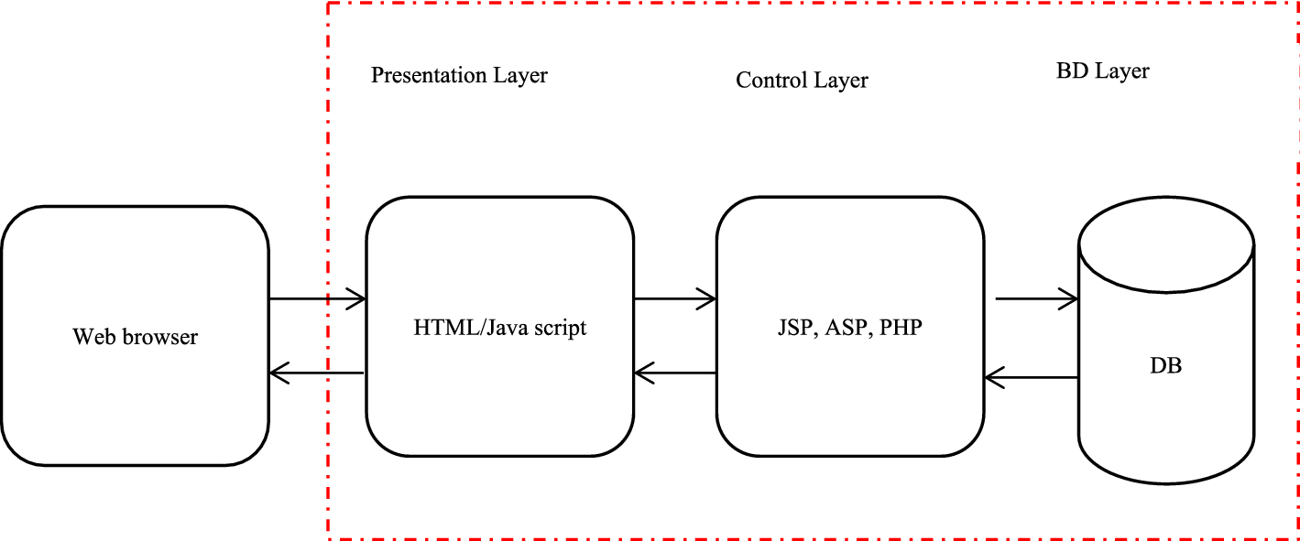
Fig: Web application Architecture
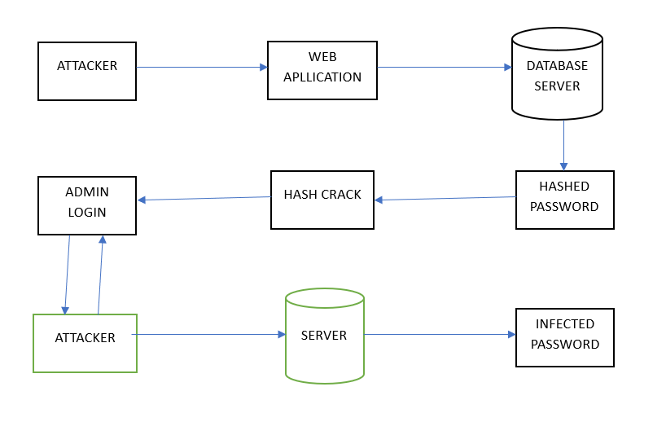
Fig: SQL Injection Attack
Activity Diagram:
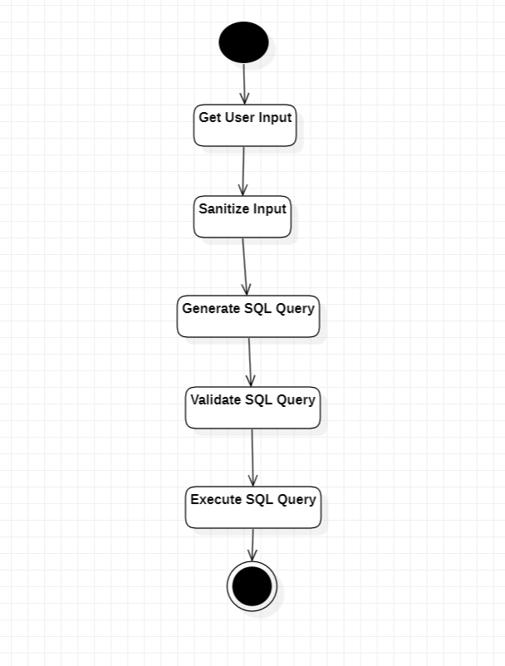

USER MANUAL:

Sign Up Page
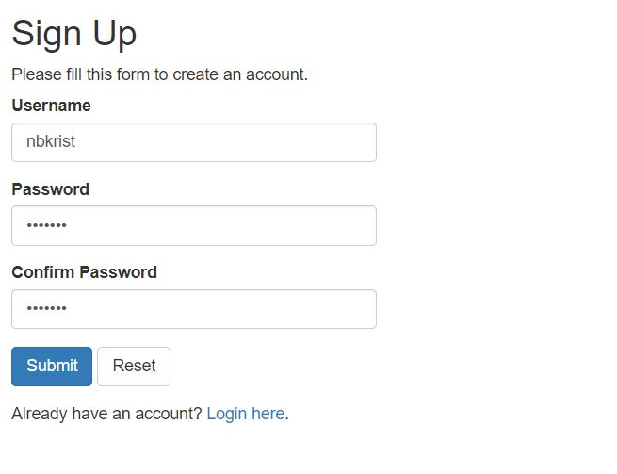

Login Page
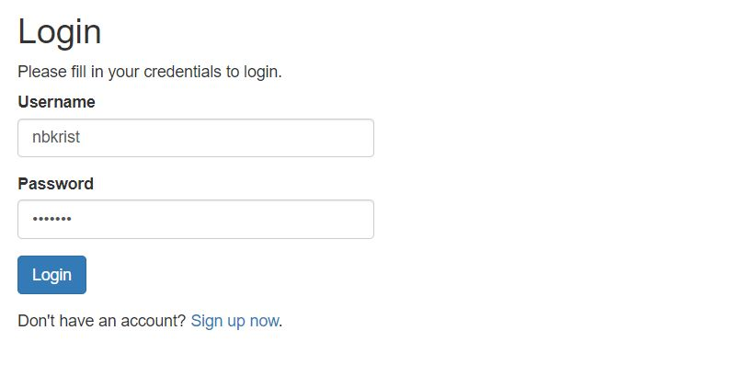

Welcome Page
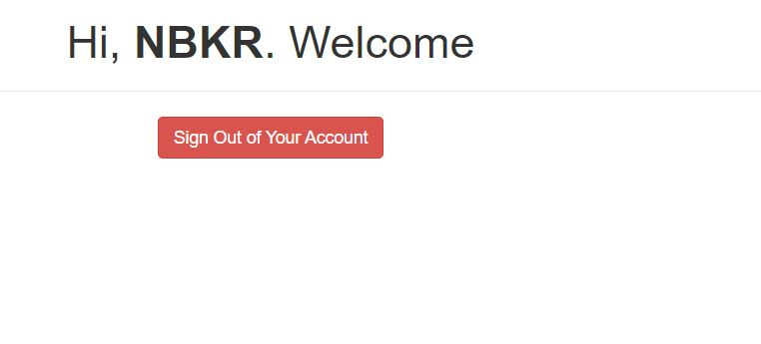

CONCLUSION:

SQL injection attackers are smarter and more comprehensive in finding vulnerable websites. There are some new methods of SQL attack. Hackers can use various tools to speed up the process of exploiting vulnerabilities. Let us look at the Asprox Trojan, which is spread mainly through a botnet that publishes mail. The whole process of its work can be described as follows: First, the Trojan is installed on the computer through spam sent by the controlled host. Then, the computer infected by the Trojan will download a binary code, and when it starts, it will use search. Index engine search uses Microsoft's ASP technology to build forms and vulnerable websites. The results of the search become a list of targets for SQL injection attacks. Then, the Trojan Horse will launch SQL injection attacks on these sites, making some sites under ontrol and destruction. Users visiting these controlled and destroyed sites will be tricked into downloading a malicious piece of JavaScript code from another site. Finally, this code guides users to the third site, where there are more malware, such as Trojan horses stealing passwords.

FUTURE ENHANCEMENT:

In the future, additional enhancements to SQL injection prevention may include:

- Machine Learning-Based Detection: Machine learning algorithms can be used to analyze user input and identify patterns that are indicative of SQL injection attacks. By using machine learning, web applications can proactively detect and prevent SQL injection attacks before they occur.

- Real-Time Monitoring: Real-time monitoring involves continuously monitoring user input and database activity for suspicious behavior. By using real-time monitoring, web applications can quickly identify and respond to SQL injection attacks as they occur.

- Database Firewalls: Database firewalls can be used to monitor and filter incoming traffic to the database. By using a database firewall, you can block malicious traffic and prevent SQL injection attacks from reaching the database.

- Automatic Patching: Automatic patching involves automatically applying security updates and patches to web applications and databases. By using automatic patching, web applications can stay up-to-date with the latest security fixes and prevent known vulnerabilities from being exploited.

REFERENCE:

- Shen Qingni, Qingsi. Operating system security design. Beijing: Machinery Industry Press, 2013.
- Yu Chaohui, Wang Changzheng, Zhao Yicheng. Practical Treasure Book of Network Security System Protection and Hacker Attack and Defense. Beijing: China Railway Publishing House, 2013.
- Ma Limei, Wang Fangwei. Computer Network Security and Experimental Course, tsinghua university press,ISBN:9787302439332
- Ma Limei,GuoQing,ZhangLinwei Ubuntu Linux operating system and Experimental Course, tsinghua university press,ISBN:9787302438236
- Dong Zhenliang. Application of cryptographic algorithms and international standardization [D]. Financial Information Center of the People's Bank of China, 2018.
- Zhou Yinqing, Ouyang Zichun. Brief discussion on the implementation and management of information system security level protection evaluation [D]. Digital Communication World, 2018.
- Liang Lixin and Li Jun. Information Security Level Protection Evaluation Based on Virtualization [D]. Police Technology, 2014
- Wubin,Liu Dun. SQL Injection Attack and Vulnerability Detection Network Security Technology & Application,2017

WEBSITES

- https://github.com/rkhal101/Web-Security-Academy-Series/tree/main/sql-injection/theory

- https://phrack.org/issues/54/8.html

- https://www.alertlogic.com/blog/tried-and-true-sql-injection-still-a-leading-method-of-cyber-attack-d58

- https://www.owasp.orgjindex.php/Top 10 2013-Top 10

