Lahore Shaadi - Comprehensive User Manual & Technical Workflow Report
Generated on: 28 February 2026, 00:01
Version: 1.0

Executive Summary
Lahore Shaadi is a luxury wedding planning web application focused on Lahore venues and related planning workflows. The platform provides discovery, comparison, budgeting, checklist management, inspiration, and vendor coordination in a single Next.js application.

Project Scope
- Venue discovery and filtering for premium marquees
- Detailed venue profile pages with packages and amenities
- Favorites and side-by-side comparison workflows
- Advanced multi-event budget calculator
- Planning checklist with persistent progress and countdown
- Vendor, gallery, and testimonial support workflows

Technology Stack
Layer | Technology | Version | Purpose
Frontend Framework | Next.js (Pages Router) | 14.x | Routing, SSR/static rendering, build pipeline
UI Library | React | 18.2 | Component architecture and stateful UI
Styling | Tailwind CSS | 3.3 | Utility-first design system with custom tokens
Icons | Lucide React | 0.294 | Consistent iconography across pages
Runtime | Node.js | 18+ recommended | Development server and production build execution
Build Tools | PostCSS + Autoprefixer | 8.4 / 10.4 | CSS processing and compatibility
Persistence | Browser localStorage | N/A | Client-side persistence for user planning state

Route Map
Route | File | Primary Workflow
/ | pages/index.js | Homepage discovery, hero CTA, featured sections, planning entry points
/marquees | pages/marquees/index.js | Venue exploration with filters, sorting, and view mode
/marquees/[slug] | pages/marquees/[slug].js | Venue deep-dive: gallery, packages, amenities, actions
/calculator | pages/calculator.js | Multi-event budgeting, per-head calculations, optimization hints
/checklist | pages/checklist.js | Task tracking, date countdown, export progress
/compare | pages/compare.js | Side-by-side comparison of selected venues
/favorites | pages/favorites.js | Saved venue shortlist and quick compare path
/vendors | pages/vendors.js | Vendor search, category filtering, sorting, contact actions
/gallery | pages/gallery.js | Wedding photo browsing by venue and event type
/testimonials | pages/testimonials.js | Review browsing, rating/guest sorting, trust signals

WeddingContext State Model
- favorites: saved venue slugs with toggleFavorite() and isFavorite().
- compareList: up to 4 venue slugs with toggleCompare() limit enforcement.
- searchQuery/searchResults/isSearchOpen: global search modal control.
- weddingDate: selected date with getDaysUntilWedding() utility.
- recentlyViewed: capped recency list from venue detail visits.
- inquiryCart: list of inquiry intents keyed by venue slug.
- notification: ephemeral toast state managed by showNotification().

localStorage Keys and Purpose
- wedding_favorites: persists shortlist across sessions.
- compare_list: preserves comparison set.
- inquiry_cart: stores venues queued for inquiry.
- wedding_date: stores selected wedding date in ISO format.
- recently_viewed: retains recent venue history.
- checklist_completed/checklist_notes: stores planning task progress and notes.

End-to-End Workflows

Workflow 1: Discover and Shortlist Venues
- User lands on homepage and navigates to All Marquees.
- User applies filters (category, area, min capacity, max budget) and sort preference.
- User opens a venue detail page for deep inspection.
- User adds venue to Favorites and/or Compare list.
- User repeats for multiple venues, then goes to Compare page for decision support.

Workflow 2: Compare Finalists
- Compare page loads selected venue slugs and resolves full records from data.
- User changes any selector to swap a candidate venue.
- System renders row-wise comparison: rating, capacity, pricing, packages, amenities, contact.
- User proceeds either to venue detail page or budget calculator for final viability checks.

Workflow 3: Build Wedding Budget
- User selects venue and event set (e.g., mehndi/barat/valima).
- System initializes event presets for menu, counters, and guest ratio defaults.
- User customizes menus, starter quantities, counters, and add-on services.
- Calculator aggregates per-event and shared costs, then applies tax/contingency logic.
- UI updates animated totals, pie chart split, and optional optimization suggestions.

Workflow 4: Manage Planning Checklist
- User sets wedding date via modal; countdown appears automatically.
- User checks/unchecks tasks across period buckets (12 months to day-before).
- System persists task completion and notes in localStorage.
- User exports checklist as JSON for offline backup or sharing.

Workflow 5: Vendor Selection
- User searches vendors by text, category, and sorting criteria.
- User views featured vendors when no restrictive filter is applied.
- User switches between grid/list views based on review needs.
- User initiates direct contact (tel/mail) from vendor cards or list rows.

Workflow 6: Gallery and Testimonials for Validation
- User opens Gallery for inspiration, filtered by venue or event type.
- User reviews testimonials and sorts by recency/rating/guest count.
- User uses social proof to validate final venue/vendor choices.

System Diagrams
Diagram 1 - Layered Architecture
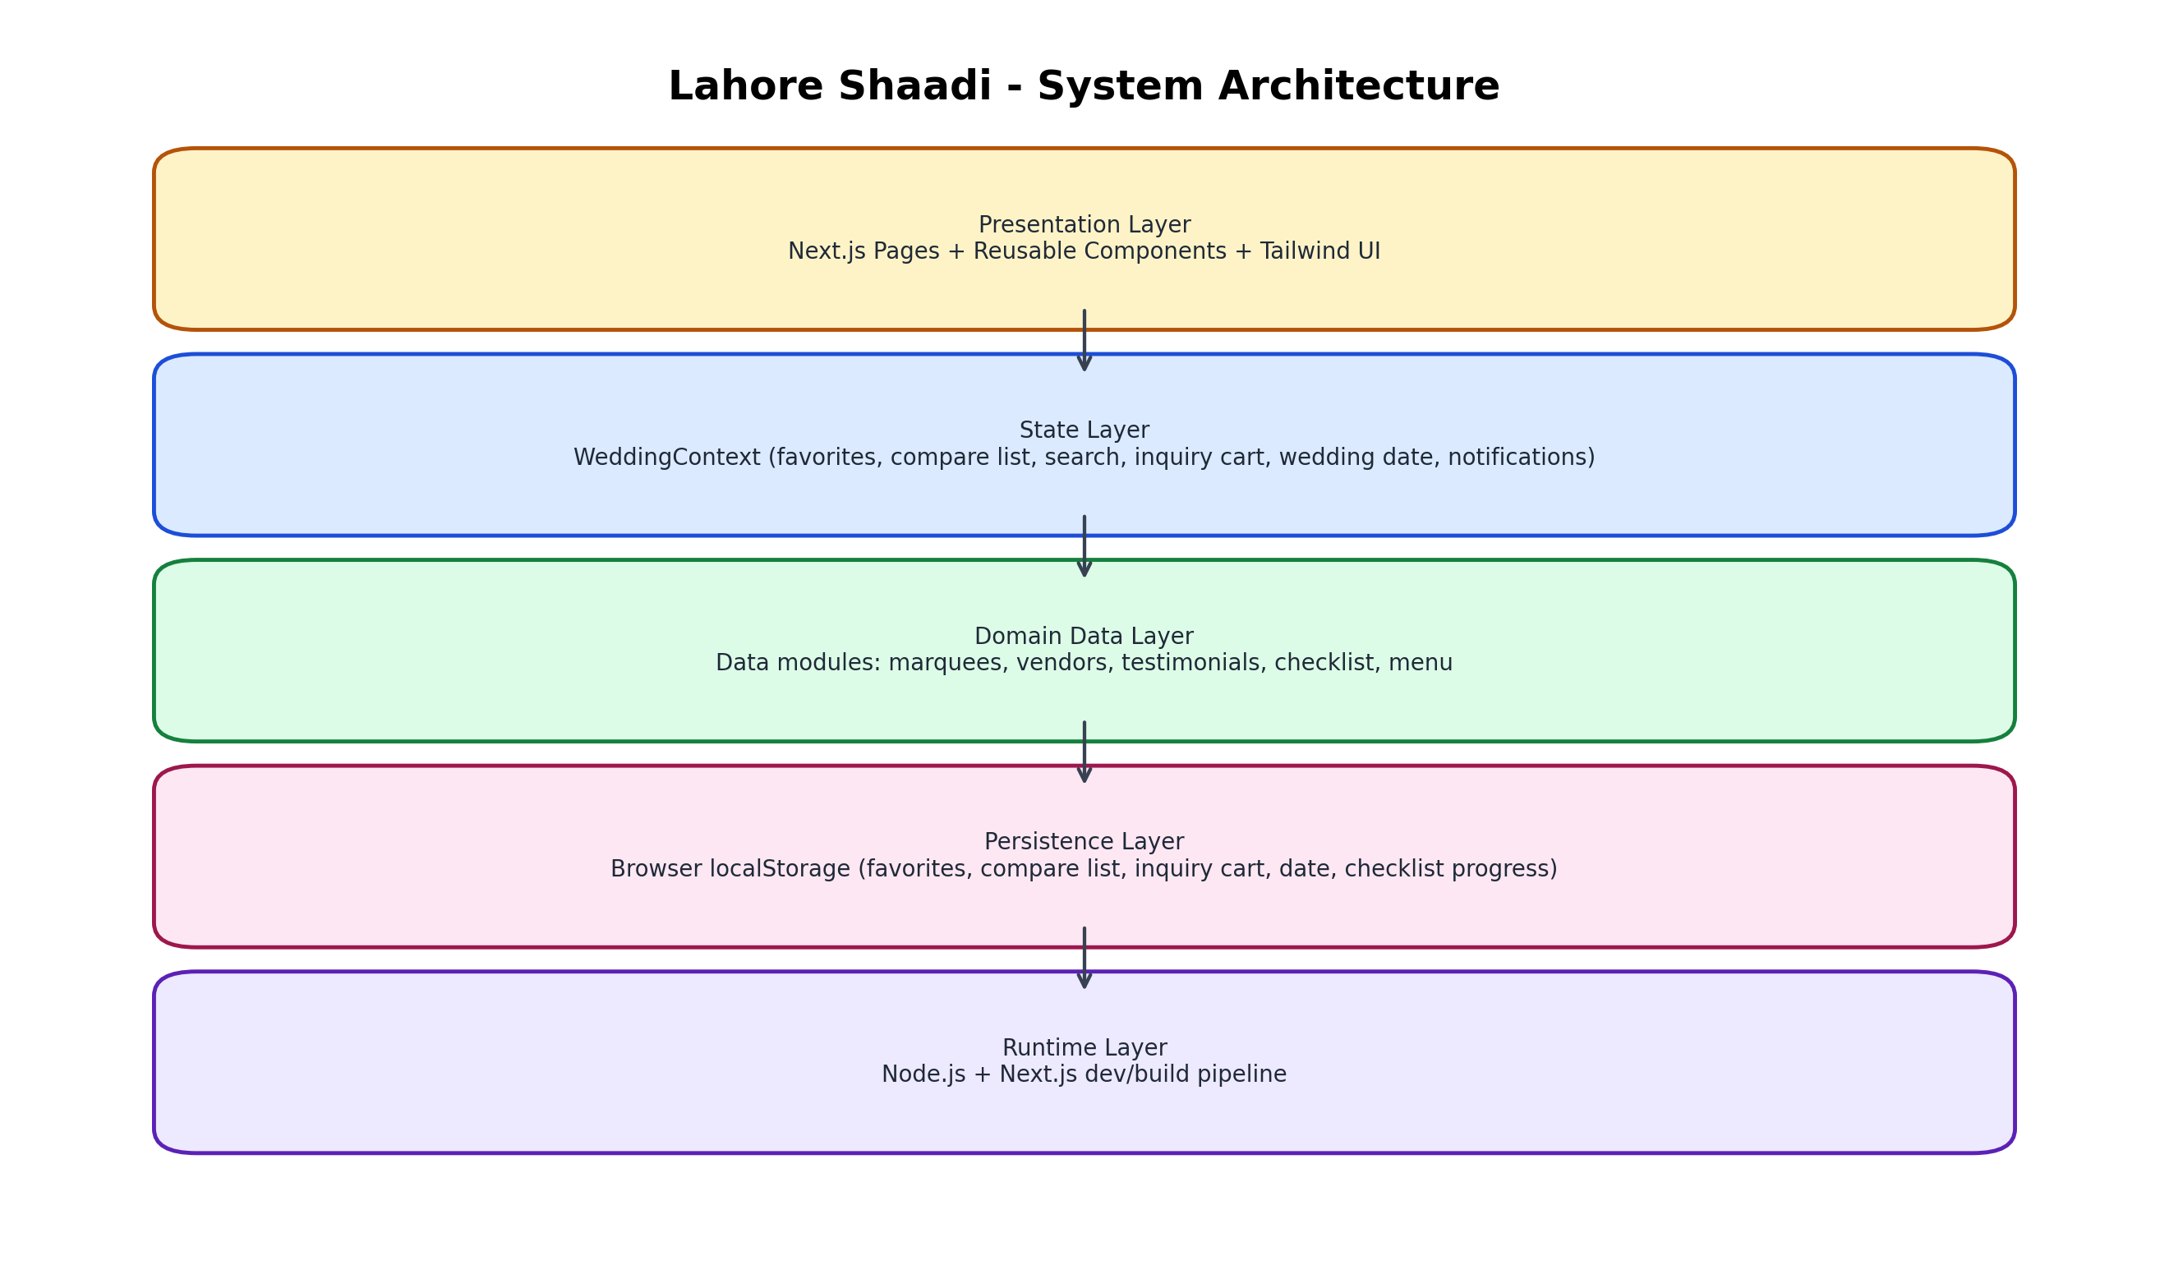

Diagram 2 - Primary User Workflows
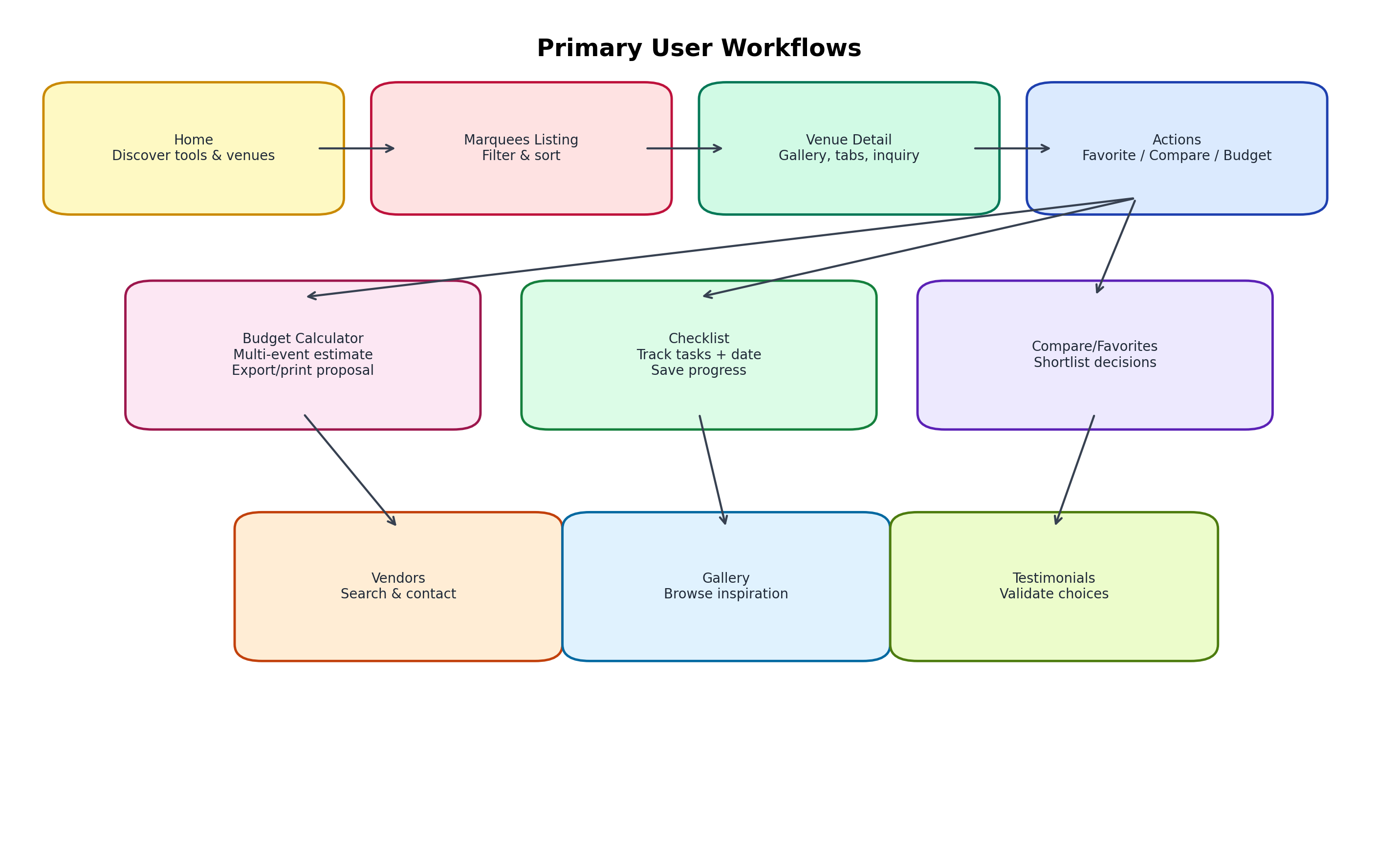

Diagram 3 - Context and Persistence Data Flow
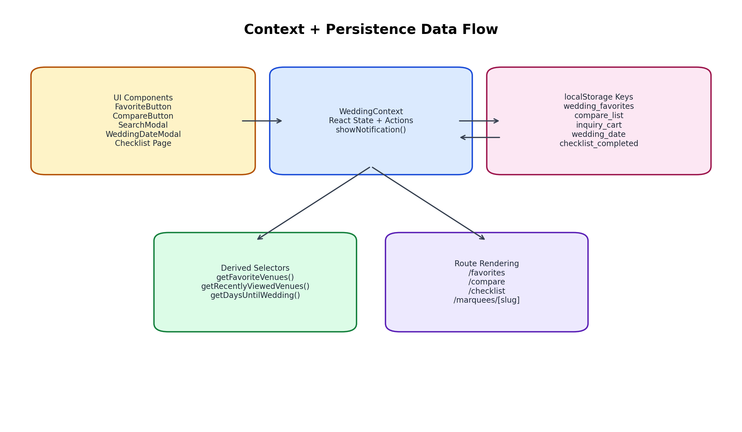

Diagram 4 - Budget Calculator Pipeline
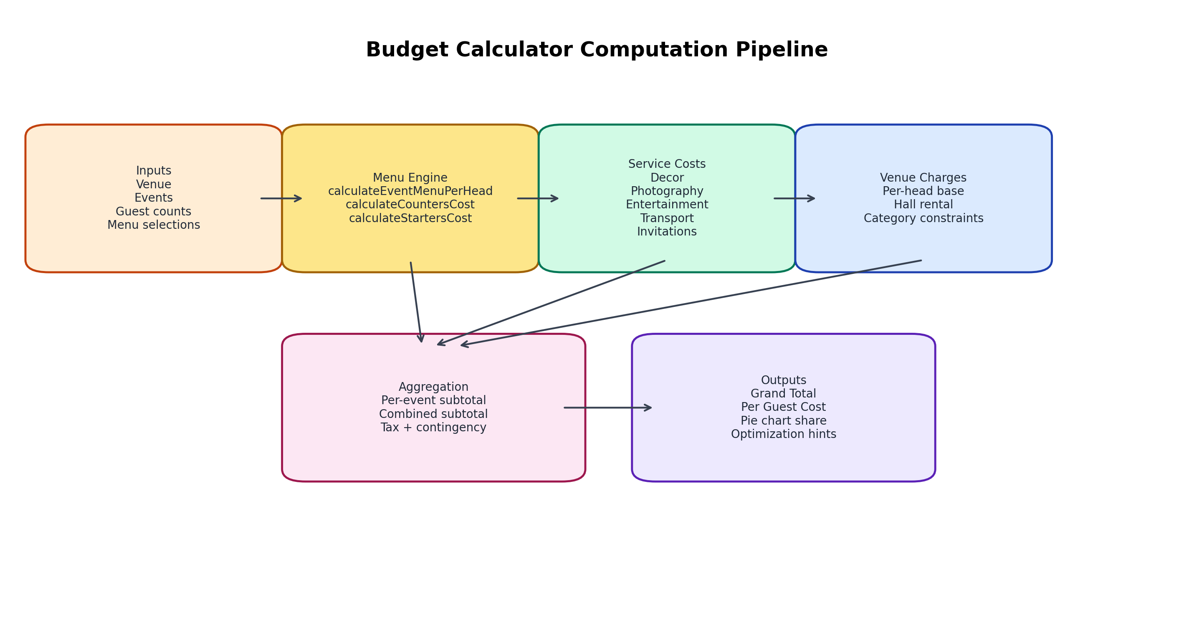

Setup and Operations

Prerequisites
- Windows/macOS/Linux with Node.js 18+.
- npm package manager.
- Modern browser for local testing.

Installation
- Open terminal in project root (C:\WeddingPlannerApp).
- Run: npm install
- Run production check: npx next build

Development Server (Environment Note)
In this project environment, direct next binary invocation is the most reliable command for local runtime:
- node node_modules/next/dist/bin/next dev -p 3000
- Open http://localhost:3000 in browser

Build and Release
- Build: npx next build
- Start production: npx next start
- Validate route generation and static optimization after each major UI/data change

Testing Checklist
- Run full build and ensure all pages are generated without error.
- Validate favorites/compare/checklist persistence by browser refresh.
- Verify calculator totals for different event combinations and guest counts.
- Confirm responsive layouts on mobile/tablet/desktop breakpoints.
- Check external image loading from allowed domains.

Troubleshooting Guide
Issue | Likely Cause | Resolution
Dev server fails with npm run dev | CLI wrapper inconsistency in environment | Use node node_modules/next/dist/bin/next dev -p 3000
Missing user state after reload | localStorage disabled/cleared | Enable storage and verify keys in browser devtools
Incorrect comparison count | Compare list max limit reached | Remove one venue then add another
Image not rendering | Invalid URL or blocked domain | Check URL and next.config.js image domain policy

Security, Privacy, and Current Limits
- No backend/database is used; this is a client-driven data model with static datasets.
- User planning data is stored in browser localStorage and remains device-local.
- No authentication/authorization is currently implemented.
- Contact/inquiry actions rely on tel/mail links, not integrated CRM APIs.
- Data updates are code-driven and require deployment to publish changes.

Recommended Enhancements
- Add backend API + database for real-time venue/vendor updates.
- Introduce authenticated user accounts and cloud sync.
- Implement PDF quote generation from calculator scenarios.
- Add analytics funnel for shortlist-to-contact conversion.
- Create admin CMS for non-technical content updates.

Appendix: Key Project Modules
- pages/: route-level screens and workflow orchestration
- components/: reusable UI blocks (cards, modals, buttons, timers)
- context/WeddingContext.js: global state and persistence bridge
- data/: static domain models and utility selectors
- styles/globals.css + tailwind.config.js: design system and theme tokens

