SE331 CONTINUOUS ASSESSMENT 1 (CA1)
Individual Prototype & UI/UX Design Submission
Assigned Module: User Registration, Profile Management & Onboarding Hub
1. Student & Project Metadata
Student Name | Nadim
Student ID | [Insert Your Student ID — e.g. 211-35-XXXX]
Course Code & Title | SE331 – Software Engineering
Project Name | JOB HUB — AI-Powered Smart Placement & Semantic Matching Platform
Assigned Git Branch | https://github.com/Saif-AlSaad/JobHub/tree/Nadim
Live Interactive Demo | https://saif-alsaad.github.io/JobHub/ (GitHub Pages)

2. Group Discussion & Page Division Summary
During the group discussion phase, our team (Saif, Nadim, Rizvi) inventoried all required platform modules and partitioned the screens equally to ensure individual accountability and clean separation of concerns:
Team Member | Assigned Module & Screens | Core Design Responsibilities
Nadim (Me) | User Onboarding & Profile Ecosystem  • User Registration Page (/register)  • Profile & Resume Studio (/profile)  • Role Gateway & Sign In (/login) | Dual-role sign up (Seeker/Recruiter), dynamic password strength entropy meter, interactive avatar manager modal, AI resume parser studio, interactive skill taxonomy tags, academic metrics, and geospatial placement radar.
Saif | Analytics & System Governance  • Candidate Dashboard (/)  • Recruiter Pipeline Hub (/recruiter)  • System Admin Governance (/admin) | Placement metrics scorecards, candidate Kanban pipelines, activity feeds, and platform administration.
Rizvi | Job Discovery & Application Tracking  • Jobs Search & Filters (/jobs)  • Job Details & Match (/jobs/:id)  • Applications Tracker (/applications) | Search filtering, match score breakdown card, application timeline tracking, and recruiter applicant review.

3. Detailed Screen Architecture & Feature Breakdown
3.1 Screen 1: User Registration Page (/register)
- Dual-Role Onboarding Switcher: Enables instant role toggling between 'Job Seeker / Student' and 'Recruiter / Employer' directly inside the form. Automatically modifies labels and input fields (e.g. 'Full Name' transitions dynamically to 'Company Name').
- Dynamic Password Strength Meter: Evaluates password entropy in real-time across four discrete tiers (Weak, Fair, Good, Strong). Visual progress bar changes colors dynamically from Red to Amber, Teal, and Emerald.
- Form Integrity & Accessibility: Interactive Show/Hide password toggles, confirm password equality validation, and integrated Terms of Service consent checkbox.
- Demo Evaluation Helper: Built-in 'Fill sample info' button to immediately populate test data for rapid instructor verification.
3.2 Screen 2: Candidate Profile & Credentials Management (/profile)
- Interactive Avatar Studio: Features custom photo uploads with client-side HTML5 Canvas compression (< 100 KB payload) and an interactive 'Choose Sample Avatar' modal offering curated professional headshot presets.
- AI Resume Parser Studio: Drag-and-drop or file upload supporting PDF/DOCX (up to 5 MB) with automated extraction into academic degree, CGPA, graduation data, and skills.
- Interactive Skills Taxonomy Manager: Removable skill chips with instant deletion (×), custom skill entry with keyboard Enter support, and one-click suggested presets (+ TypeScript, + AWS) with live taxonomy counters.
- Academic Background & CGPA Metrics: Direct inputs for University, Major, Degree, Cumulative CGPA spinbutton, and candidate bio.
- Geospatial Placement Radar: Campus/urban anchor selection (Banani, Savar / DIU Smart City, Mohakhali, Dhanmondi, etc.) and proximity radius selector (2 km, 5 km, 10 km, 20 km) using privacy-preserving Haversine equations.
- Dual Recruiter Mode: When logged in as a corporate recruiter, the profile dynamically adapts into an employer management hub (company size, industry, corporate website, office location anchor).
4. UI/UX Design System Specification
Design Language | Nordic Clean & Human-Centric Minimalism
Color Palette | Warm Canvas (#FAF8F5), Deep Charcoal Text (#1C1917), Muted Slate (#57534E / #E7E5E4), Candidate Teal (#0F766E), Recruiter Amber (#EA580C), Success Emerald (#059669).
Typography | Modern System Sans-Serif (Inter / Calibri hierarchy: 24-26px H1, 18-20px H2, 13-14px Body, 11-12px Microcopy).
Micro-Interactions | Active scale compression (active:scale-95), smooth 200ms transitions, focus ring outlines for accessible keyboard navigation.
Accessibility (a11y) | Strict adherence to WCAG 2.1 AA color contrast and visible outline rings on keyboard focus.

5. Visual Prototype Gallery & Screen Evidence
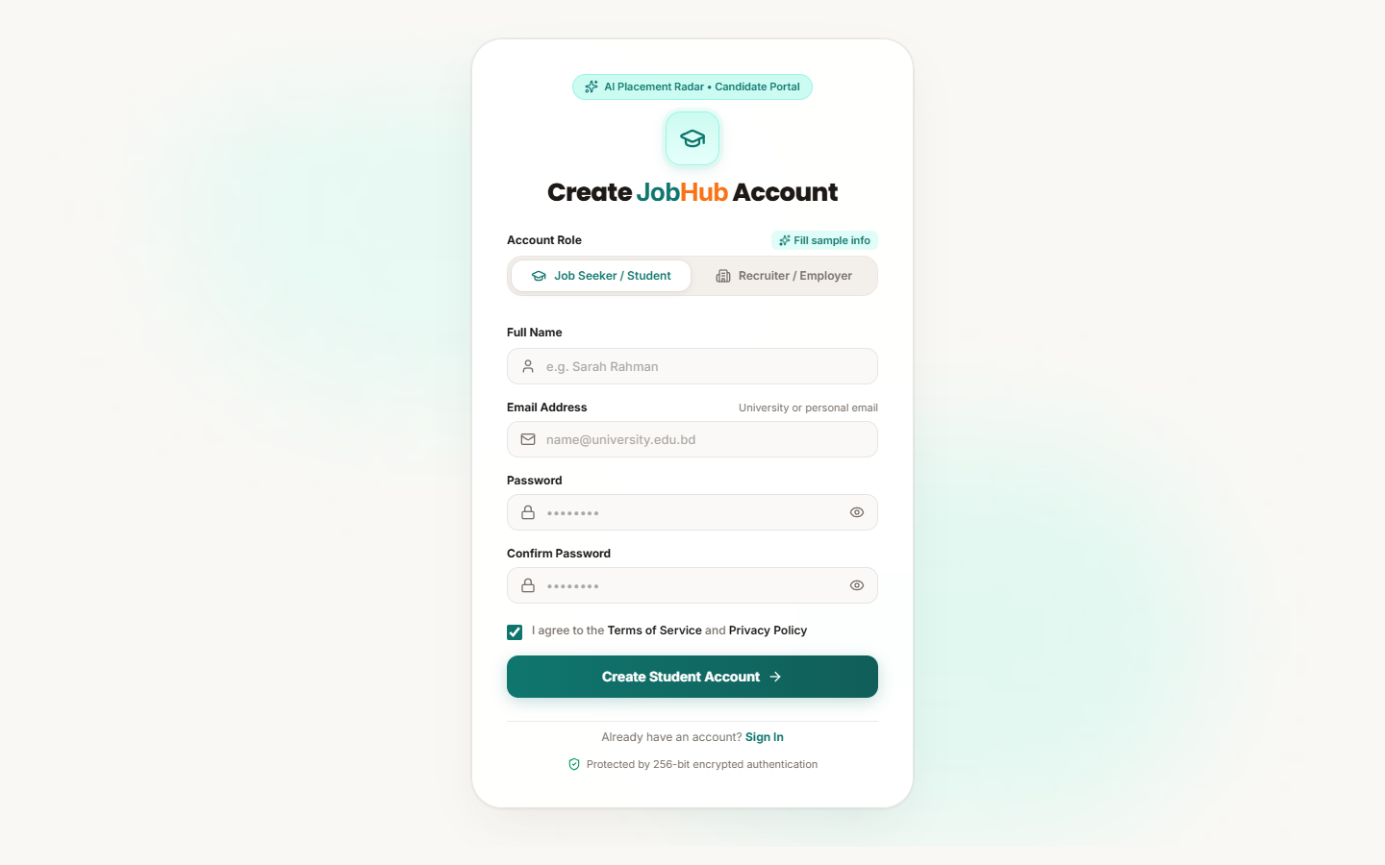
Figure 1: User Registration Page — Job Seeker / Student View
Displays the student registration form, dual-role selector tabs, and clean Nordic input styling.
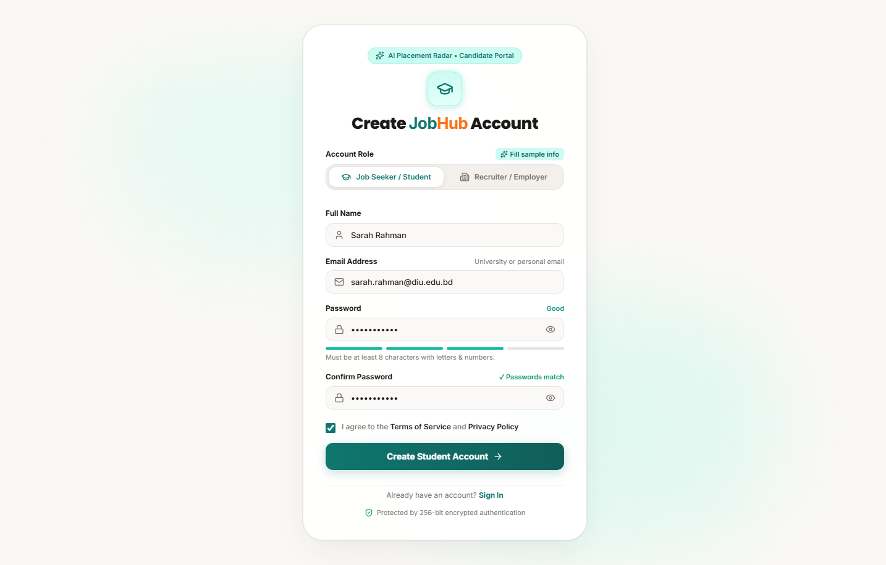
Figure 2: User Registration Page — Dynamic Password Strength Meter
Demonstrates real-time password entropy scoring (Good/Strong tier), visual progress indicator, and terms consent.
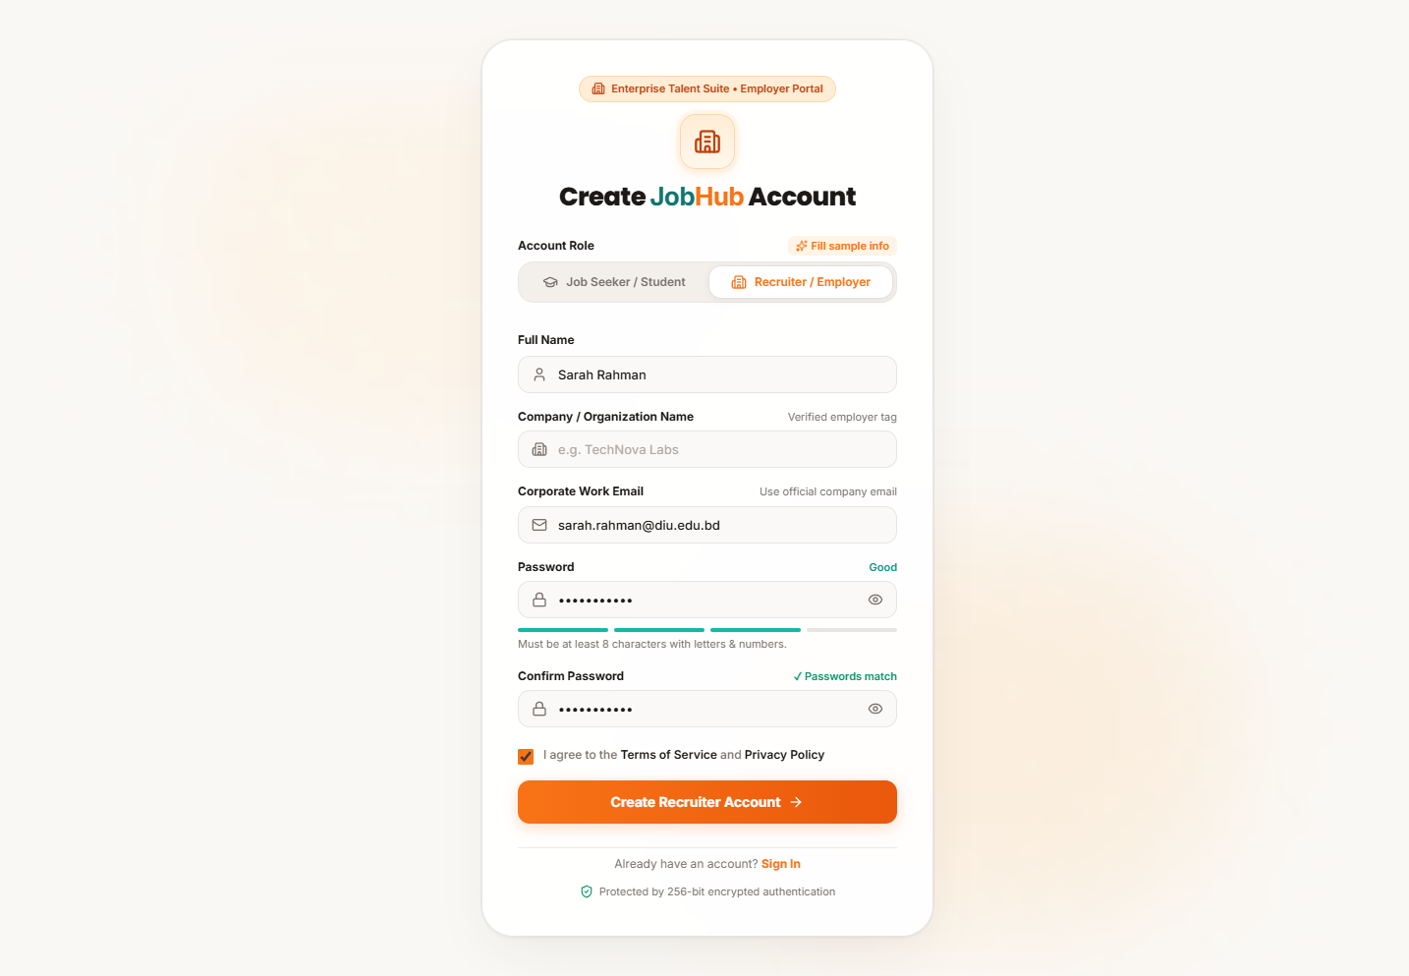
Figure 3: User Registration Page — Recruiter / Employer View
Shows dynamic input adaptation: 'Full Name' switches to 'Company Name' and corporate work email format.
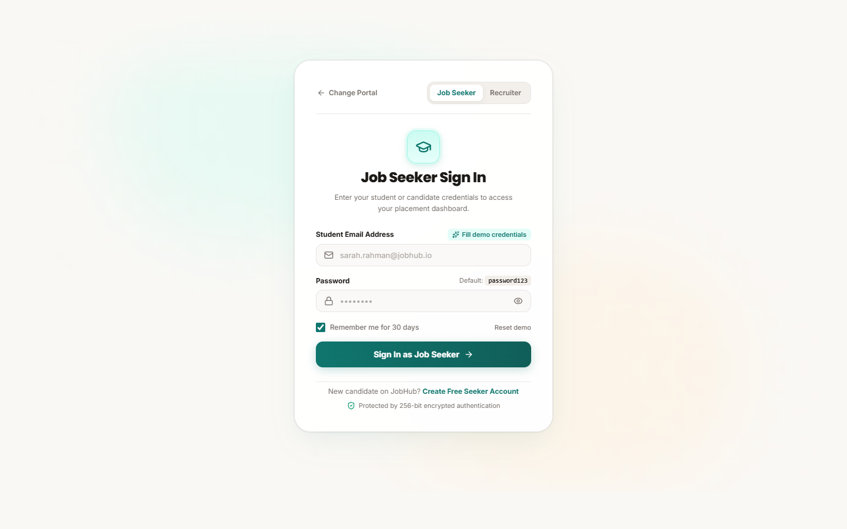
Figure 4: Sign In Authentication Gateway
Role-based candidate and employer login portal with quick prefill assistance for evaluation.
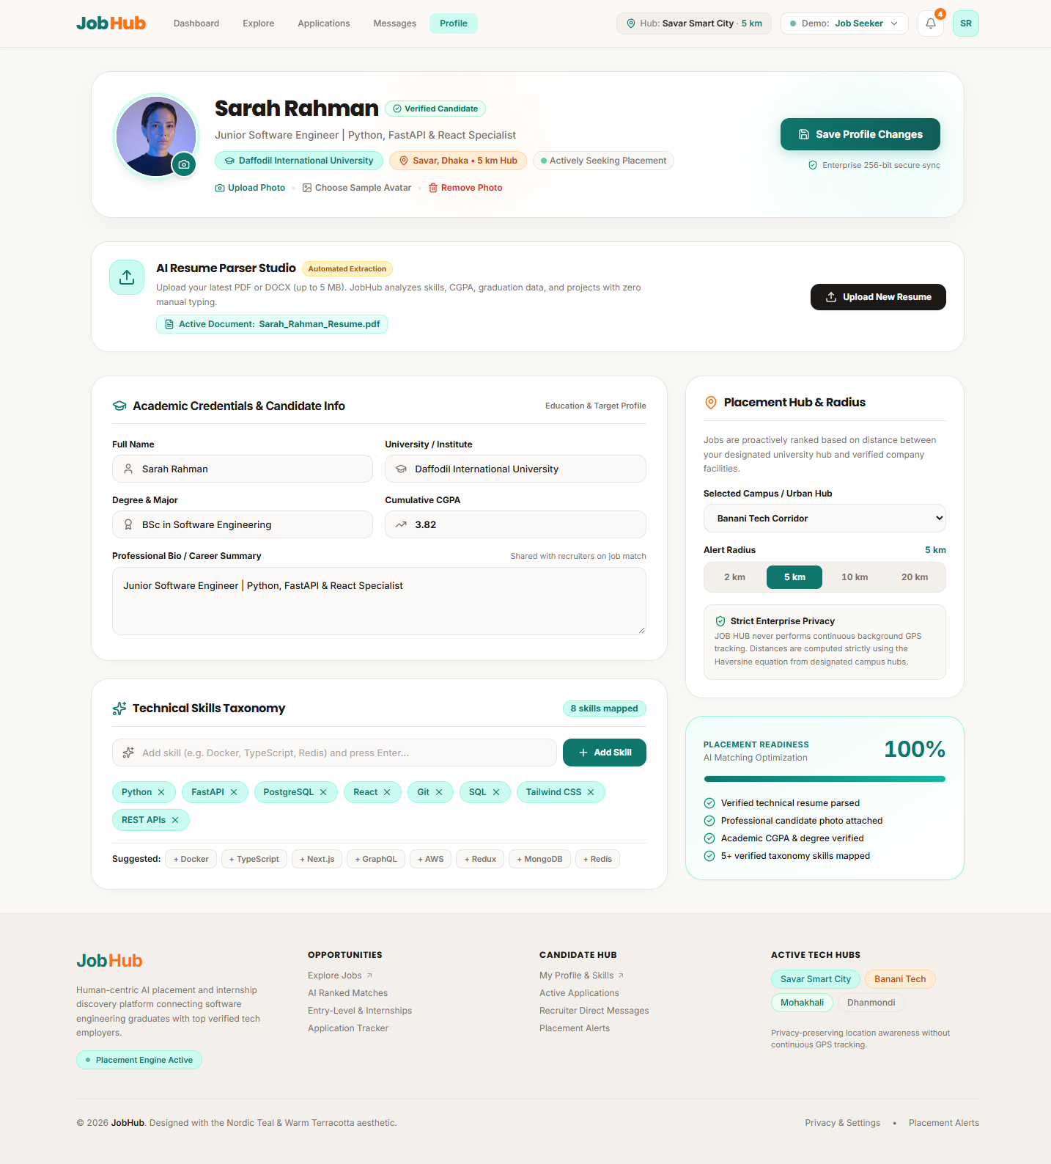
Figure 5: Candidate Profile Management Screen (/profile)
Complete view of the Job Seeker profile featuring AI Resume Studio, Academic Credentials (DIU, BSc SWE, CGPA 3.82), Skills Taxonomy, and Geospatial Placement Radar.
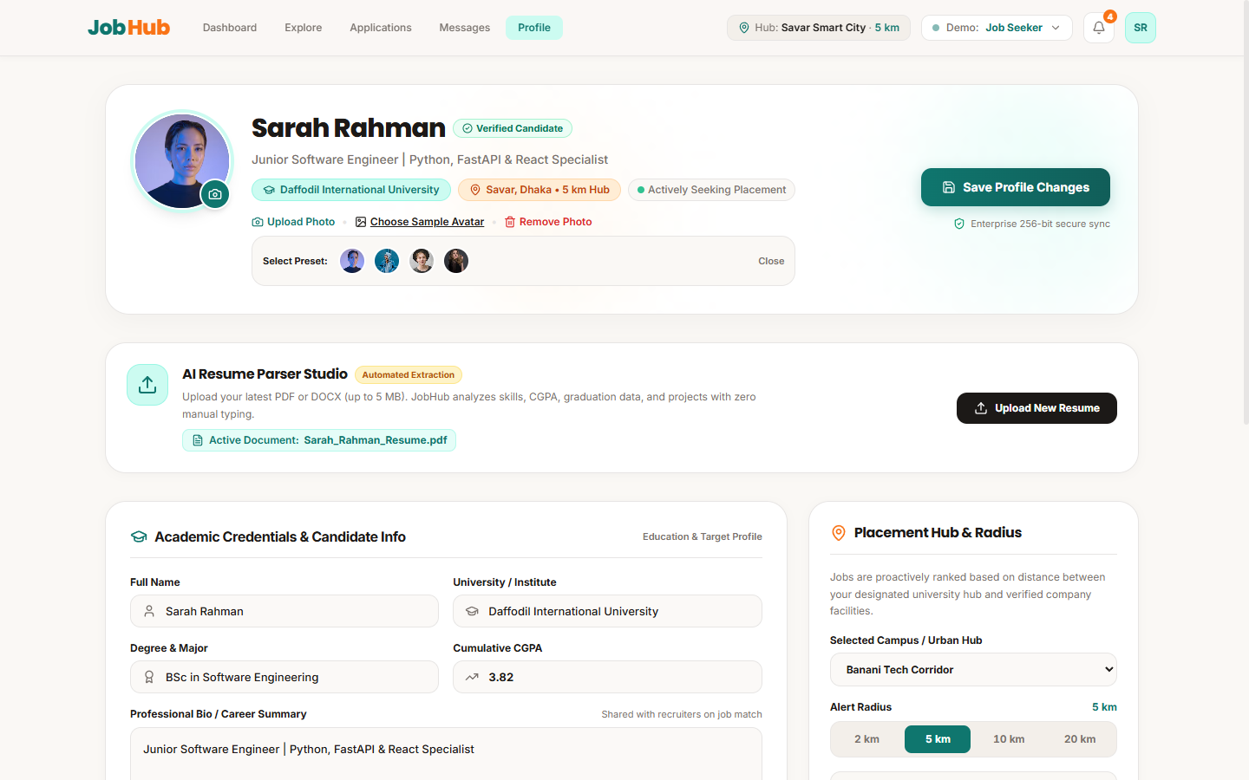
Figure 6: Interactive Avatar Chooser Modal
Modal dialog offering curated professional avatar presets with client-side image compression and photo preview.
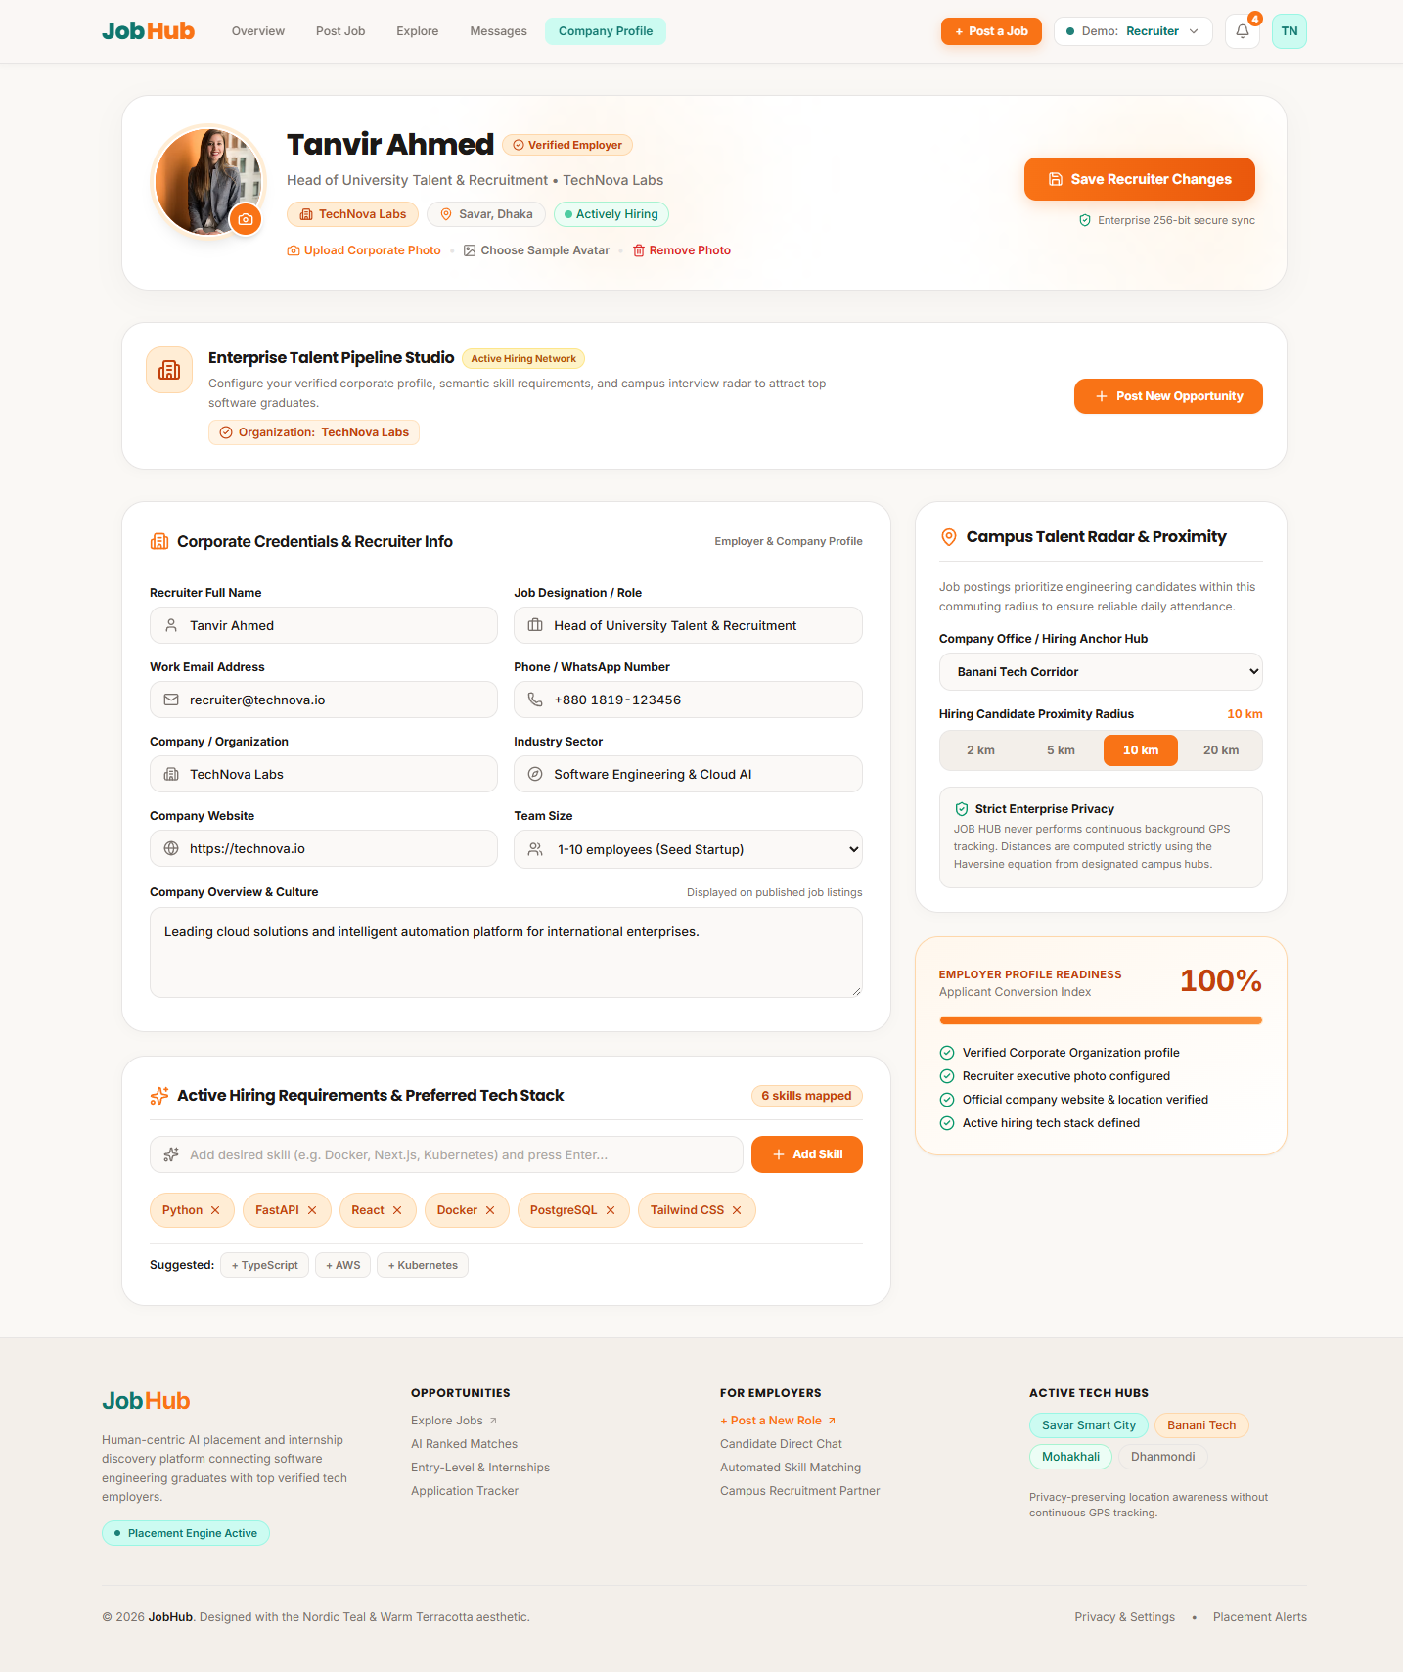
Figure 7: Recruiter Corporate Profile Screen (/profile)
Recruiter organization view featuring company size, industry classification, corporate website, Banani office anchor, and hiring tech stack.
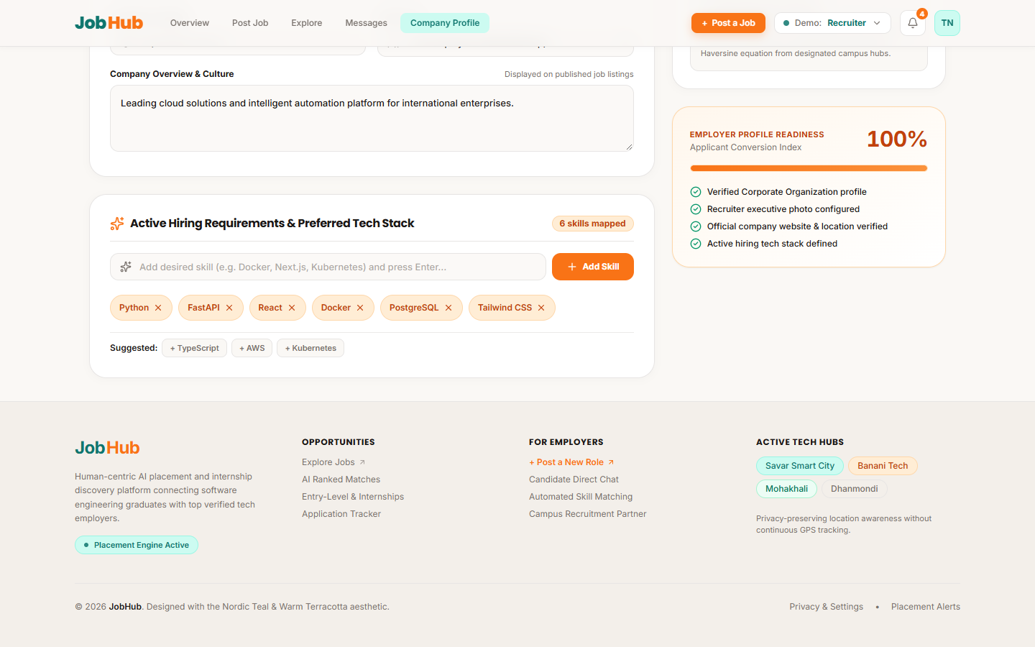
Figure 8: Interactive Skills Taxonomy Management
Demonstrates dynamic chip additions (+ TypeScript, + AWS), tag removal buttons, and live taxonomy count indicator.
6. Verification & Prototype Access Links
The interactive prototype is fully operational and can be reviewed via the following channels:
- Live Cloud Prototype (GitHub Pages): https://saif-alsaad.github.io/JobHub/ (Instant web browser access, zero installation required).
- Official Repository Branch: https://github.com/Saif-AlSaad/JobHub/tree/Nadim
- Demo Evaluation Credentials:
• Job Seeker: sarah.rahman@jobhub.io / password123
• Recruiter: recruiter@technova.io / password123
• Admin: admin@jobhub.io / password123

