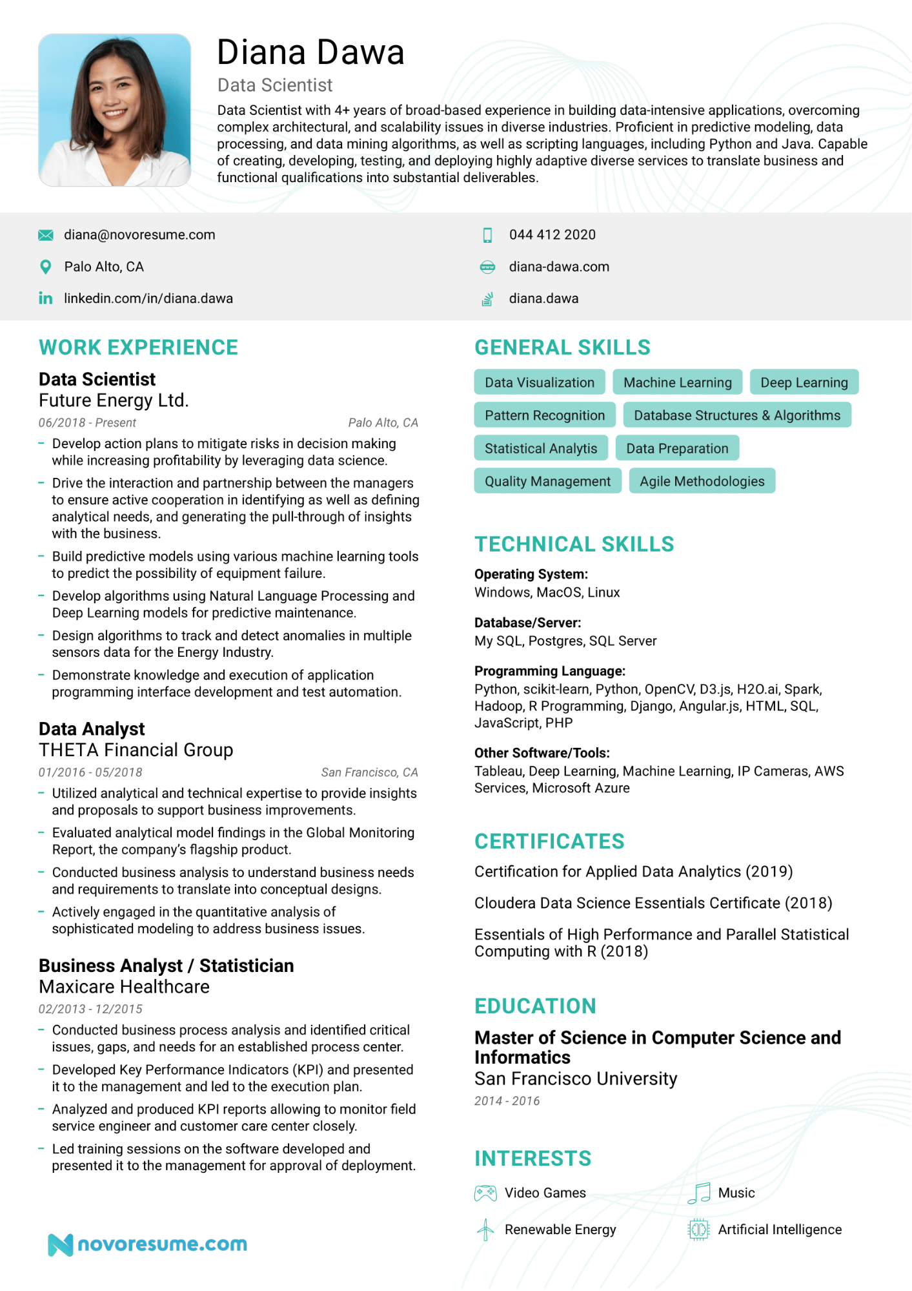

Diana Dawa

Data Scientist

Data Scientist with 4+ years of broad-based experience in building data-intensive applications, overcoming complex architectural, and scalability issues in diverse industries. Proficient in predictive modeling, data processing, and data mining algorithms, as well as scripting languages, including Python and Java. Capable of creating, developing, testing, and deploying highly adaptive diverse services to translate business and functional qualifications into substantial deliverables.

diana@novoresume.com

Palo Alto, CA

in linkedin.com/in/diana.dawa

**WORK EXPERIENCE**

**Data Scientist**

044 412 2020

diana-dawa.com

diana.dawa

**GENERAL SKILLS**

Future Energy Ltd.

06/2018 - Present

-

—

—

-

Deep Learning

Database Structures & Algorithms

Data Visualization

Machine Learning

Pattern Recognition

*Palo Alto, CA*

Statistical Analytis

Develop action plans to mitigate risks in decision making while increasing profitability by leveraging data science.

Drive the interaction and partnership between the managers to ensure active cooperation in identifying as well as defining analytical needs, and generating the pull-through of insights with the business.

Build predictive models using various machine learning tools to predict the possibility of equipment failure.

Develop algorithms using Natural Language Processing and Deep Learning models for predictive maintenance.

Design algorithms to track and detect anomalies in multiple sensors data for the Energy Industry.

Demonstrate knowledge and execution of application programming interface development and test automation.

**Data Analyst**

THETA Financial Group

*01/2016-05/2018*

—

*San Francisco, CA*

Utilized analytical and technical expertise to provide insights and proposals to support business improvements. Evaluated analytical model findings in the Global Monitoring Report, the company's flagship product.

Conducted business analysis to understand business needs and requirements to translate into conceptual designs.

- Actively engaged in the quantitative analysis of sophisticated modeling to address business issues.

**Business Analyst / Statistician Maxicare Healthcare**

02/2013 12/2015

-

-

Conducted business process analysis and identified critical issues, gaps, and needs for an established process center. Developed Key Performance Indicators (KPI) and presented it to the management and led to the execution plan. Analyzed and produced KPI reports allowing to monitor field service engineer and customer care center closely. Led training sessions on the software developed and presented it to the management for approval of deployment.

Data Preparation

Quality Management Agile Methodologies

**TECHNICAL SKILLS**

**Operating System: Windows, MacOS, Linux**

**Database/Server:**

My SQL, Postgres, SQL Server

**Programming Language:**

Python, scikit-learn, Python, OpenCV, D3.js, H2O.ai, Spark, Hadoop, R Programming, Django, Angular.js, HTML, SQL, JavaScript, PHP

**Other Software/Tools:**

Tableau, Deep Learning, Machine Learning, IP Cameras, AWS Services, Microsoft Azure

**CERTIFICATES**

Certification for Applied Data Analytics (2019)

Cloudera Data Science Essentials Certificate (2018)

Essentials of High Performance and Parallel Statistical Computing with R (2018)

**EDUCATION**

**Master of Science in Computer Science and Informatics**

San Francisco University

2014-2016

**INTERESTS**

Video Games

**Nnovoresume.com**

Music

Renewable Energy

Artificial Intelligence