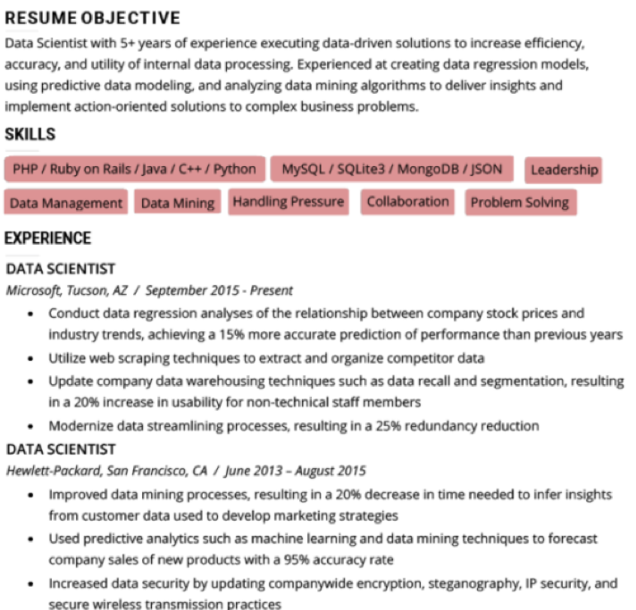

**RESUME OBJECTIVE**

Data Scientist with 5+ years of experience executing data-driven solutions to increase efficiency, accuracy, and utility of internal data processing. Experienced at creating data regression models, using predictive data modeling, and analyzing data mining algorithms to deliver insights and implement action-oriented solutions to complex business problems.

**SKILLS**

PHP/Ruby on Rails/Java/C++/Python

MySQL/SQLite3/MongoDB/JSON

Leadership

Data Management Data Mining Handling Pressure Collaboration Problem Solving

**EXPERIENCE**

DATA SCIENTIST

Microsoft, Tucson, AZ / September 2015 - Present

• Conduct data regression analyses of the relationship between company stock prices and industry trends, achieving a 15% more accurate prediction of performance than previous years

• Utilize web scraping techniques to extract and organize competitor data

• Update company data warehousing techniques such as data recall and segmentation, resulting in a 20% increase in usability for non-technical staff members

• Modernize data streamlining processes, resulting in a 25% redundancy reduction

DATA SCIENTIST

*Hewlett-Packard, San Francisco, CA / June 2013 - August 2015*

• Improved data mining processes, resulting in a 20% decrease in time needed to infer insights from customer data used to develop marketing strategies

• Used predictive analytics such as machine learning and data mining techniques to forecast company sales of new products with a 95% accuracy rate

• Increased data security by updating companywide encryption, steganography, IP security, and secure wireless transmission practices