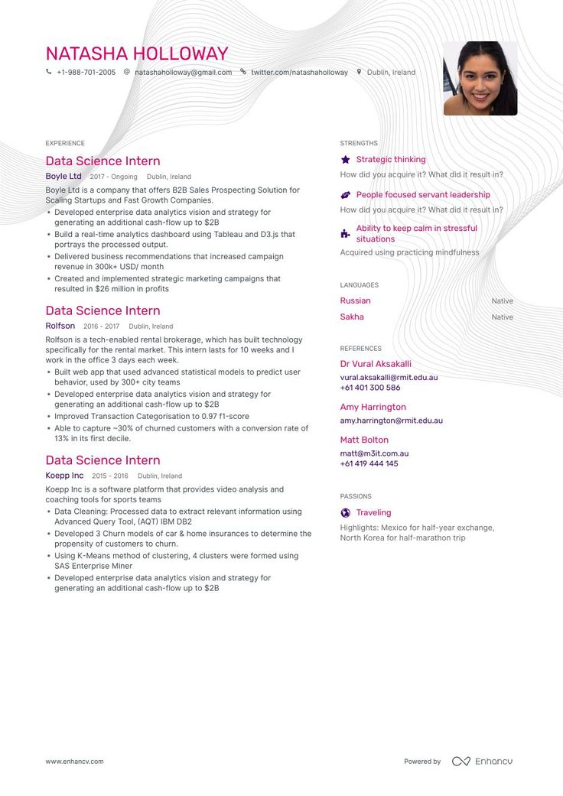

NATASHA HOLLOWAY

+1-988-701-2005 @natashaholloway@gmail.com twitter.com/natashaholloway Dublin, Ireland

EXPERIENCE

Data Science Intern

Boyle Ltd 2017-Ongoing Dublin, Ireland

Boyle Ltd is a company that offers B2B Sales Prospecting Solution for Scaling Startups and Fast Growth Companies.

• Developed enterprise data analytics vision and strategy for generating an additional cash-flow up to $2B

• Build a real-time analytics dashboard using Tableau and D3.js that portrays the processed output.

• Delivered business recommendations that increased campaign revenue in 300k+ USD/ month

• Created and implemented strategic marketing campaigns that resulted in $26 million in profits

Data Science Intern

STRENGTHS

★ Strategic thinking

How did you acquire it? What did it result in?

People focused servant leadership How did you acquire it? What did it result in? Ability to keep calm in stressful situations

Acquired using practicing mindfulness

LANGUAGES

Russian

Sakha

Native

Native

Rolfson 2016-2017 Dublin, Ireland

Rolfson is a tech-enabled rental brokerage, which has built technology specifically for the rental market. This intern lasts for 10 weeks and I

work in the office 3 days each week.

.

• Built web app that used advanced statistical models to predict user behavior, used by 300+ city teams

• Developed enterprise data analytics vision and strategy for

generating an additional cash-flow up to $2B

• Improved Transaction Categorisation to 0.97 f1-score

• Able to capture ~30% of churned customers with a conversion rate of 13% in its first decile.

Data Science Intern

Koepp Inc 2015-2016 Dublin, Ireland

Koepp Inc is a software platform that provides video analysis and coaching tools for sports teams

⚫ Data Cleaning: Processed data to extract relevant information using Advanced Query Tool, (AQT) IBM DB2

• Developed 3 Churn models of car & home insurances to determine the propensity of customers to churn.

⚫ Using K-Means method of clustering, 4 clusters were formed using SAS Enterprise Miner

• Developed enterprise data analytics vision and strategy for generating an additional cash-flow up to $2B

REFERENCES

Dr Vural Aksakalli vural.aksakalli@rmit.edu.au

+61 401 300 586

Amy Harrington amy.harrington@rmit.edu.au

Matt Bolton

matt@m3it.com.au

+61 419 444 145

PASSIONS

Traveling

Highlights: Mexico for half-year exchange, North Korea for half-marathon trip

www.enhancv.com

Powered by Enhancu