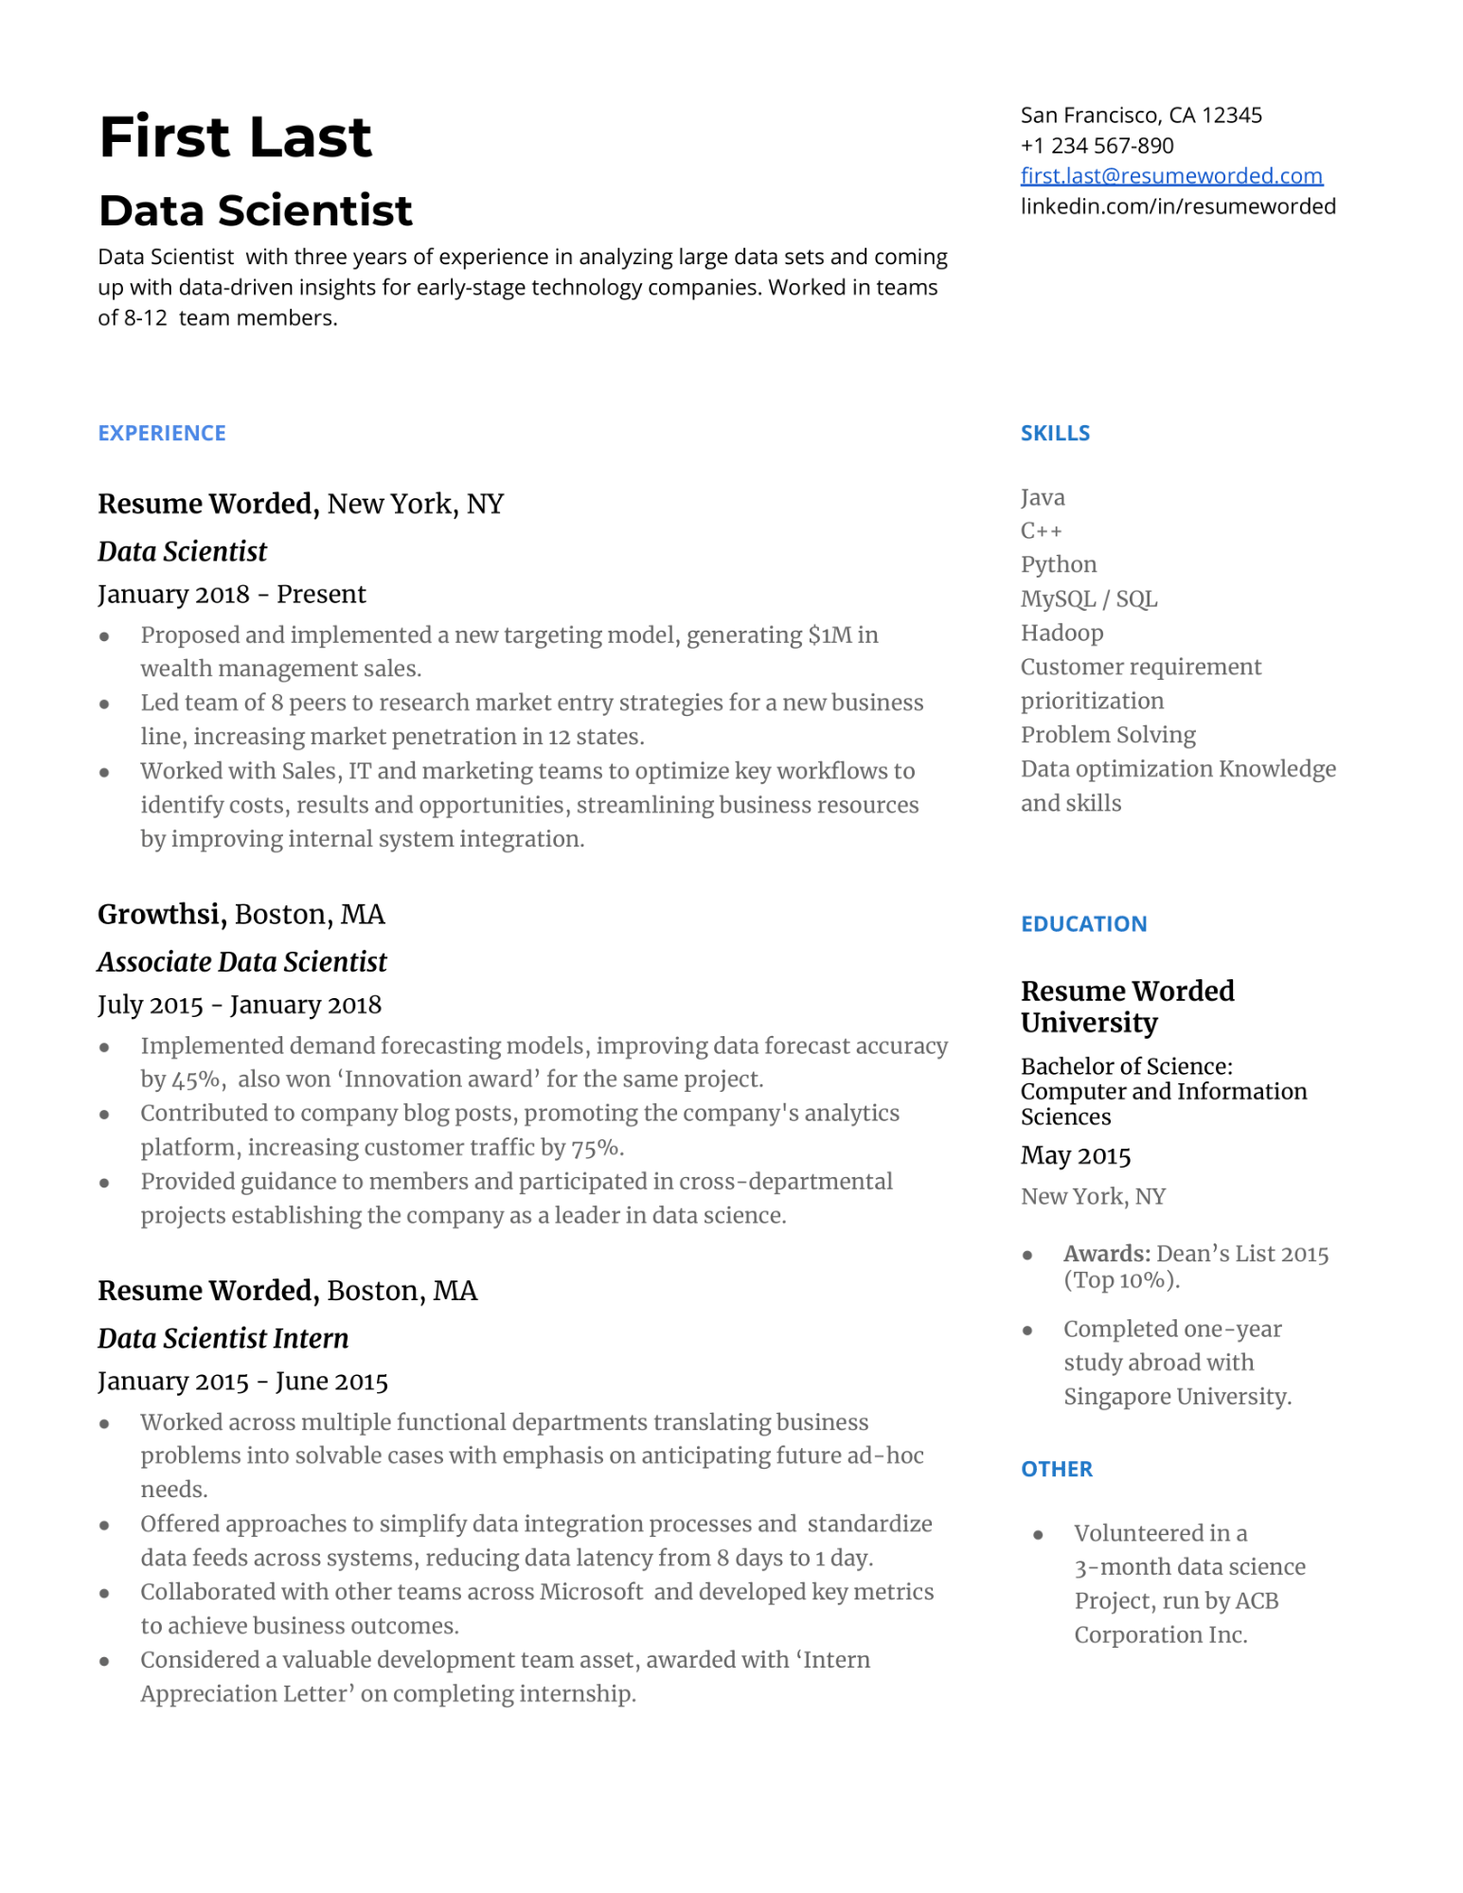

**First Last**

**Data Scientist**

Data Scientist with three years of experience in analyzing large data sets and coming up with data-driven insights for early-stage technology companies. Worked in teams of 8-12 team members.

San Francisco, CA 12345

+1 234 567-890

first.last@resumeworded.com

linkedin.com/in/resumeworded

**EXPERIENCE**

**Resume Worded, New York, NY**

***Data Scientist***

January 2018 - Present

•

•

Proposed and implemented a new targeting model, generating $1M in wealth management sales.

Led team of 8 peers to research market entry strategies for a new business line, increasing market penetration in 12 states.

Worked with Sales, IT and marketing teams to optimize key workflows to identify costs, results and opportunities, streamlining business resources by improving internal system integration.

**Growthsi, Boston, MA**

**SKILLS**

Java

C++

Python MySQL/SQL Hadoop

Customer requirement prioritization

Problem Solving

Data optimization Knowledge and skills

*Associate Data Scientist*

July 2015 - January 2018

Implemented demand forecasting models, improving data forecast accuracy by 45%, also won 'Innovation award' for the same project. Contributed to company blog posts, promoting the company's analytics platform, increasing customer traffic by 75%.

Provided guidance to members and participated in cross-departmental projects establishing the company as a leader in data science.

**Resume Worded, Boston, MA**

***Data Scientist Intern***

January 2015 - June 2015

Worked across multiple functional departments translating business problems into solvable cases with emphasis on anticipating future ad-hoc needs.

Offered approaches to simplify data integration processes and standardize data feeds across systems, reducing data latency from 8 days to 1 day. Collaborated with other teams across Microsoft and developed key metrics to achieve business outcomes.

Considered a valuable development team asset, awarded with 'Intern Appreciation Letter' on completing internship.

**EDUCATION**

**Resume Worded University**

Bachelor of Science: Computer and Information Sciences

May 2015

New York, NY

•

**Awards: Dean's List 2015 (Top 10%).**

•

Completed one-year

study abroad with

Singapore University.

**OTHER**

Volunteered in a 3-month data science

Project, run by ACB Corporation Inc.