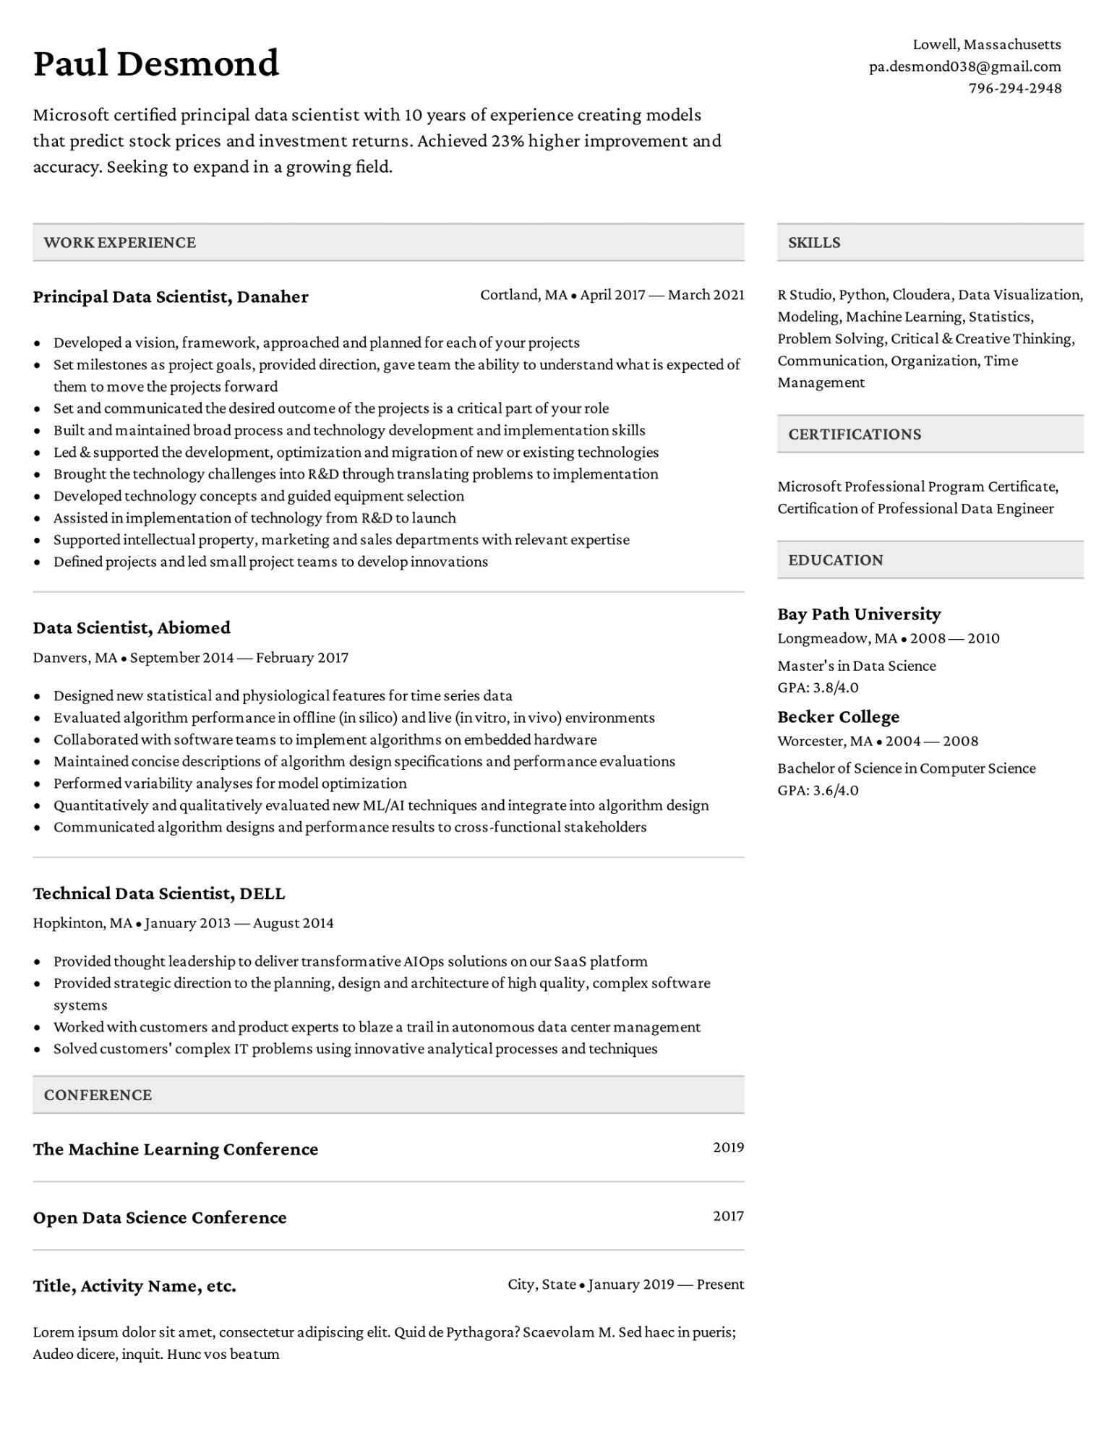

**Paul Desmond**

Microsoft certified principal data scientist with 10 years of experience creating models that predict stock prices and investment returns. Achieved 23% higher improvement and accuracy. Seeking to expand in a growing field.

**WORK EXPERIENCE**

**SKILLS**

Lowell, Massachusetts pa.desmond038@gmail.com

796-294-2948

**Principal Data Scientist, Danaher**

Cortland, MA. April 2017 March 2021

• Developed a vision, framework, approached and planned for each of your projects

• Set milestones as project goals, provided direction, gave team the ability to understand what is expected of them to move the projects forward

⚫ Set and communicated the desired outcome of the projects is a critical part of your role

•

•

•

Built and maintained broad process and technology development and implementation skills

Led & supported the development, optimization and migration of new or existing technologies

Brought the technology challenges into R&D through translating problems to implementation

Developed technology concepts and guided equipment selection

• Assisted in implementation of technology from R&D to launch

•

•

Supported intellectual property, marketing and sales departments with relevant expertise

Defined projects and led small project teams to develop innovations

R Studio, Python, Cloudera, Data Visualization, Modeling, Machine Learning, Statistics, Problem Solving, Critical & Creative Thinking, Communication, Organization, Time Management

**CERTIFICATIONS**

Microsoft Professional Program Certificate, Certification of Professional Data Engineer

**EDUCATION**

**Data Scientist, Abiomed**

Danvers, MA⚫ September 2014 — February 2017

• Designed new statistical and physiological features for time series data

• Evaluated algorithm performance in offline (in silico) and live (in vitro, in vivo) environments Collaborated with software teams to implement algorithms on embedded hardware

•

•

•

•

Maintained concise descriptions of algorithm design specifications and performance evaluations Performed variability analyses for model optimization

Quantitatively and qualitatively evaluated new ML/AI techniques and integrate into algorithm design

Communicated algorithm designs and performance results to cross-functional stakeholders

**Bay Path University**

Longmeadow, MA. 2008-2010

Master's in Data Science

GPA: 3.8/4.0

**Becker College**

Worcester, MA⚫ 2004-2008

Bachelor of Science in Computer Science

GPA: 3.6/4.0

**Technical Data Scientist, DELL**

Hopkinton, MA⚫ January 2013 - August 2014

•

Provided thought leadership to deliver transformative AIOps solutions on our SaaS platform

Provided strategic direction to the planning, design and architecture of high quality, complex software systems

Worked with customers and product experts to blaze a trail in autonomous data center management

• Solved customers' complex IT problems using innovative analytical processes and techniques

**CONFERENCE**

**The Machine Learning Conference**

**Open Data Science Conference**

2019

2017

**Title, Activity Name, etc.**

City, State January 2019- Present

Lorem ipsum dolor sit amet, consectetur adipiscing elit. Quid de Pythagora? Scaevolam M. Sed haec in pueris; Audeo dicere, inquit. Hunc vos beatum