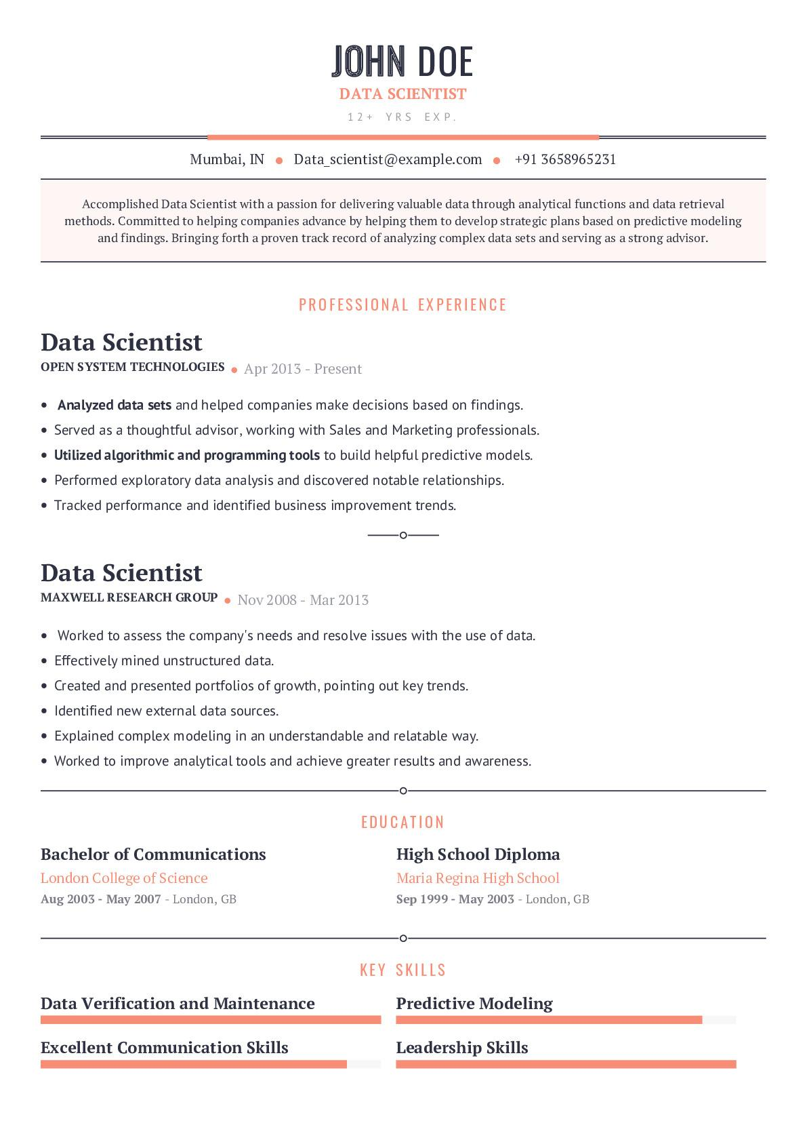

JOHN DOE

**DATA SCIENTIST**

12+ YRS EXP.

Mumbai, IN Data_scientist @example.com. +91 3658965231

Accomplished Data Scientist with a passion for delivering valuable data through analytical functions and data retrieval methods. Committed to helping companies advance by helping them to develop strategic plans based on predictive modeling and findings. Bringing forth a proven track record of analyzing complex data sets and serving as a strong advisor.

PROFESSIONAL EXPERIENCE

**Data Scientist**

**OPEN SYSTEM TECHNOLOGIES. Apr 2013 - Present**

• Analyzed data sets and helped companies make decisions based on findings. • Served as a thoughtful advisor, working with Sales and Marketing professionals. • Utilized algorithmic and programming tools to build helpful predictive models.

• Performed exploratory data analysis and discovered notable relationships.

• Tracked performance and identified business improvement trends.

**Data Scientist**

**MAXWELL RESEARCH GROUP. Nov 2008 - Mar 2013**

• Worked to assess the company's needs and resolve issues with the use of data.

• Effectively mined unstructured data.

• Created and presented portfolios of growth, pointing out key trends.

Identified new external data sources.

• Explained complex modeling in an understandable and relatable way.

• Worked to improve analytical tools and achieve greater results and awareness.

**Bachelor of Communications**

London College of Science

Aug 2003 May 2007 - London, GB

**Data Verification and Maintenance**

**Excellent Communication Skills**

EDUCATION

**High School Diploma**

Maria Regina High School

Sep 1999 - May 2003 - London, GB

KEY SKILLS

**Predictive Modeling**

**Leadership Skills**