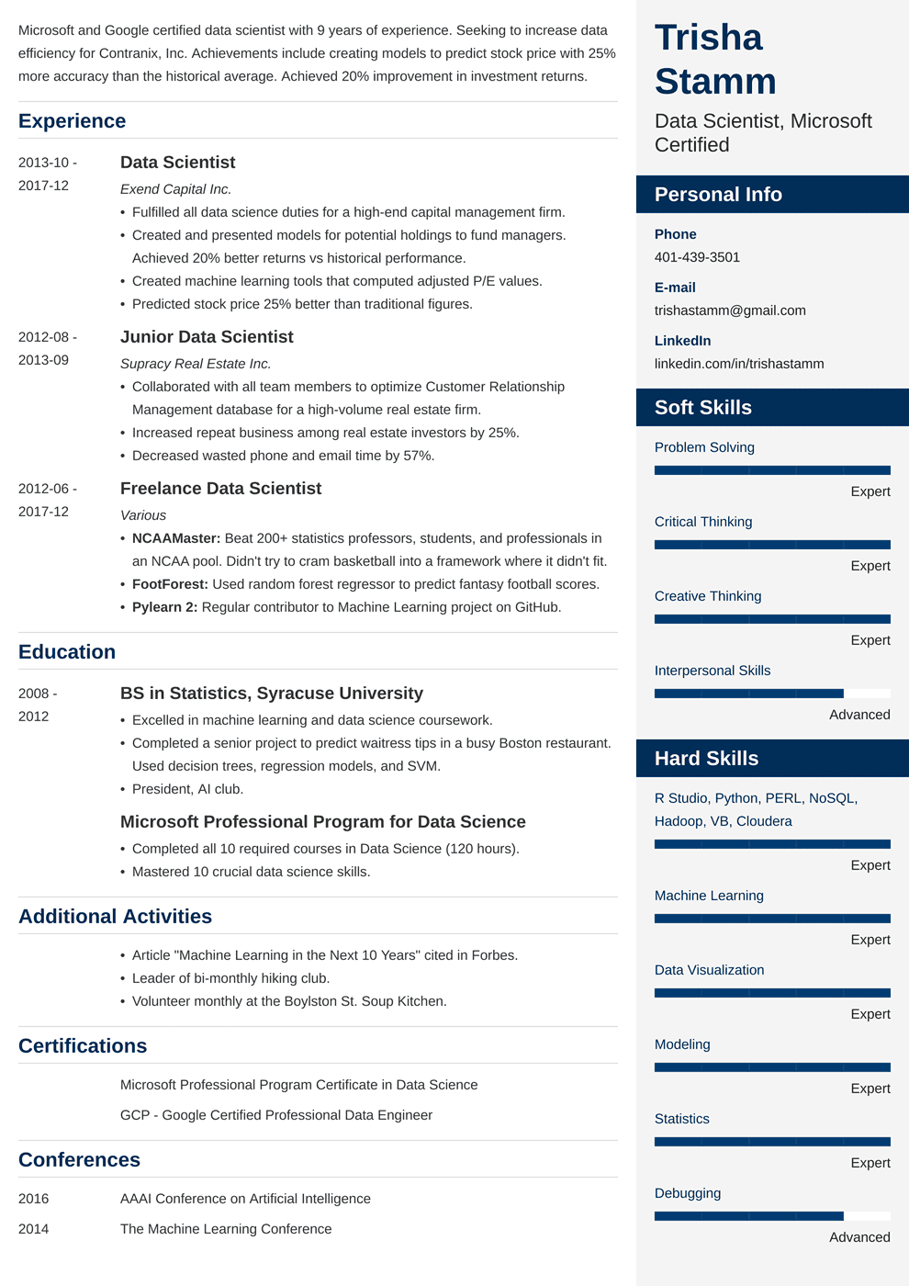

Microsoft and Google certified data scientist with 9 years of experience. Seeking to increase data efficiency for Contranix, Inc. Achievements include creating models to predict stock price with 25% more accuracy than the historical average. Achieved 20% improvement in investment returns.

**Experience**

2013-10-

2017-12

2012-08-

2013-09

2012-06-

**Data Scientist**

*Exend Capital Inc.*

• Fulfilled all data science duties for a high-end capital management firm.

• Created and presented models for potential holdings to fund managers. Achieved 20% better returns vs historical performance.

• Created machine learning tools that computed adjusted P/E values. • Predicted stock price 25% better than traditional figures.

**Junior Data Scientist**

*Supracy Real Estate Inc.*

• Collaborated with all team members to optimize Customer Relationship Management database for a high-volume real estate firm.

• Increased repeat business among real estate investors by 25%.

• Decreased wasted phone and email time by 57%.

**Freelance Data Scientist**

**Trisha Stamm**

Data Scientist, Microsoft Certified

**Personal Info**

Phone 401-439-3501

**E-mail**

trishastamm@gmail.com

**LinkedIn**

linkedin.com/in/trishastamm

Soft Skills

Problem Solving

Expert

2017-12

Critical Thinking

• NCAAMaster: Beat 200+ statistics professors, students, and professionals in an NCAA pool. Didn't try to cram basketball into a framework where it didn't fit.

Expert

• FootForest: Used random forest regressor to predict fantasy football scores. • Pylearn 2: Regular contributor to Machine Learning project on GitHub.

Creative Thinking

*Various*

**Education**

2008 - 2012

**BS in Statistics, Syracuse University**

• Excelled in machine learning and data science coursework.

• Completed a senior project to predict waitress tips in a busy Boston restaurant. Used decision trees, regression models, and SVM.

• President, Al club.

**Microsoft Professional Program for Data Science**

• Completed all 10 required courses in Data Science (120 hours). • Mastered 10 crucial data science skills.

**Additional Activities**

Expert

Interpersonal Skills

**Hard Skills**

Advanced

R Studio, Python, PERL, NoSQL, Hadoop, VB, Cloudera

Expert

Machine Learning

Expert

• Article "Machine Learning in the Next 10 Years" cited in Forbes.

Data Visualization

• Leader of bi-monthly hiking club.

• Volunteer monthly at the Boylston St. Soup Kitchen.

**Certifications**

Expert

Modeling

Microsoft Professional Program Certificate in Data Science GCP - Google Certified Professional Data Engineer

Expert

Statistics

Expert

Debugging

**Conferences**

2016

AAAI Conference on Artificial Intelligence

2014

The Machine Learning Conference

Advanced