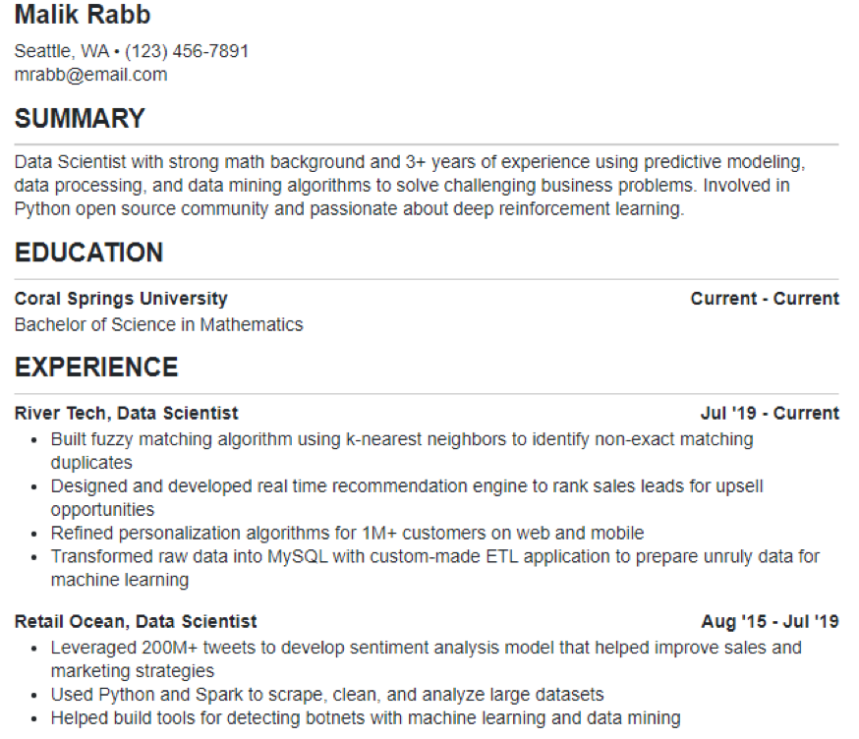

**Malik Rabb**

Seattle, WA. (123) 456-7891 mrabb@email.com

**SUMMARY**

Data Scientist with strong math background and 3+ years of experience using predictive modeling, data processing, and data mining algorithms to solve challenging business problems. Involved in Python open source community and passionate about deep reinforcement learning.

**EDUCATION**

**Coral Springs University**

Bachelor of Science in Mathematics

**EXPERIENCE**

**River Tech, Data Scientist**

**Current - Current**

Jul '19 - Current

• Built fuzzy matching algorithm using k-nearest neighbors to identify non-exact matching duplicates

• Designed and developed real time recommendation engine to rank sales leads for upsell opportunities

• Refined personalization algorithms for 1M+ customers on web and mobile

• Transformed raw data into MySQL with custom-made ETL application to prepare unruly data for machine learning

Retail Ocean, Data Scientist

Aug '15 - Jul '19

• Leveraged 200M+ tweets to develop sentiment analysis model that helped improve sales and marketing strategies

• Used Python and Spark to scrape, clean, and analyze large datasets

• Helped build tools for detecting botnets with machine learning and data mining