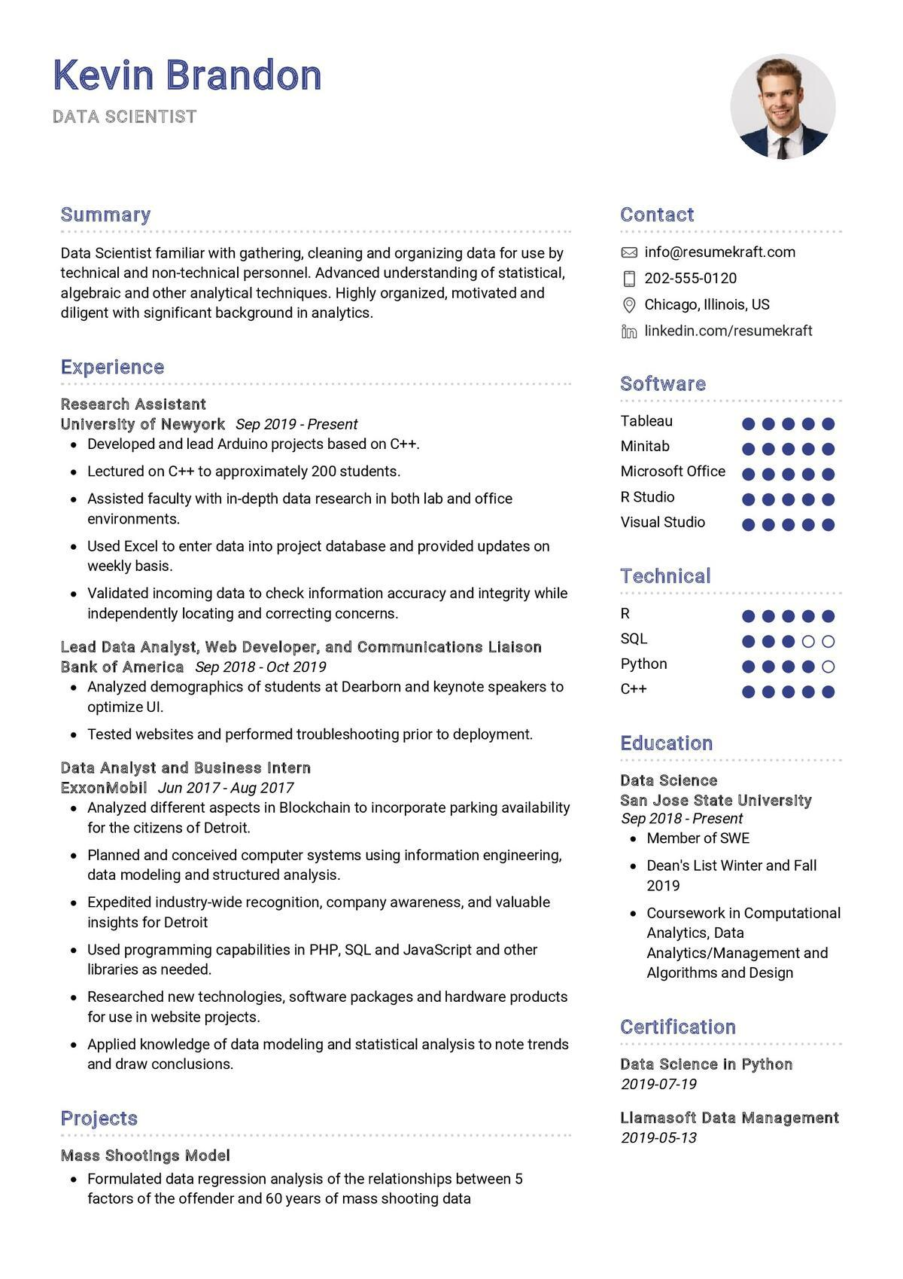

**Kevin Brandon**

DATA SCIENTIST

**Summary**

Data Scientist familiar with gathering, cleaning and organizing data for use by technical and non-technical personnel. Advanced understanding of statistical, algebraic and other analytical techniques. Highly organized, motivated and diligent with significant background in analytics.

**Experience**

Research Assistant

University of Newyork Sep 2019 - Present

Developed and lead Arduino projects based on C++.

• Lectured on C++ to approximately 200 students.

• Assisted faculty with in-depth data research in both lab and office environments.

• Used Excel to enter data into project database and provided updates on weekly basis.

• Validated incoming data to check information accuracy and integrity while independently locating and correcting concerns.

Lead Data Analyst, Web Developer, and Communications Liaison Bank of America Sep 2018 - Oct 2019

• Analyzed demographics of students at Dearborn and keynote speakers to optimize UI.

• Tested websites and performed troubleshooting prior to deployment.

Data Analyst and Business Intern

ExxonMobil Jun 2017- Aug 2017

Analyzed different aspects in Blockchain to incorporate parking availability for the citizens of Detroit.

• Planned and conceived computer systems using information engineering, data modeling and structured analysis.

·

Expedited industry-wide recognition, company awareness, and valuable insights for Detroit

• Used programming capabilities in PHP, SQL and JavaScript and other libraries as needed.

• Researched new technologies, software packages and hardware products for use in website projects.

• Applied knowledge of data modeling and statistical analysis to note trends and draw conclusions.

Projects

Mass Shootings Model

• Formulated data regression analysis of the relationships between 5 factors of the offender and 60 years of mass shooting data

Contact

info@resumekraft.com

202-555-0120

Chicago, Illinois, US

in linkedin.com/resumekraft

**Software**

Tableau

Minitab

Microsoft Office

R Studio

Visual Studio

**Technical**

R

SQL

Python C++

Education

Data Science

San Jose State University Sep 2018-Present

• Member of SWE

• Dean's List Winter and Fall 2019

⚫ Coursework in Computational Analytics, Data Analytics/Management and Algorithms and Design

Certification

*Data Science in Python 2019-07-19*

Llamasoft Data Management 2019-05-13