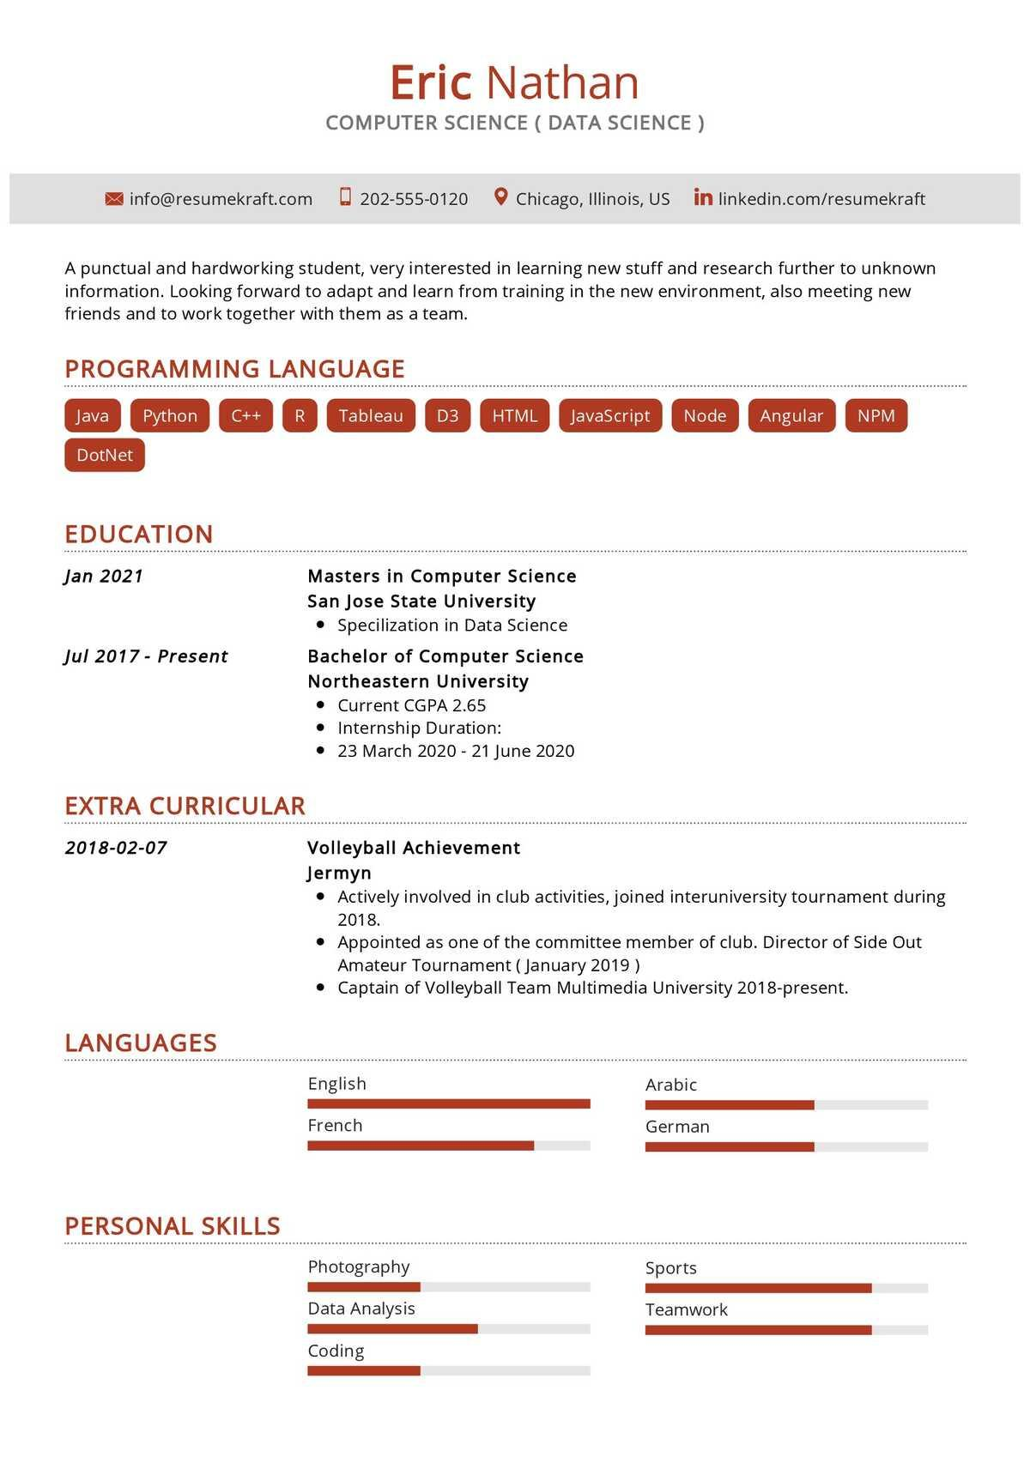

info@resumekraft.com

Eric Nathan

COMPUTER SCIENCE (DATA SCIENCE)

202-555-0120

Chicago, Illinois, US in linkedin.com/resumekraft

A punctual and hardworking student, very interested in learning new stuff and research further to unknown information. Looking forward to adapt and learn from training in the new environment, also meeting new friends and to work together with them as a team.

PROGRAMMING LANGUAGE

Java Python C++ R Tableau D3 HTML

JavaScript Node Angular NPM

DotNet

EDUCATION

***Jan 2021***

*Jul 2017 - Present*

Masters in Computer Science San Jose State University • Specilization in Data Science Bachelor of Computer Science Northeastern University

• Current CGPA 2.65

• Internship Duration:

23 March 2020 - 21 June 2020

EXTRA CURRICULAR

2018-02-07

**LANGUAGES**

Volleyball Achievement Jermyn

• Actively involved in club activities, joined interuniversity tournament during 2018.

• Appointed as one of the committee member of club. Director of Side Out Amateur Tournament (January 2019)

• Captain of Volleyball Team Multimedia University 2018-present.

English

French

Arabic

German

PERSONAL SKILLS

Photography

Data Analysis

Coding

Sports

Teamwork