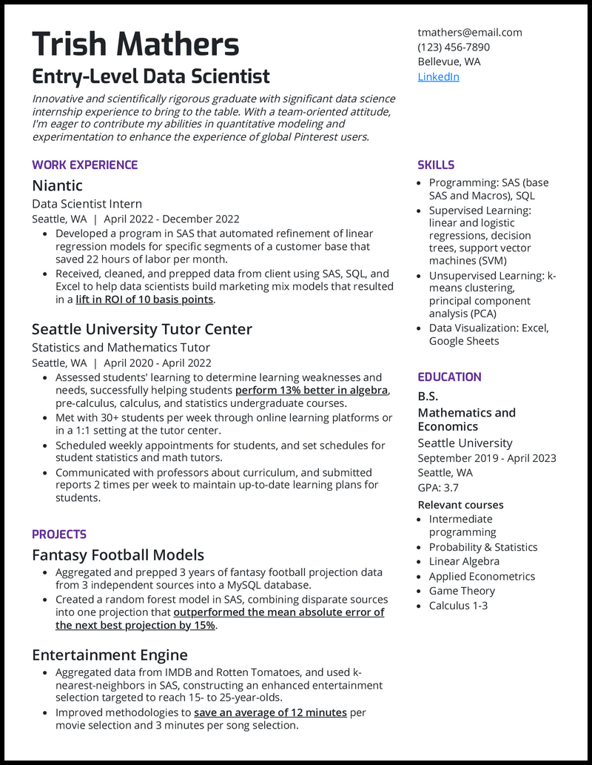

**Trish Mathers**

**Entry-Level Data Scientist**

*Innovative and scientifically rigorous graduate with significant data science internship experience to bring to the table. With a team-oriented attitude, I'm eager to contribute my abilities in quantitative modeling and experimentation to enhance the experience of global Pinterest users.*

**WORK EXPERIENCE**

Niantic

Data Scientist Intern

Seattle, WA | April 2022 - December 2022

• Developed a program in SAS that automated refinement of linear regression models for specific segments of a customer base that saved 22 hours of labor per month.

• Received, cleaned, and prepped data from client using SAS, SQL, and Excel to help data scientists build marketing mix models that resulted in a lift in ROI of 10 basis points.

Seattle University Tutor Center

Statistics and Mathematics Tutor

Seattle, WA | April 2020 - April 2022

• Assessed students' learning to determine learning weaknesses and needs, successfully helping students perform 13% better in algebra, pre-calculus, calculus, and statistics undergraduate courses.

• Met with 30+ students per week through online learning platforms or in a 1:1 setting at the tutor center.

• Scheduled weekly appointments for students, and set schedules for student statistics and math tutors.

• Communicated with professors about curriculum, and submitted reports 2 times per week to maintain up-to-date learning plans for students.

**PROJECTS**

Fantasy Football Models

• Aggregated and prepped 3 years of fantasy football projection data from 3 independent sources into a MySQL database.

• Created a random forest model in SAS, combining disparate sources into one projection that outperformed the mean absolute error of the next best projection by 15%.

Entertainment Engine

• Aggregated data from IMDB and Rotten Tomatoes, and used k- nearest-neighbors in SAS, constructing an enhanced entertainment selection targeted to reach 15- to 25-year-olds.

• Improved methodologies to save an average of 12 minutes per movie selection and 3 minutes per song selection.

tmathers@email.com

(123) 456-7890 Bellevue, WA LinkedIn

SKILLS

• Programming: SAS (base SAS and Macros), SQL • Supervised Learning: linear and logistic regressions, decision trees, support vector machines (SVM)

• Unsupervised Learning: k- means clustering, principal component analysis (PCA)

• Data Visualization: Excel, Google Sheets

**EDUCATION**

B.S.

Mathematics and Economics

Seattle University September 2019 - April 2023 Seattle, WA

GPA: 3.7

Relevant courses

• Intermediate programming

• Probability & Statistics • Linear Algebra • Applied Econometrics

Game Theory

• Calculus 1-3