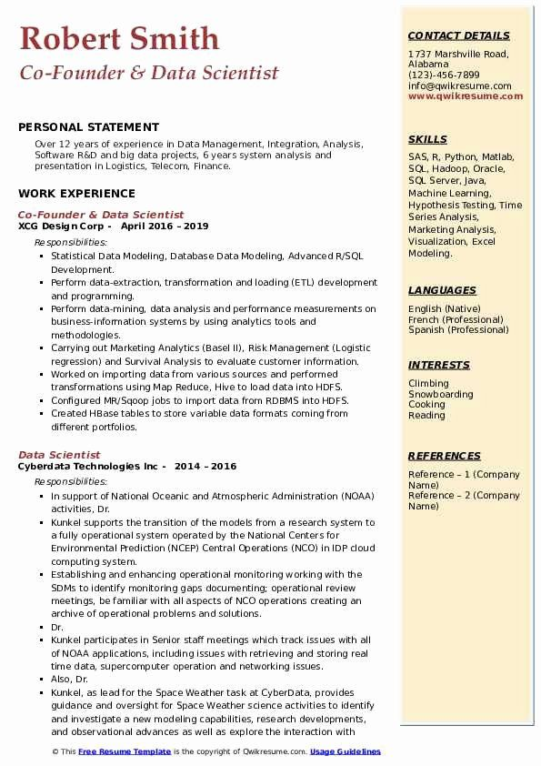

**Robert Smith**

Co-Founder & Data Scientist

**CONTACT DETAILS**

1737 Marshville Road, Alabama

(123)-456-7899

info@qwikresume.com www.qwikresume.com

**PERSONAL STATEMENT**

Over 12 years of experience in Data Management, Integration, Analysis, Software R&D and big data projects, 6 years system analysis and presentation in Logistics, Telecom, Finance.

**WORK EXPERIENCE**

Co-Founder & Data Scientist

XCG Design Corp

Responsibilities:

April 2016-2019

■ Statistical Data Modeling, Database Data Modeling, Advanced R/SQL Development.

• Perform data-extraction, transformation and loading (ETL) development and programming.

• Perform data-mining, data analysis and performance measurements on business-information systems by using analytics tools and

methodologies.

• Carrying out Marketing Analytics (Basel II), Risk Management (Logistic regression) and Survival Analysis to evaluate customer information. • Worked on importing data from various sources and performed transformations using Map Reduce, Hive to load data into HDFS. Configured MR/Sqoop jobs to import data from RDBMS Into HDFS. • Created HBase tables to store variable data formats coming from different portfolios.

Data Scientist

Cyberdata Technologies Inc 2014-2016

Responsibilities:

• In support of National Oceanic and Atmospheric Administration (NOAA) activities, Dr.

• Kunkel supports the transition of the models from a research system to a fully operational system operated by the National Centers for Environmental Prediction (NCEP) Central Operations (NCO) in IDP cloud computing system.

• Establishing and enhancing operational monitoring working with the SDMs to identify monitoring gaps documenting: operational review meetings, be familiar with all aspects of NCO operations creating an archive of operational problems and solutions.

■ Dr.

• Kunkel participates in Senior staff meetings which track issues with all of NOAA applications, including issues with retrieving and storing real time data, supercomputer operation and networking issues. Also, Dr.

• Kunkel, as lead for the Space Weather task at CyberData, provides guidance and oversight for Space Weather science activities to identify and investigate a new modeling capabilities, research developments, and observational advances as well as explore the interaction with

© This Free Resume Template is the copyright of Qwikresume.com. Usage Guidelines

SKILLS

SAS, R, Python, Matlab, SOL, Hadoop, Oracle, SQL Server, Java, Machine Learning.

Hypothesis Testing, Time Series Analysis, Marketing Analysis, Visualization, Excel Modeling.

**LANGUAGES**

English (Native) French (Professional) Spanish (Professional)

**INTERESTS**

Climbing Snowboarding

Cooking Reading

**REFERENCES**

Reference 1 (Company) Name)

Reference 2 (Company

Name)