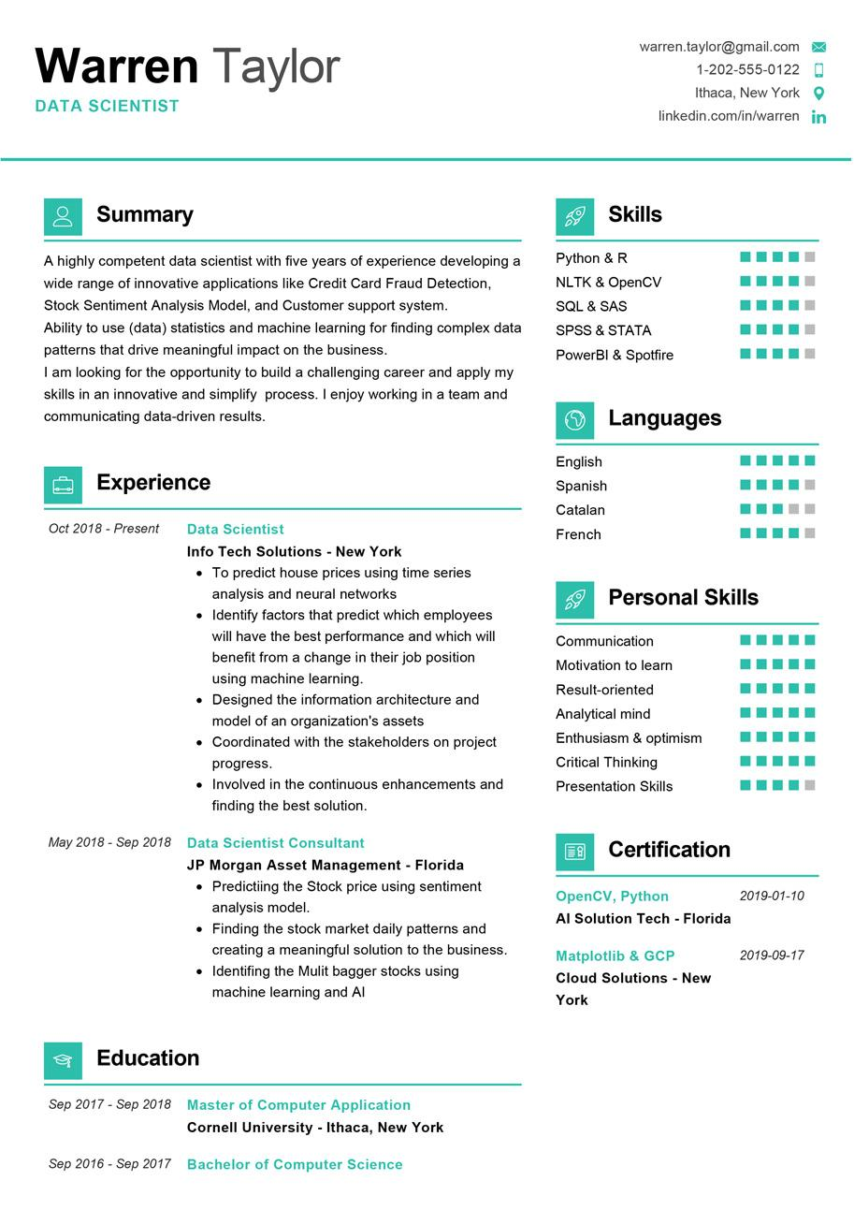

Warren Taylor

**DATA SCIENTIST**

warren.taylor@gmail.com

1-202-555-0122

Ithaca, New York O linkedin.com/in/warren in

**Summary**

A highly competent data scientist with five years of experience developing a wide range of innovative applications like Credit Card Fraud Detection, Stock Sentiment Analysis Model, and Customer support system. Ability to use (data) statistics and machine learning for finding complex data patterns that drive meaningful impact on the business.

I am looking for the opportunity to build a challenging career and apply my skills in an innovative and simplify process. I enjoy working in a team and communicating data-driven results.

**Skills**

Python & R

NLTK & OpenCV SQL & SAS

SPSS & STATA

PowerBI & Spotfire

**Languages**

**Experience**

*Oct 2018 - Present*

Data Scientist

English

Spanish

Catalan French

Info Tech Solutions - New York

• To predict house prices using time series analysis and neural networks

• Identify factors that predict which employees will have the best performance and which will benefit from a change in their job position using machine learning.

• Designed the information architecture and model of an organization's assets

• Coordinated with the stakeholders on project progress.

⚫ Involved in the continuous enhancements and finding the best solution.

**May 2018 - Sep 2018 Data Scientist Consultant**

JP Morgan Asset Management - Florida • Predictiing the Stock price using sentiment analysis model.

⚫ Finding the stock market daily patterns and creating a meaningful solution to the business. • Identifing the Mulit bagger stocks using machine learning and Al

**Personal Skills**

Communication

Motivation to learn

Result-oriented

Analytical mind

Enthusiasm & optimism Critical Thinking

Presentation Skills

**Certification**

OpenCV, Python

**Al Solution Tech - Florida**

*2019-01-10*

**Matplotlib & GCP Cloud Solutions - New York**

2019-09-17

**Education**

**Sep 2017 - Sep 2018 Master of Computer Application**

**Cornell University - Ithaca, New York**

Sep 2016 - Sep 2017 Bachelor of Computer Science