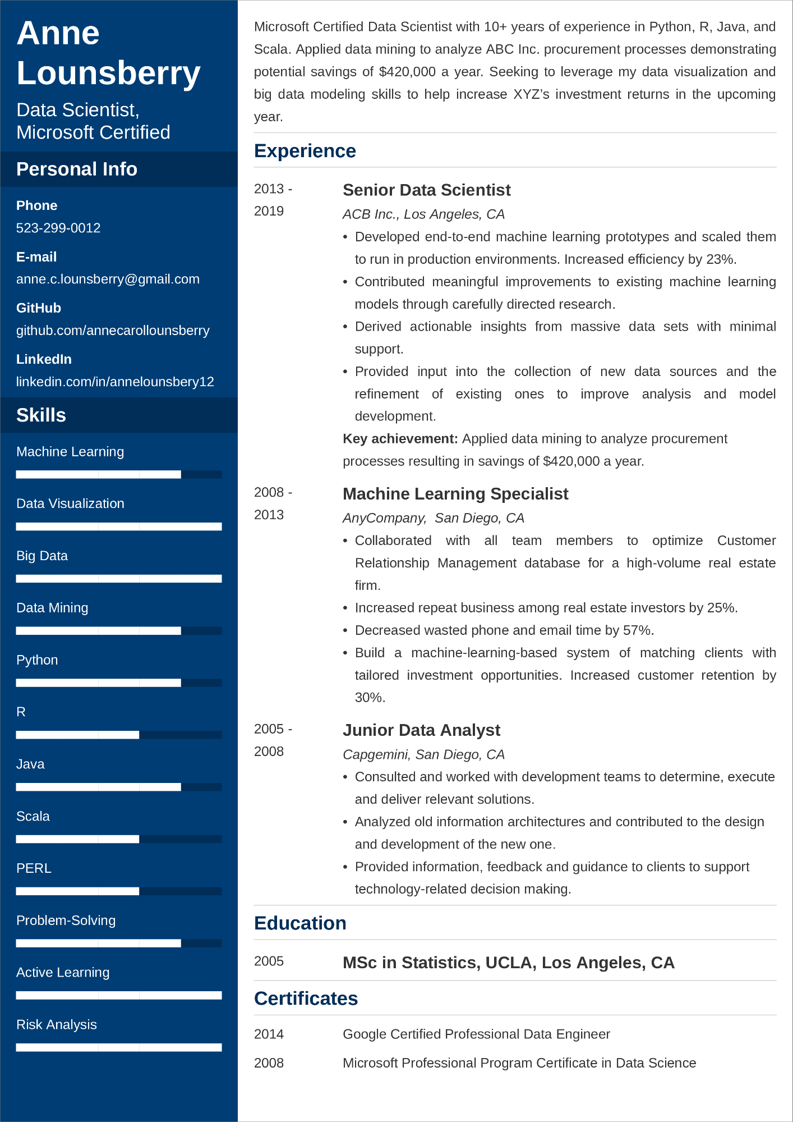

**Anne Lounsberry**

Data Scientist,

Microsoft Certified

**Personal Info**

**Phone**

523-299-0012

**E-mail**

anne.c.lounsberry@gmail.com

**GitHub**

github.com/annecarollounsberry

**LinkedIn**

linkedin.com/in/annelounsbery12

**Skills**

Machine Learning

Microsoft Certified Data Scientist with 10+ years of experience in Python, R, Java, and Scala. Applied data mining to analyze ABC Inc. procurement processes demonstrating potential savings of $420,000 a year. Seeking to leverage my data visualization and big data modeling skills to help increase XYZ's investment returns in the upcoming year.

**Experience**

2013 -

2019

2008 -

Data Visualization

2013

Big Data

Data Mining

Python

R

Java

Scala

PERL

2005 -

2008

**Senior Data Scientist**

*ACB Inc., Los Angeles, CA*

•

•

•

Developed end-to-end machine learning prototypes and scaled them to run in production environments. Increased efficiency by 23%. Contributed meaningful improvements to existing machine learning models through carefully directed research.

Derived actionable insights from massive data sets with minimal support.

Provided input into the collection of new data sources and the refinement of existing ones to improve analysis and model development.

Key achievement: Applied data mining to analyze procurement

processes resulting in savings of $420,000 a year.

**Machine Learning Specialist**

*AnyCompany, San Diego, CA*

•

•

Collaborated with all team team members to optimize Customer Relationship Management database for a high-volume real estate

firm.

Increased repeat business among real estate investors by 25%.

• Decreased wasted phone and email time by 57%.

• Build a machine-learning-based system of matching clients with

tailored investment opportunities. Increased customer retention by 30%.

**Junior Data Analyst**

*Capgemini, San Diego, CA*

•

•

Consulted and worked with development teams to determine, execute and deliver relevant solutions.

Analyzed old information architectures and contributed to the design and development of the new one.

Provided information, feedback and guidance to clients to support technology-related decision making.

Problem-Solving

Active Learning

**Education**

2005

**MSc in Statistics, UCLA, Los Angeles, CA**

**Certificates**

Google Certified Professional Data Engineer

Risk Analysis

2014

2008

Microsoft Professional Program Certificate in Data Science