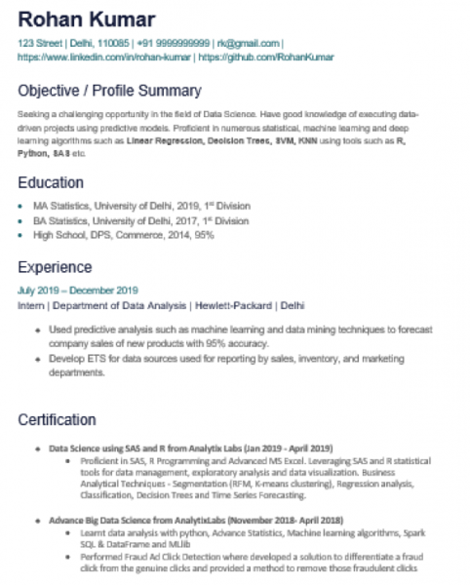

**Rohan Kumar**

**123 Street | Delhi, 110085 | +91 9999999999 | rk@gmail.com https://www.linkedin.com/in/rohan-kumar | https://github.com/Rohankumar**

Objective / Profile Summary

Seeking a challenging opportunity in the field of Data Science. Have good knowledge of executing data- driven projects using predictive models. Proficient in numerous statistical, machine leaming and deep learning algorithms such as Linear Regression, Decision Trees, 3VM, KNN using tools such as R, Python, 8A8 etc.

Education

⚫ MA Statistics, University of Delhi, 2019, 1" Division ⚫ BA Statistics, University of Delhi, 2017, 1o Division

**• High School, DPS, Commerce, 2014, 95%**

Experience

July 2019-December 2019

Intern | Department of Data Analysis | Hewlett-Packard | Delhi

• Used predictive analysis such as machine leaming and data mining techniques to forecast company sales of new products with 95% accuracy.

• Develop ETS for data sources used for reporting by sales, inventory, and marketing departments.

Certification

**⚫ Data Science using SAS and R from Analytix Labs (Jan 2019-April 2019)**

• Proficient in SAS, R Programming and Advanced MS Excel. Leveraging SAS and R statistical tools for data management, exploratory analysis and data visualization. Business Analytical Techniques - Segmentation (RFM, K-means clustering), Regression analysis, Classification, Decision Trees and Time Series Forecasting.

**• Advance Big Data Science from AnalytixLabs (November 2018- April 2018)**

⚫ Learnt data analysis with python, Advance Statistics, Machine learning algorithms, Spark SQL & DataFrame and MLib

• Performed Fraud Ad Click Detection where developed a solution to differentiate a fraud click from the genuine clicks and provided a method to remove those fraudulent clicks