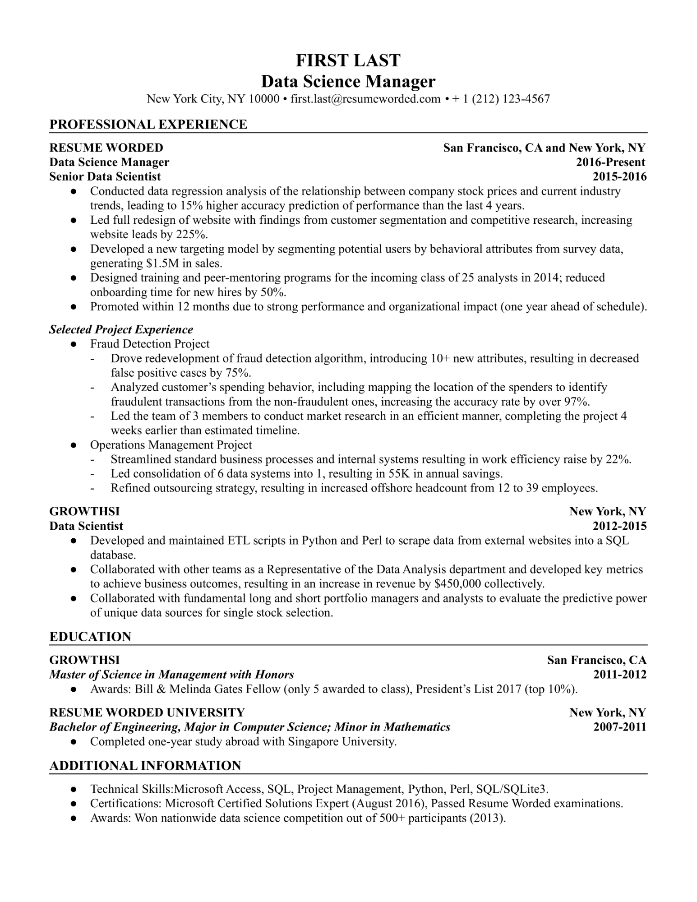

**FIRST LAST**

**Data Science Manager**

New York City, NY 10000⚫ first.last@resumeworded.com • + 1 (212) 123-4567

**PROFESSIONAL EXPERIENCE**

**RESUME WORDED Data Science Manager**

**Senior Data Scientist**

•

•

•

**San Francisco, CA and New York, NY**

**2016-Present 2015-2016**

Conducted data regression analysis of the relationship between company stock prices and current industry trends, leading to 15% higher accuracy prediction of performance than the last 4 years.

Led full redesign of website with findings from customer segmentation and competitive research, increasing website leads by 225%.

Developed a new targeting model by segmenting potential users by behavioral attributes from survey data, generating $1.5M in sales.

Designed training and peer-mentoring programs for the incoming class of 25 analysts in 2014; reduced onboarding time for new hires by 50%.

• Promoted within 12 months due to strong performance and organizational impact (one year ahead of schedule).

***Selected Project Experience***

•

Fraud Detection Project

Drove redevelopment of fraud detection algorithm, introducing 10+ new attributes, resulting in decreased false positive cases by 75%.

Analyzed customer's spending behavior, including mapping the location of the spenders to identify fraudulent transactions from the non-fraudulent ones, increasing the accuracy rate by over 97%.

Led the team of 3 members to conduct market research in an efficient manner, completing the project 4 weeks earlier than estimated timeline.

Operations Management Project

Streamlined standard business processes and internal systems resulting in work efficiency raise by 22%. Led consolidation of 6 data systems into 1, resulting in 55K in annual savings.

Refined outsourcing strategy, resulting in increased offshore headcount from 12 to 39 employees.

**GROWTHSI**

**Data Scientist**

•

•

•

**New York, NY 2012-2015**

Developed and maintained ETL scripts in Python and Perl to scrape data from external websites into a SQL database.

Collaborated with other teams as a Representative of the Data Analysis department and developed key metrics to achieve business outcomes, resulting in an increase in revenue by $450,000 collectively. Collaborated with fundamental long and short portfolio managers and analysts to evaluate the predictive power of unique data sources for single stock selection.

**EDUCATION**

**GROWTHSI**

***Master of Science in Management with Honors***

**San Francisco, CA 2011-2012**

• Awards: Bill & Melinda Gates Fellow (only 5 awarded to class), President's List 2017 (top 10%). RESUME WORDED UNIVERSITY

***Bachelor of Engineering, Major in Computer Science; Minor in Mathematics***

• Completed one-year study abroad with Singapore University.

**ADDITIONAL INFORMATION**

**New York, NY**

**2007-2011**

Technical Skills:Microsoft Access, SQL, Project Management, Python, Perl, SQL/SQLite3. Certifications: Microsoft Certified Solutions Expert (August 2016), Passed Resume Worded examinations. Awards: Won nationwide data science competition out of 500+ participants (2013).