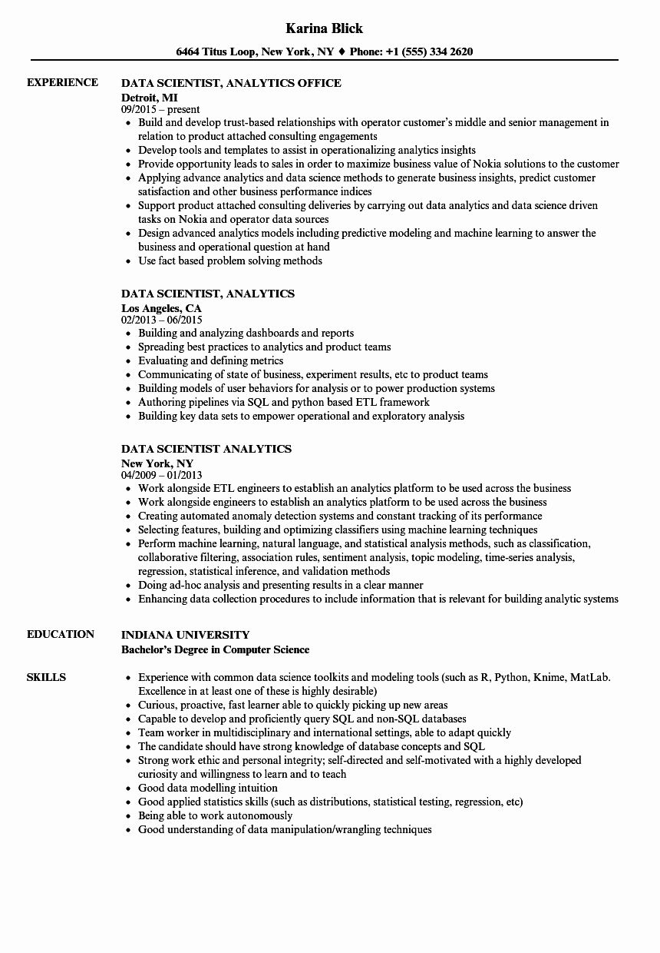

**EXPERIENCE**

**EDUCATION**

**Karina Blick**

**6464 Titus Loop, New York, NY♦ Phone: +1 (555) 334 2620**

**DATA SCIENTIST, ANALYTICS OFFICE**

**Detroit, MI**

09/2015-present

• Build and develop trust-based relationships with operator customer's middle and senior management in relation to product attached consulting engagements

• Develop tools and templates to assist in operationalizing analytics insights

• Provide opportunity leads to sales in order to maximize business value of Nokia solutions to the customer • Applying advance analytics and data science methods to generate business insights, predict customer satisfaction and other business performance indices

• Support product attached consulting deliveries by carrying out data analytics and data science driven tasks on Nokia and operator data sources

• Design advanced analytics models including predictive modeling and machine learning to answer the business and operational question at hand

• Use fact based problem solving methods

**DATA SCIENTIST, ANALYTICS**

**Los Angeles, CA**

02/2013 - 06/2015

⚫ Building and analyzing dashboards and reports

• Spreading best practices to analytics and product teams

⚫ Evaluating and defining metrics

• Communicating of state of business, experiment results, etc to product teams

• Building models of user behaviors for analysis or to power production systems

• Authoring pipelines via SQL and python based ETL framework

⚫ Building key data sets to empower operational and exploratory analysis

**DATA SCIENTIST ANALYTICS**

New York, NY

04/2009 - 01/2013

• Work alongside ETL engineers to establish an analytics platform to be used across the business

• Work alongside engineers to establish an analytics platform to be used across the business

• Creating automated anomaly detection systems and constant tracking of its performance

⚫ Selecting features, building and optimizing classifiers using machine learning techniques

• Perform machine learning, natural language, and statistical analysis methods, such as classification, collaborative filtering, association rules, sentiment analysis, topic modeling, time-series analysis, regression, statistical inference, and validation methods

⚫ Doing ad-hoc analysis and presenting results in a clear manner

• Enhancing data collection procedures to include information that is relevant for building analytic systems

**SKILLS**

**INDIANA UNIVERSITY**

Bachelor's Degree in Computer Science

• Experience with common data science toolkits and modeling tools (such as R, Python, Knime, MatLab. Excellence in at least one of these is highly desirable)

• Curious, proactive, fast learner able to quickly picking up new areas

⚫ Capable to develop and proficiently query SQL and non-SQL databases

⚫ Team worker in multidisciplinary and international settings, able to adapt quickly

• The candidate should have strong knowledge of database concepts and SQL

• Strong work ethic and personal integrity; self-directed and self-motivated with a highly developed curiosity and willingness to learn and to teach

• Good data modelling intuition

• Good applied statistics skills (such as distributions, statistical testing, regression, etc)

• Being able to work autonomously

• Good understanding of data manipulation/wrangling techniques