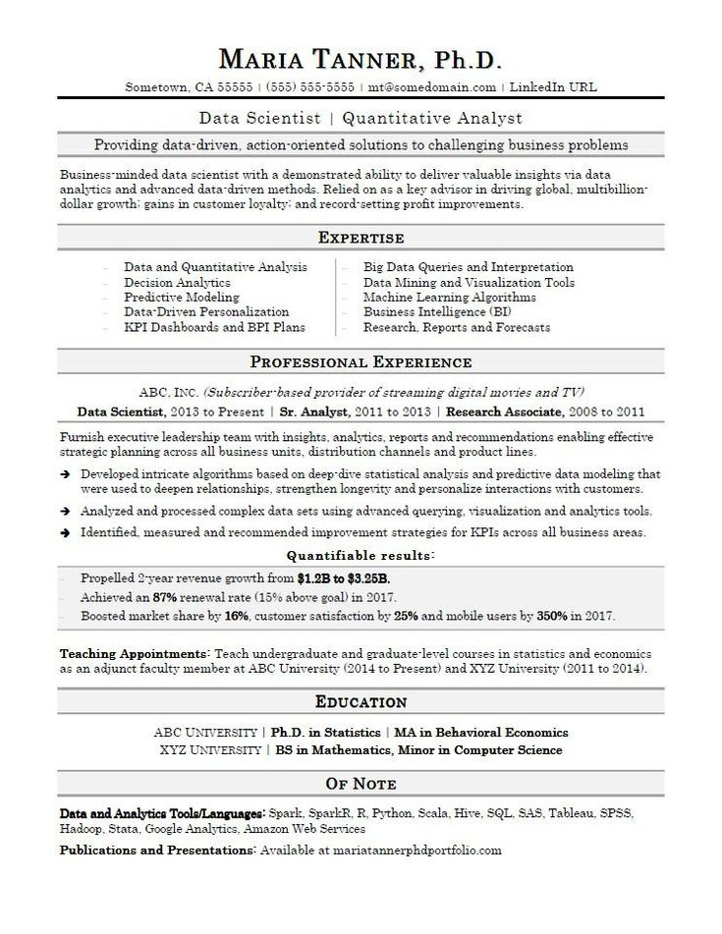

MARIA TANNER, Ph.D.

Sometown, CA 55555 | (555) 555-5555 | mt@somedomain.com | LinkedIn URL

Data Scientist | Quantitative Analyst

Providing data-driven, action-oriented solutions to challenging business problems Business-minded data scientist with a demonstrated ability to deliver valuable insights via data analytics and advanced data-driven methods. Relied on as a key advisor in driving global, multibillion- dollar growth: gains in customer loyalty: and record-setting profit improvements.

Data and Quantitative Analysis

Decision Analytics

Predictive Modeling

Data-Driven Personalization

KPI Dashboards and BPI Plans

EXPERTISE

Big Data Queries and Interpretation Data Mining and Visualization Tools Machine Learning Algorithms Business Intelligence (BI)

Research, Reports and Forecasts

PROFESSIONAL EXPERIENCE

ABC. INC. (Subscriber based provider of streaming digital movies and TV) Data Scientist, 2013 to Present | Sr. Analyst, 2011 to 2013 | Research Associate, 2008 to 2011 Furnish executive leadership team with insights, analytics, reports and recommendations enabling effective strategic planning across all business units, distribution channels and product lines.

→ Developed intricate algorithms based on deep-dive statistical analysis and predictive data modeling that were used to deepen relationships, strengthen longevity and personalize interactions with customers. → Analyzed and processed complex data sets using advanced querying, visualization and analytics tools. → Identified, measured and recommended improvement strategies for KPIs across all business areas. Quantifiable results:

Propelled 2-year revenue growth from $1.2B to $3.25B.

Achieved an 87% renewal rate (15% above goal) in 2017.

Boosted market share by 16%, customer satisfaction by 25% and mobile users by 350% in 2017.

Teaching Appointments: Teach undergraduate and graduate-level courses in statistics and economics as an adjunct faculty member at ABC University (2014 to Present) and XYZ University (2011 to 2014).

**EDUCATION**

ABC UNIVERSITY | Ph.D. in Statistics | MA in Behavioral Economics

XYZ UNIVERSITY | BS in Mathematics, Minor in Computer Science

OF NOTE

Data and Analytics Tools/Languages: Spark, SparkR, R, Python, Scala, Hive, SQL, SAS, Tableau, SPSS, Hadoop. Stata, Google Analytics, Amazon Web Services

Publications and Presentations: Available at mariatannerphdportfolio.com