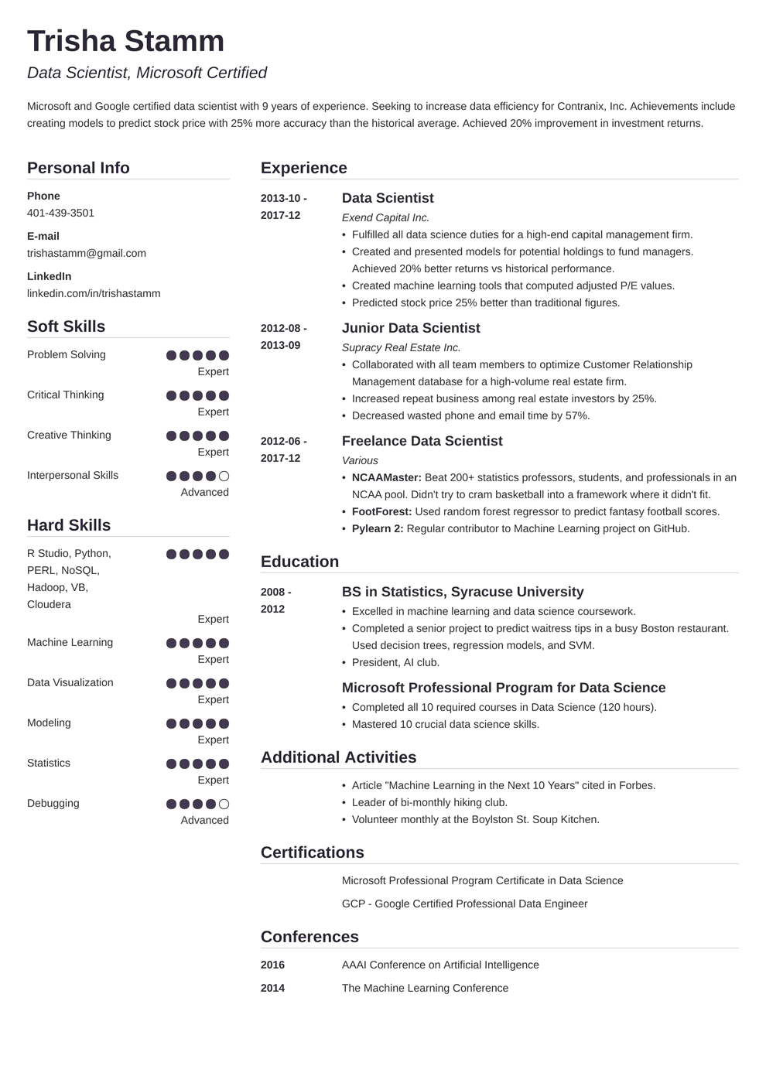

**Trisha Stamm**

*Data Scientist, Microsoft Certified*

Microsoft and Google certified data scientist with 9 years of experience. Seeking to increase data efficiency for Contranix, Inc. Achievements include creating models to predict stock price with 25% more accuracy than the historical average. Achieved 20% improvement in investment returns.

**Personal Info**

Phone

401-439-3501

E-mail

trishastamm@gmail.com

LinkedIn

linkedin.com/in/trishastamm

**Experience**

**2013-10-**

**2017-12**

**2012-08- 2013-09**

**Soft Skills**

Problem Solving

Expert

Critical Thinking

Expert

Creative Thinking

Expert

**2012-06- 2017-12**

Interpersonal Skills

Advanced

**Hard Skills**

R Studio, Python,

PERL, NOSQL,

Hadoop, VB,

Cloudera

**Education**

2008 -

**2012**

Expert

Machine Learning

Expert

Data Visualization

Expert

Expert

Statistics

Expert

Modeling

Debugging

Advanced

**Data Scientist**

*Exend Capital Inc.*

• Fulfilled all data science duties for a high-end capital management firm.

• Created and presented models for potential holdings to fund managers. Achieved 20% better returns vs historical performance.

• Created machine learning tools that computed adjusted P/E values.

• Predicted stock price 25% better than traditional figures.

**Junior Data Scientist**

*Supracy Real Estate Inc.*

• Collaborated with all team members to optimize Customer Relationship Management database for a high-volume real estate firm.

• Increased repeat business among real estate investors by 25%.

• Decreased wasted phone and email time by 57%.

**Freelance Data Scientist**

*Various*

• NCAAMaster: Beat 200+ statistics professors, students, and professionals in an NCAA pool. Didn't try to cram basketball into a framework where it didn't fit.

⚫ FootForest: Used random forest regressor to predict fantasy football scores.

• Pylearn 2: Regular contributor to Machine Learning project on GitHub.

BS in Statistics, Syracuse University

• Excelled in machine learning and data science coursework.

• Completed a senior project to predict waitress tips in a busy Boston restaurant. Used decision trees, regression models, and SVM.

• President, Al club.

**Microsoft Professional Program for Data Science**

• Completed all 10 required courses in Data Science (120 hours). Mastered 10 crucial data science skills.

**Additional Activities**

• Article "Machine Learning in the Next 10 Years" cited in Forbes.

• Leader of bi-monthly hiking club.

• Volunteer monthly at the Boylston St. Soup Kitchen.

**Certifications**

Microsoft Professional Program Certificate in Data Science GCP - Google Certified Professional Data Engineer

**Conferences**

**2016**

AAAI Conference on Artificial Intelligence

**2014**

The Machine Learning Conference