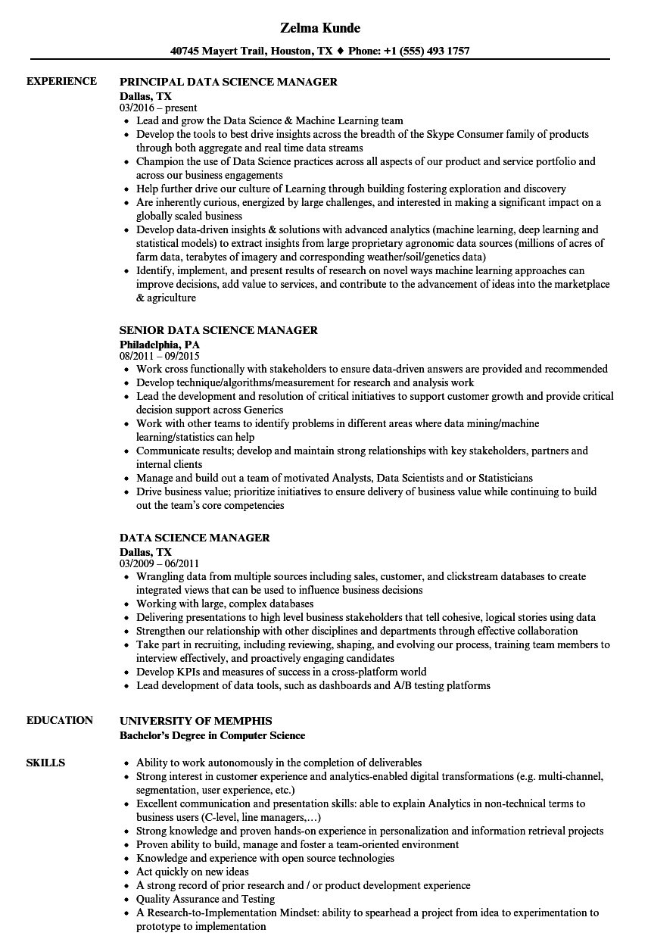

**EXPERIENCE**

**Zelma Kunde**

**40745 Mayert Trail, Houston, TX ♦ Phone: +1 (555) 493 1757**

**PRINCIPAL DATA SCIENCE MANAGER**

Dallas, TX 03/2016-present

• Lead and grow the Data Science & Machine Learning team

• Develop the tools to best drive insights across the breadth of the Skype Consumer family of products through both aggregate and real time data streams

• Champion the use of Data Science practices across all aspects of our product and service portfolio and across our business engagements

• Help further drive our culture of Learning through building fostering exploration and discovery

• Are inherently curious, energized by large challenges, and interested in making a significant impact on a globally scaled business

• Develop data-driven insights & solutions with advanced analytics (machine learning, deep learning and statistical models) to extract insights from large proprietary agronomic data sources (millions of acres of farm data, terabytes of imagery and corresponding weather/soil/genetics data)

• Identify, implement, and present results of research on novel ways machine learning approaches can improve decisions, add value to services, and contribute to the advancement of ideas into the marketplace & agriculture

**SENIOR DATA SCIENCE MANAGER**

**Philadelphia, PA**

08/2011-09/2015

• Work cross functionally with stakeholders to ensure data-driven answers are provided and recommended • Develop technique/algorithms/measurement for research and analysis work

• Lead the development and resolution of critical initiatives to support customer growth and provide critical decision support across Generics

• Work with other teams to identify problems in different areas where data mining/machine learning/statistics can help

• Communicate results; develop and maintain strong relationships with key stakeholders, partners and internal clients

• Manage and build out a team of motivated Analysts, Data Scientists and or Statisticians

• Drive business value; prioritize initiatives to ensure delivery of business value while continuing to build out the team's core competencies

**DATA SCIENCE MANAGER**

**Dallas, TX**

03/2009 - 06/2011

• Wrangling data from multiple sources including sales, customer, and clickstream databases to create integrated views that can be used to influence business decisions

• Working with large, complex databases

• Delivering presentations to high level business stakeholders that tell cohesive, logical stories using data

• Strengthen our relationship with other disciplines and departments through effective collaboration

• Take part in recruiting, including reviewing, shaping, and evolving our process, training team members to interview effectively, and proactively engaging candidates

• Develop KPIs and measures of success in a cross-platform world

• Lead development of data tools, such as dashboards and A/B testing platforms

**EDUCATION**

**SKILLS**

**UNIVERSITY OF MEMPHIS**

**Bachelor's Degree in Computer Science**

• Ability to work autonomously in the completion of deliverables

• Strong interest in customer experience and analytics-enabled digital transformations (e.g. multi-channel, segmentation, user experience, etc.)

• Excellent communication and presentation skills: able to explain Analytics in non-technical terms to business users (C-level, line managers,...)

• Strong knowledge and proven hands-on experience in personalization and information retrieval projects

• Proven ability to build, manage and foster a team-oriented environment

• Knowledge and experience with open source technologies

⚫ Act quickly on new ideas

• A strong record of prior research and/or product development experience

• Quality Assurance and Testing

A Research-to-Implementation Mindset: ability to spearhead a project from idea to experimentation to prototype to implementation