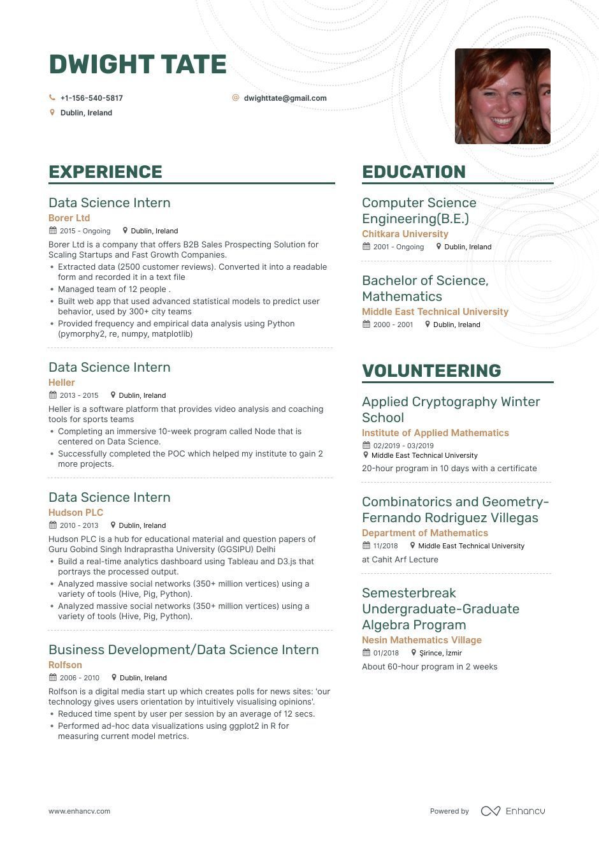

**DWIGHT TATE**

+1-156-540-5817

Dublin, Ireland

dwighttate@gmail.com

**EXPERIENCE**

Data Science Intern

Borer Ltd

2015- Ongoing Dublin, Ireland

Borer Ltd is a company that offers B2B Sales Prospecting Solution for Scaling Startups and Fast Growth Companies.

• Extracted data (2500 customer reviews). Converted it into a readable form and recorded it in a text file

• Managed team of 12 people.

• Built web app that used advanced statistical models to predict user behavior, used by 300+ city teams

• Provided frequency and empirical data analysis using Python (pymorphy2, re, numpy, matplotlib)

Data Science Intern

Heller

2013-2015 Dublin, Ireland

Heller is a software platform that provides video analysis and coaching tools for sports teams

⚫ Completing an immersive 10-week program called Node that is centered on Data Science.

Successfully completed the POC which helped my institute to gain 2 more projects.

Data Science Intern

Hudson PLC

2010-2013 Dublin, Ireland

Hudson PLC is a hub for educational material and question papers of Guru Gobind Singh Indraprastha University (GGSIPU) Delhi

• Build a real-time analytics dashboard using Tableau and D3.js that portrays the processed output.

• Analyzed massive social networks (350+ million vertices) using a variety of tools (Hive, Pig, Python).

• Analyzed massive social networks (350+ million vertices) using a variety of tools (Hive, Pig, Python).

Business Development/Data Science Intern

Rolfson

2006-2010 Dublin, Ireland

Rolfson is a digital media start up which creates polls for news sites: 'our technology gives users orientation by intuitively visualising opinions'. • Reduced time spent by user per session by an average of 12 secs. • Performed ad-hoc data visualizations using ggplot2 in R for measuring current model metrics.

**EDUCATION**

Computer Science Engineering (B.E.) Chitkara University

2001 - Ongoing Dublin, Ireland

Bachelor of Science, Mathematics

Middle East Technical University 2000-2001

Dublin, Ireland

**VOLUNTEERING**

Applied Cryptography Winter School

**Institute of Applied Mathematics 02/2019-03/2019**

Middle East Technical University

20-hour program in 10 days with a certificate

Combinatorics and Geometry- Fernando Rodriguez Villegas Department of Mathematics

11/2018

Middle East Technical University

at Cahit Arf Lecture

Semesterbreak

Undergraduate-Graduate Algebra Program

Nesin Mathematics Village 01/2018 Şirince, İzmir About 60-hour program in 2 weeks

www.enhancv.com

Powered by

Enhancu