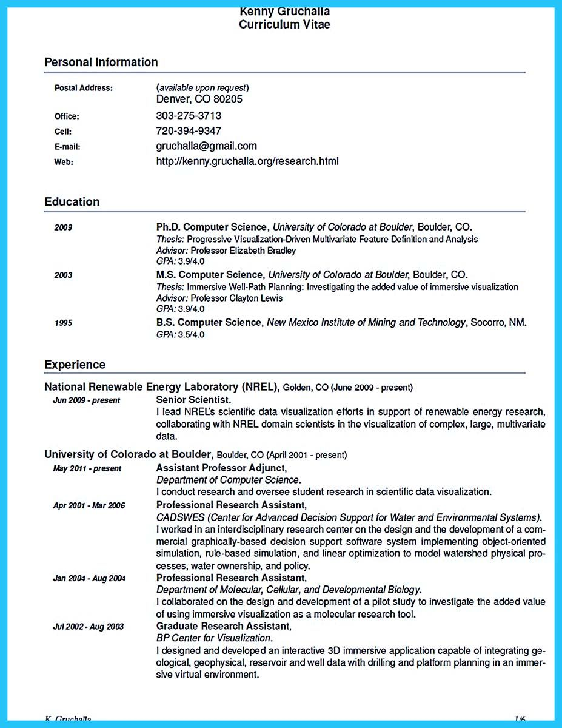

**Kenny Gruchalla Curriculum Vitae**

**Personal Information**

**Postal Address:**

**Office:**

Cell:

**E-mail:**

**Web:**

*(available upon request) Denver, CO 80205*

303-275-3713

720-394-9347

gruchalla@gmail.com

http://kenny.gruchalla.org/research.html

**Education**

2009

**2003**

1995

Ph.D. Computer Science, University of Colorado at Boulder, Boulder, CO. Thesis: Progressive Visualization-Driven Multivariate Feature Definition and Analysis Advisor: Professor Elizabeth Bradley

GPA: 3.9/4.0

M.S. Computer Science, University of Colorado at Boulder, Boulder, CO. Thesis: Immersive Well-Path Planning: Investigating the added value of immersive visualization Advisor: Professor Clayton Lewis

GPA: 3.9/4.0

*B.S. Computer Science, New Mexico Institute of Mining and Technology, Socorro, NM. GPA: 3.5/4.0*

Experience

National Renewable Energy Laboratory (NREL), Golden, CO (June 2009 - present) Jun 2009 - present

**Senior Scientist.**

I lead NREL's scientific data visualization efforts in support of renewable energy research, collaborating with NREL domain scientists in the visualization of complex, large, multivariate data.

University of Colorado at Boulder, Boulder, CO (April 2001 - present)

May 2011-present

Assistant Professor Adjunct,

*Department of Computer Science.*

**Apr 2001 - Mar 2006**

Jan 2004-Aug 2004

Jul 2002-Aug 2003

I conduct research and oversee student research in scientific data visualization. Professional Research Assistant,

CADSWES (Center for Advanced Decision Support for Water and Environmental Systems). I worked in an interdisciplinary research center on the design and the development of a com- mercial graphically-based decision support software system implementing object-oriented simulation, rule-based simulation, and linear optimization to model watershed physical pro- cesses, water ownership, and policy.

**Professional Research Assistant,**

*Department of Molecular, Cellular, and Developmental Biology.*

**I collaborated on the design and development of a pilot study to investigate the added value of using immersive visualization as a molecular research tool. Graduate Research Assistant,**

*BP Center for Visualization.*

I designed and developed an interactive 3D immersive application capable of integrating ge- ological, geophysical, reservoir and well data with drilling and platform planning in an immer- sive virtual environment.

K Gruchalla

16