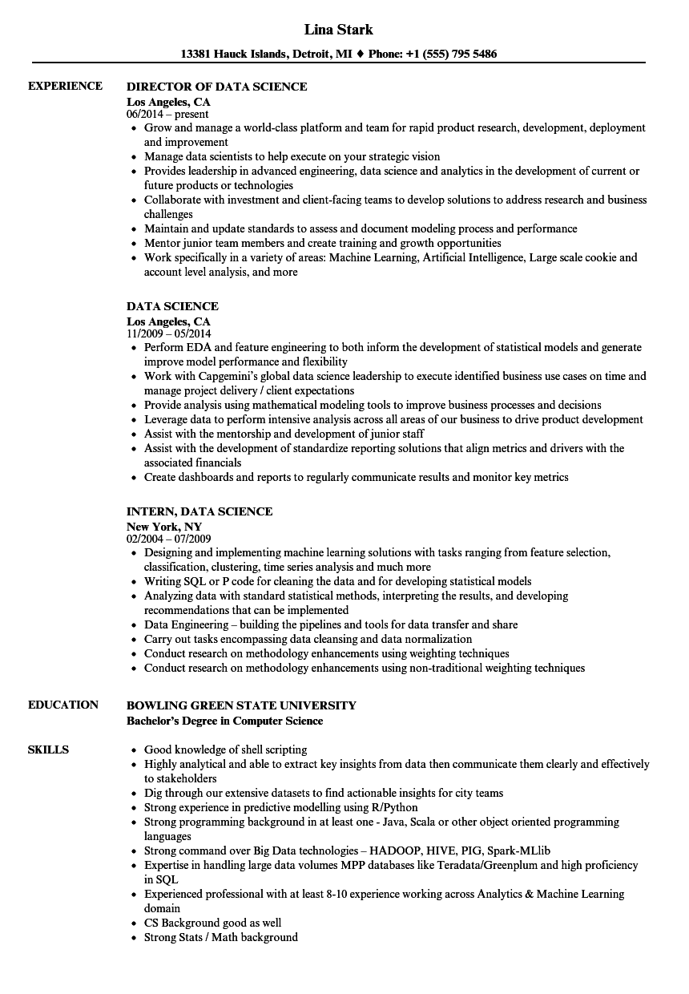

**EXPERIENCE**

**EDUCATION**

**SKILLS**

**Lina Stark**

**13381 Hauck Islands, Detroit, MI ♦ Phone: +1 (555) 795 5486**

**DIRECTOR OF DATA SCIENCE**

**Los Angeles, CA**

06/2014-present

• Grow and manage a world-class platform and team for rapid product research, development, deployment and improvement

**• Manage data scientists to help execute on your strategic vision**

• Provides leadership in advanced engineering, data science and analytics in the development of current or future products or technologies

• Collaborate with investment and client-facing teams to develop solutions to address research and business challenges

• Maintain and update standards to assess and document modeling process and performance

• Mentor junior team members and create training and growth opportunities

• Work specifically in a variety of areas: Machine Learning, Artificial Intelligence, Large scale cookie and account level analysis, and more

**DATA SCIENCE**

**Los Angeles, CA**

11/2009 - 05/2014

• Perform EDA and feature engineering to both inform the development of statistical models and generate improve model performance and flexibility

• Work with Capgemini's global data science leadership to execute identified business use cases on time and manage project delivery / client expectations

• Provide analysis using mathematical modeling tools to improve business processes and decisions

• Leverage data to perform intensive analysis across all areas of our business to drive product development • Assist with the mentorship and development of junior staff

• Assist with the development of standardize reporting solutions that align metrics and drivers with the associated financials

• Create dashboards and reports to regularly communicate results and monitor key metrics

**INTERN, DATA SCIENCE**

**New York, NY**

02/2004-07/2009

• Designing and implementing machine learning solutions with tasks ranging from feature selection, classification, clustering, time series analysis and much more

• Writing SQL or P code for cleaning the data and for developing statistical models

• Analyzing data with standard statistical methods, interpreting the results, and developing recommendations that can be implemented

⚫ Data Engineering - building the pipelines and tools for data transfer and share

• Carry out tasks encompassing data cleansing and data normalization

• Conduct research on methodology enhancements using weighting techniques

• Conduct research on methodology enhancements using non-traditional weighting techniques

**BOWLING GREEN STATE UNIVERSITY**

**Bachelor's Degree in Computer Science**

• Good knowledge of shell scripting

• Highly analytical and able to extract key insights from data then communicate them clearly and effectively to stakeholders

• Dig through our extensive datasets to find actionable insights for city teams

• Strong experience in predictive modelling using R/Python

• Strong programming background in at least one - Java, Scala or other object oriented programming languages

• Strong command over Big Data technologies – HADOOP, HIVE, PIG, Spark-MLlib

• Expertise in handling large data volumes MPP databases like Teradata/Greenplum and high proficiency in SQL

• Experienced professional with at least 8-10 experience working across Analytics & Machine Learning domain

⚫ CS Background good as well

• Strong Stats / Math background