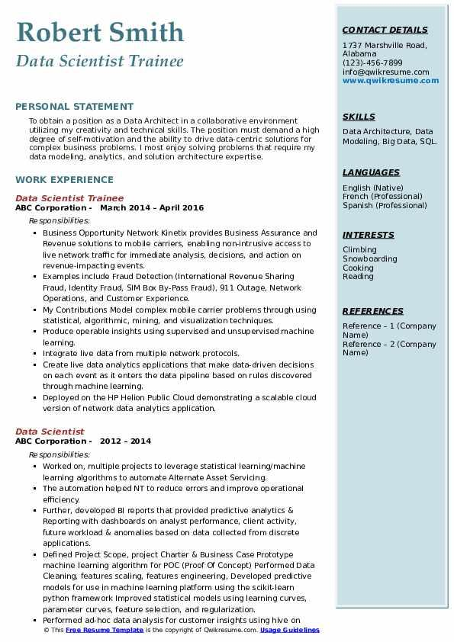

**Robert Smith**

*Data Scientist Trainee*

**CONTACT DETAILS**

1737 Marshville Road, Alabama

(123)-456-7899

info@qwikresume.com www.qwikresume.com

**PERSONAL STATEMENT**

To obtain a position as a Data Architect in a collaborative environment utilizing my creativity and technical skills. The position must demand a high degree of self-motivation and the ability to drive data-centric solutions for complex business problems. I most enjoy solving problems that require my data modeling, analytics, and solution architecture expertise.

**WORK EXPERIENCE**

Data Scientist Trainee

ABC Corporation March 2014 - April 2016

Responsibilities:

• Business Opportunity Network Kinetix provides Business Assurance and Revenue solutions to mobile carriers, enabling non-intrusive access to live network traffic for immediate analysis, decisions, and action on revenue-impacting events.

Examples include Fraud Detection (International Revenue Sharing Fraud, Identity Fraud, SIM Box By-Pass Fraud), 911 Outage, Network Operations, and Customer Experience.

My Contributions Model complex mobile carrier problems through using statistical, algorithmic, mining, and visualization techniques.

• Produce operable insights using supervised and unsupervised machine learning.

⚫ Integrate live data from multiple network protocols.

Create live data analytics applications that make data-driven decisions on each event as it enters the data pipeline based on rules discovered through machine learning.

Deployed on the HP Helion Public Cloud demonstrating a scalable cloud version of network data analytics application.

Data Scientist

**ABC Corporation - 2012-2014**

Responsibilities:

• Worked on, multiple projects to leverage statistical learning/machine learning algorithms to automate Alternate Asset Servicing.

The automation helped NT to reduce errors and improve operational efficiency.

Further, developed BI reports that provided predictive analytics & Reporting with dashboards on analyst performance, client activity, future workload & anomalies based on data collected from discrete applications.

• Defined Project Scope, project Charter & Business Case Prototype machine learning algorithm for POC (Proof Of Concept) Performed Data Cleaning, features scaling, features engineering, Developed predictive models for use in machine learning platform using the scikit-learn python framework Improved statistical models using learning curves, parameter curves, feature selection, and regularization.

• Performed ad-hoc data analysis for customer insights using hive on © This Free Resume Template is the copyright of Qwikresume.com. Usage Guidelines

SKILLS

Data Architecture, Data Modeling, Big Data, SQL.

**LANGUAGES**

English (Native) French (Professional) Spanish (Professional)

INTERESTS

Climbing Snowboarding Cooking Reading

**REFERENCES**

Reference - 1 (Company

Name) Reference - 2 (Company

Name)