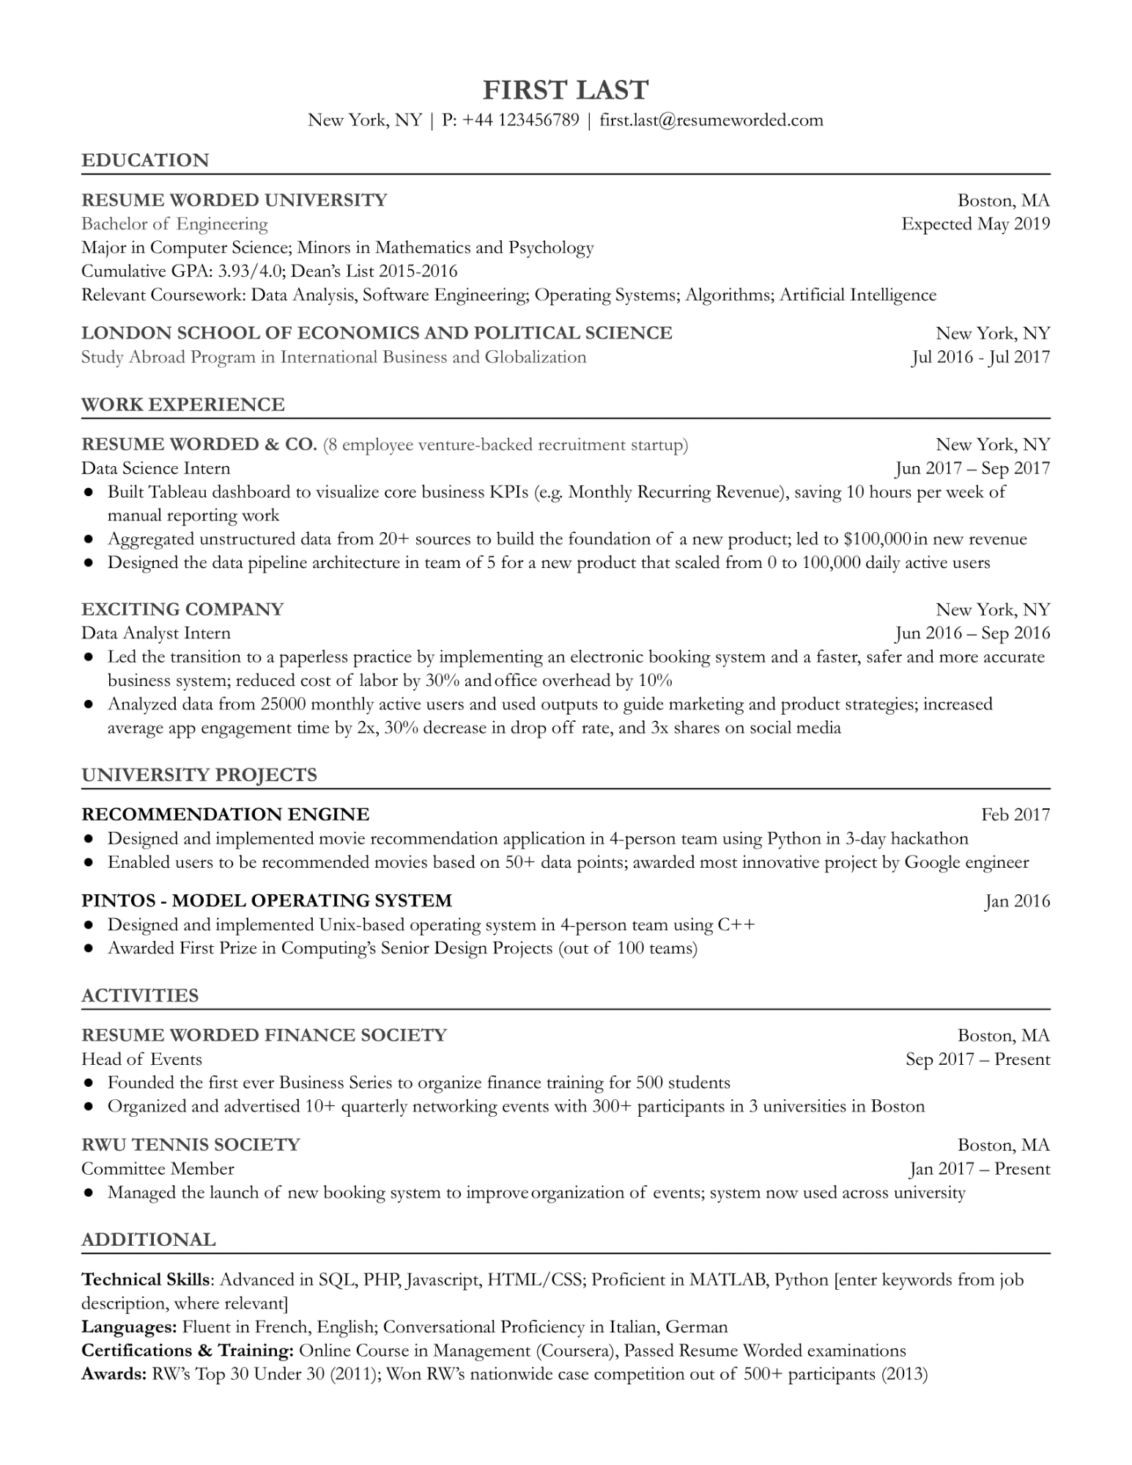

**FIRST LAST**

New York, NY | P: +44 123456789 | first.last@resumeworded.com

**EDUCATION**

**RESUME WORDED UNIVERSITY**

Bachelor of Engineering

Major in Computer Science; Minors in Mathematics and Psychology Cumulative GPA: 3.93/4.0; Dean's List 2015-2016

Boston, MA Expected May 2019

Relevant Coursework: Data Analysis, Software Engineering; Operating Systems; Algorithms; Artificial Intelligence

**LONDON SCHOOL OF ECONOMICS AND POLITICAL SCIENCE Study Abroad Program in International Business and Globalization**

**WORK EXPERIENCE**

RESUME WORDED & CO. (8 employee venture-backed recruitment startup) Data Science Intern

New York, NY Jul 2016 - Jul 2017

New York, NY

Jun 2017 - Sep 2017

• Built Tableau dashboard to visualize core business KPIs (e.g. Monthly Recurring Revenue), saving 10 hours per week of manual reporting work

• Aggregated unstructured data from 20+ sources to build the foundation of a new product; led to $100,000 in new revenue • Designed the data pipeline architecture in team of 5 for a new product that scaled from 0 to 100,000 daily active users

**EXCITING COMPANY**

Data Analyst Intern

New York, NY Jun 2016- Sep 2016

• Led the transition to a paperless practice by implementing an electronic booking system and a faster, safer and more accurate business system; reduced cost of labor by 30% and office overhead by 10%

• Analyzed data from 25000 monthly active users and used outputs to guide marketing and product strategies; increased average app engagement time by 2x, 30% decrease in drop off rate, and 3x shares on social media

**UNIVERSITY PROJECTS**

**RECOMMENDATION ENGINE**

Feb 2017

• Designed and implemented movie recommendation application in 4-person team using Python in 3-day hackathon • Enabled users to be recommended movies based on 50+ data points; awarded most innovative project by Google engineer PINTOS - MODEL OPERATING SYSTEM

• Designed and implemented Unix-based operating system in 4-person team using C++

• Awarded First Prize in Computing's Senior Design Projects (out of 100 teams)

**ACTIVITIES**

**RESUME WORDED FINANCE SOCIETY**

Head of Events

• Founded the first ever Business Series to organize finance training for 500 students

Jan 2016

Boston, MA

Sep 2017 - Present

• Organized and advertised 10+ quarterly networking events with 300+ participants in 3 universities in Boston RWU TENNIS SOCIETY

Committee Member

Boston, MA

Jan 2017 - Present

• Managed the launch of new booking system to improve organization of events; system now used across university

**ADDITIONAL**

Technical Skills: Advanced in SQL, PHP, Javascript, HTML/CSS; Proficient in MATLAB, Python [enter keywords from job description, where relevant]

Languages: Fluent in French, English; Conversational Proficiency in Italian, German

Certifications & Training: Online Course in Management (Coursera), Passed Resume Worded examinations Awards: RW's Top 30 Under 30 (2011); Won RW's nationwide case competition out of 500+ participants (2013)