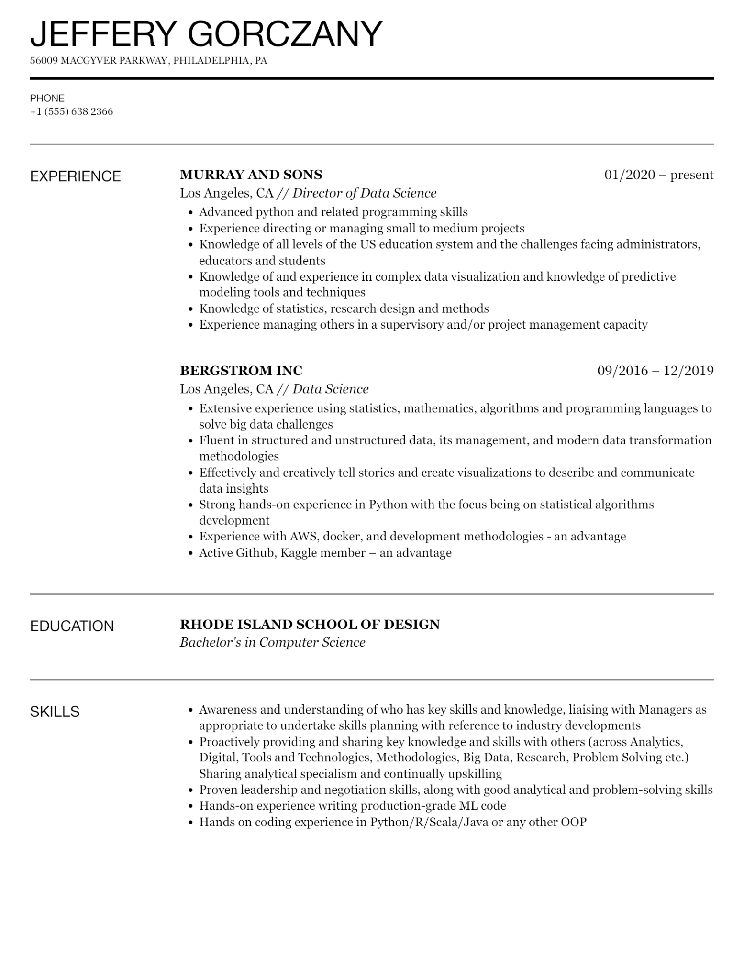

JEFFERY GORCZANY

56009 MACGYVER PARKWAY, PHILADELPHIA, PA

PHONE

+1 (555) 638 2366

EXPERIENCE

**MURRAY AND SONS**

*Los Angeles, CA // Director of Data Science*

• Advanced python and related programming skills

•

Experience directing or managing small to medium projects

01/2020 - present

•

Knowledge of all levels of the US education system and the challenges facing administrators, educators and students

Knowledge of and experience in complex data visualization and knowledge of predictive modeling tools and techniques

•

Knowledge of statistics, research design and methods

•

Experience managing others in a supervisory and/or project management capacity

**BERGSTROM INC**

*Los Angeles, CA // Data Science*

09/2016 12/2019

• Extensive experience using statistics, mathematics, algorithms and programming languages to solve big data challenges

• Fluent in structured and unstructured data, its management, and modern data transformation methodologies

·

Effectively and creatively tell stories and create visualizations to describe and communicate data insights

• Strong hands-on experience in Python with the focus being on statistical algorithms

·

development

Experience with AWS, docker, and development methodologies - an advantage

• Active Github, Kaggle member · – an advantage

EDUCATION

**RHODE ISLAND SCHOOL OF DESIGN**

*Bachelor's in Computer Science*

SKILLS

• Awareness and understanding of who has key skills and knowledge, liaising with Managers as appropriate to undertake skills planning with reference to industry developments

•

Proactively providing and sharing key knowledge and skills with others (across Analytics, Digital, Tools and Technologies, Methodologies, Big Data, Research, Problem Solving etc.) Sharing analytical specialism and continually upskilling

• Proven leadership and negotiation skills, along with good analytical and problem-solving skills

• Hands-on experience writing production-grade ML code

• Hands on coding experience in Python/R/Scala/Java or any other OOP