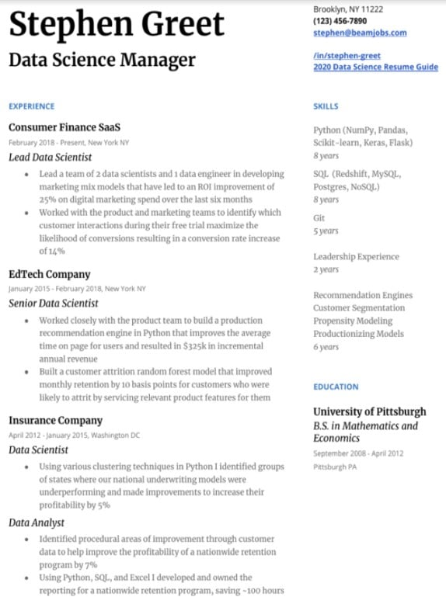

**Stephen Greet**

Data Science Manager

Brooklyn, NY 11222 (123) 456-7890 stephen@beamjobs.com

**/in/stephen-greet**

**2020 Data Science Resume Guide**

EXPERIENCE

Consumer Finance SaaS

February 2018-Present, New York NY

*Lead Data Scientist*

• Lead a team of 2 data scientists and 1 data engineer in developing marketing mix models that have led to an ROI improvement of 25% on digital marketing spend over the last six months

• Worked with the product and marketing teams to identify which customer interactions during their free trial maximize the likelihood of conversions resulting in a conversion rate increase of 14%

EdTech Company

January 2015-February 2018, New York NY Senior Data Scientist

• Worked closely with the product team to build a production recommendation engine in Python that improves the average time on page for users and resulted in $325k in incremental annual revenue

• Built a customer attrition random forest model that improved monthly retention by 10 basis points for customers who were likely to attrit by servicing relevant product features for them

**Insurance Company**

April 2012 January 2015, Washington DC

Data Scientist

⚫ Using various clustering techniques in Python I identified groups of states where our national underwriting models were underperforming and made improvements to increase their profitability by 5%

*Data Analyst*

• Identified procedural areas of improvement through customer data to help improve the profitability of a nationwide retention program by 7%

⚫ Using Python, SQL, and Excel I developed and owned the

reporting for a nationwide retention program, saving -100 hours

SKILLS

Python (NumPy, Pandas, Scikit-learn, Keras, Flask)

**8 years**

SQL (Redshift, MySQL, Postgres, NoSQL)

8 years

Git

5 years

Leadership Experience 2 years

Recommendation Engines Customer Segmentation Propensity Modeling Productionizing Models 6 years

**EDUCATION**

University of Pittsburgh B.S. in Mathematics and Economics

September 2008-April 2012 Pittsburgh PA