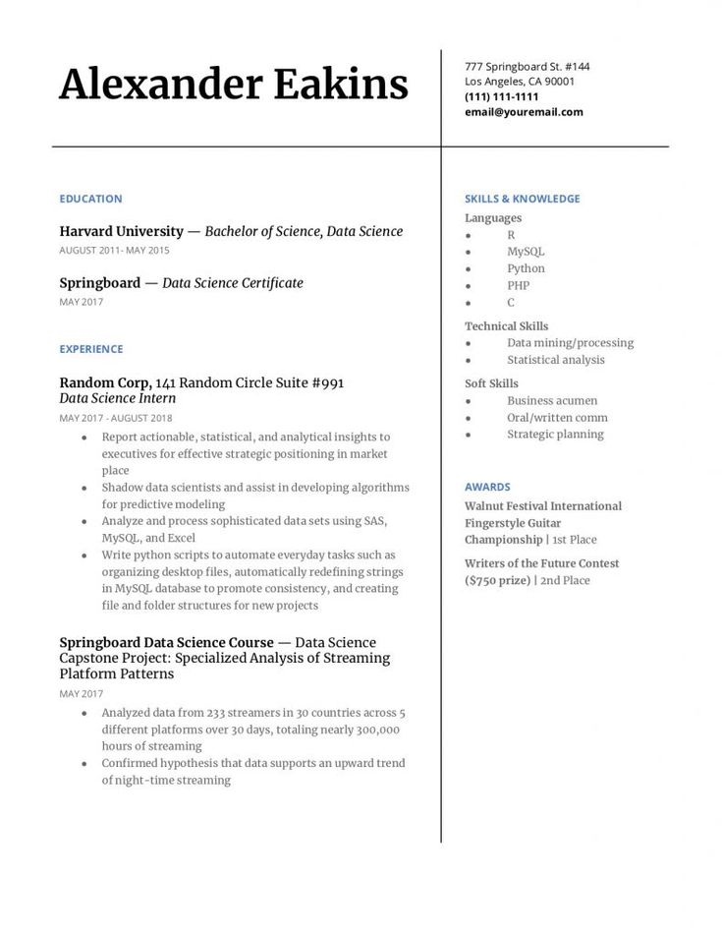

**Alexander Eakins**

777 Springboard St. #144 Los Angeles, CA 90001 (111) 111-1111 email@youremail.com

**EDUCATION**

Harvard University - Bachelor of Science, Data Science

AUGUST 2011-MAY 2015

Springboard - Data Science Certificate

MAY 2017

SKILLS & KNOWLEDGE

Languages

R

MySQL

Python

PHP

C

Technical Skills

Data mining/processing

EXPERIENCE

*Random Corp, 141 Random Circle Suite #991 Data Science Intern*

MAY 2017 AUGUST 2018

⚫

Report actionable, statistical, and analytical insights to executives for effective strategic positioning in market place

⚫ Shadow data scientists and assist in developing algorithms for predictive modeling

• Analyze and process sophisticated data sets using SAS, MySQL, and Excel

⚫ Write python scripts to automate everyday tasks such as organizing desktop files, automatically redefining strings in MySQL database to promote consistency, and creating file and folder structures for new projects

Springboard Data Science Course - Data Science Capstone Project: Specialized Analysis of Streaming Platform Patterns

MAY 2017

• Analyzed data from 233 streamers in 30 countries across 5 different platforms over 30 days, totaling nearly 300,000 hours of streaming

• Confirmed hypothesis that data supports an upward trend of night-time streaming

Statistical analysis

Soft Skills

Business acumen

**AWARDS**

Oral/written comm Strategic planning

Walnut Festival International Fingerstyle Guitar Championship | 1st Place

Writers of the Future Contest ($750 prize) | 2nd Place