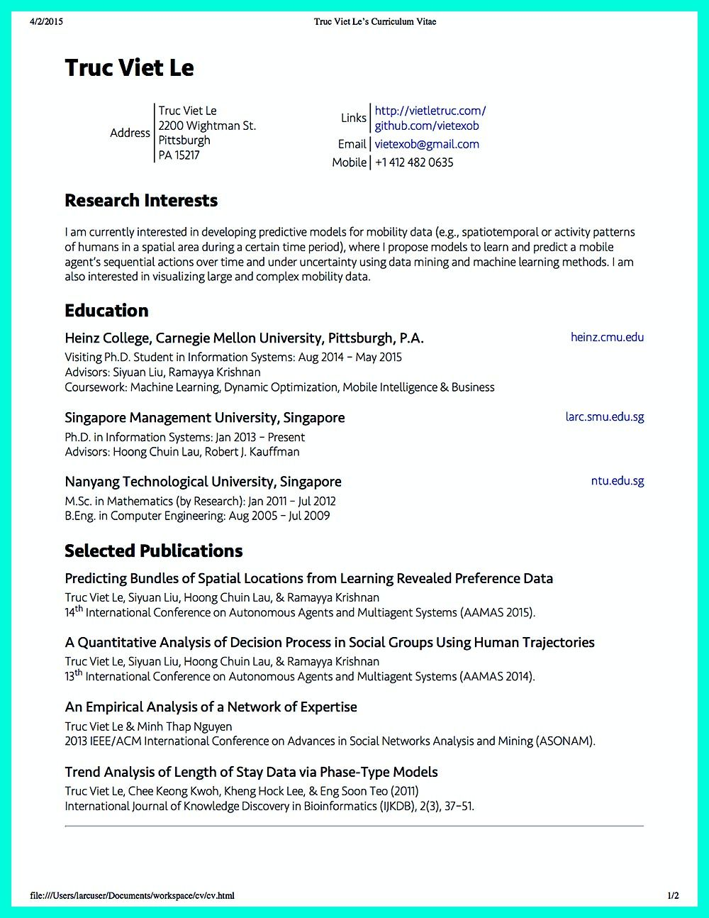

4/2/2015

Truc Viet Le's Curriculum Vitae

**Truc Viet Le**

Address

Truc Viet Le 2200 Wightman St. Pittsburgh PA 15217

Links

http://vietletruc.com/ github.com/vietexob

Email vietexob@gmail.com Mobile +1 412 482 0635

**Research Interests**

I am currently interested in developing predictive models for mobility data (e.g., spatiotemporal or activity patterns of humans in a spatial area during a certain time period), where I propose models to learn and predict a mobile agent's sequential actions over time and under uncertainty using data mining and machine learning methods. I am also interested in visualizing large and complex mobility data.

**Education**

Heinz College, Carnegie Mellon University, Pittsburgh, P.A.

Visiting Ph.D. Student in Information Systems: Aug 2014 - May 2015

Advisors: Siyuan Liu, Ramayya Krishnan

Coursework: Machine Learning, Dynamic Optimization, Mobile Intelligence & Business

Singapore Management University, Singapore

heinz.cmu.edu

larc.smu.edu.sg

Ph.D. in Information Systems: Jan 2013 - Present Advisors: Hoong Chuin Lau, Robert J. Kauffman

Nanyang Technological University, Singapore M.Sc. in Mathematics (by Research): Jan 2011 - Jul 2012 B.Eng. in Computer Engineering: Aug 2005 - Jul 2009

**Selected Publications**

Predicting Bundles of Spatial Locations from Learning Revealed Preference Data

Truc Viet Le, Siyuan Liu, Hoong Chuin Lau, & Ramayya Krishnan

14th International Conference on Autonomous Agents and Multiagent Systems (AAMAS 2015).

A Quantitative Analysis of Decision Process in Social Groups Using Human Trajectories

Truc Viet Le, Siyuan Liu, Hoong Chuin Lau, & Ramayya Krishnan

13th International Conference on Autonomous Agents and Multiagent Systems (AAMAS 2014).

An Empirical Analysis of a Network of Expertise

Truc Viet Le & Minh Thap Nguyen

2013 IEEE/ACM International Conference on Advances in Social Networks Analysis and Mining (ASONAM).

Trend Analysis of Length of Stay Data via Phase-Type Models

Truc Viet Le, Chee Keong Kwoh, Kheng Hock Lee, & Eng Soon Teo (2011)

International Journal of Knowledge Discovery in Bioinformatics (IJKDB), 2(3), 37-51.

file:///Users/larcuser/Documents/workspace/cv/cv.html

ntu.edu.sg

1/2