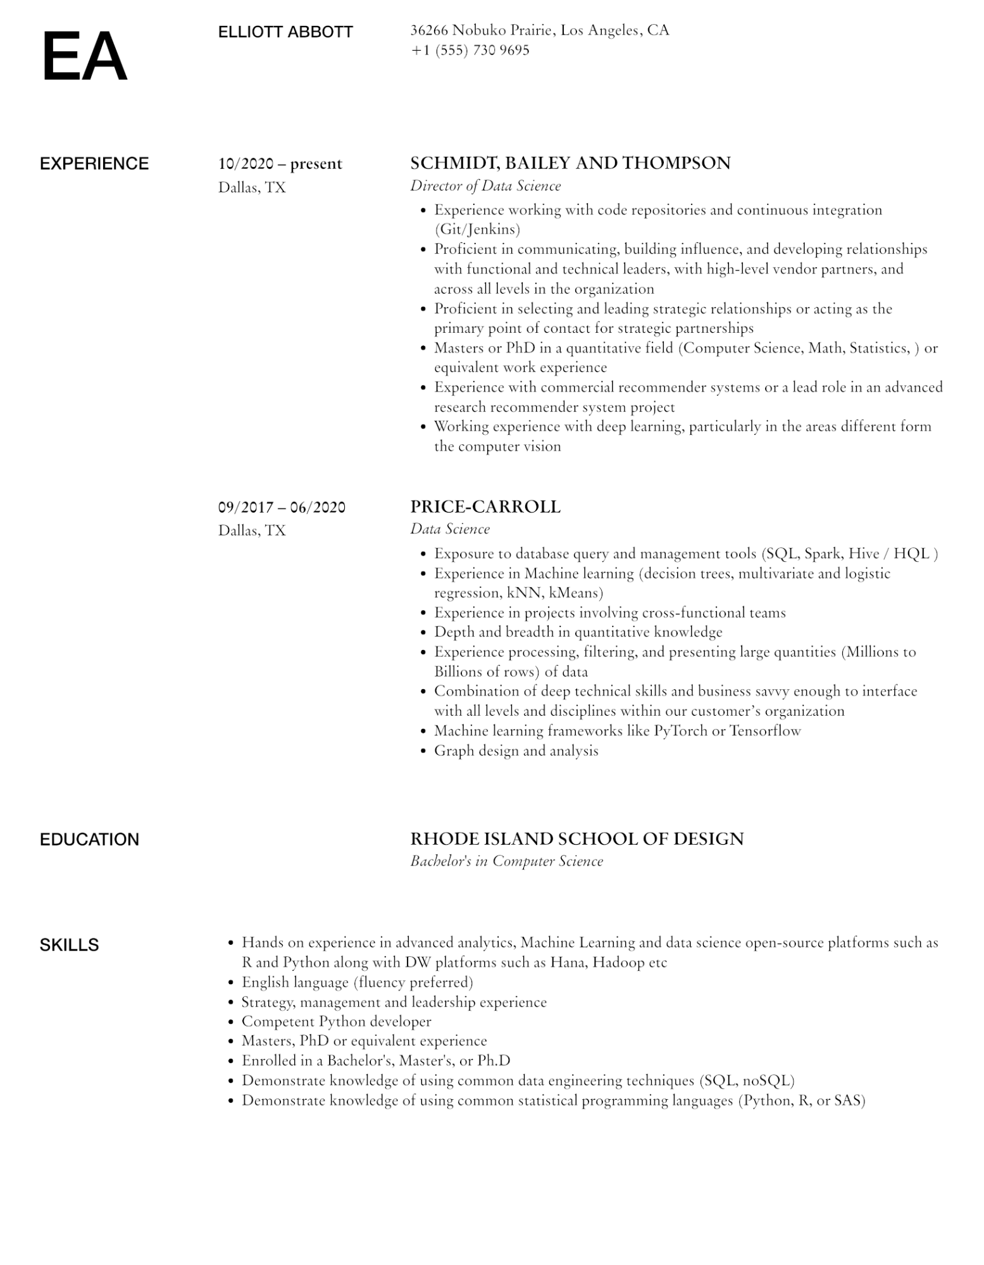

**EA**

ELLIOTT ABBOTT

36266 Nobuko Prairie, Los Angeles, CA

+1 (555) 730 9695

EXPERIENCE

10/2020-present Dallas, TX

EDUCATION

**SKILLS**

09/2017 - 06/2020 Dallas, TX

SCHMIDT, BAILEY AND THOMPSON

*Director of Data Science*

·

· Experience working with code repositories and continuous integration (Git/Jenkins)

• Proficient in communicating, building influence, and developing relationships with functional and technical leaders, with high-level vendor partners, and across all levels in the organization

• Proficient in selecting and leading strategic relationships or acting as the primary point of contact for strategic partnerships

• Masters or PhD in a quantitative field (Computer Science, Math, Statistics,) or equivalent work experience

·

•

Experience with commercial recommender systems or a lead role in an advanced research recommender system project

Working experience with deep learning, particularly in the areas different form the computer vision

**PRICE-CARROLL**

*Data Science*

•

•

·

•

·

Exposure to database query and management tools (SQL, Spark, Hive / HQL)

Experience in Machine learning (decision trees, multivariate and logistic regression, kNN, kMeans)

Experience in projects involving cross-functional teams

Depth and breadth in quantitative knowledge

Experience processing, filtering, and presenting large quantities (Millions to Billions of rows) of data

• Combination of deep technical skills and business savvy enough to interface

with all levels and disciplines within our customer's organization

• Machine learning frameworks like PyTorch or Tensorflow

·

Graph design and analysis

*RHODE ISLAND SCHOOL OF DESIGN Bachelor's in Computer Science*

• Hands on experience in advanced analytics, Machine Learning and data science open-source platforms such as R and Python along with DW platforms such as Hana, Hadoop etc

Strategy, management and leadership experience

•

English language (fluency preferred)

•

Competent Python developer

•

Masters, PhD or equivalent experience

·

Enrolled in a Bachelor's, Master's, or Ph.D

• Demonstrate knowledge of using common data engineering techniques (SQL, noSQL)

• Demonstrate knowledge of using common statistical programming languages (Python, R, or SAS)