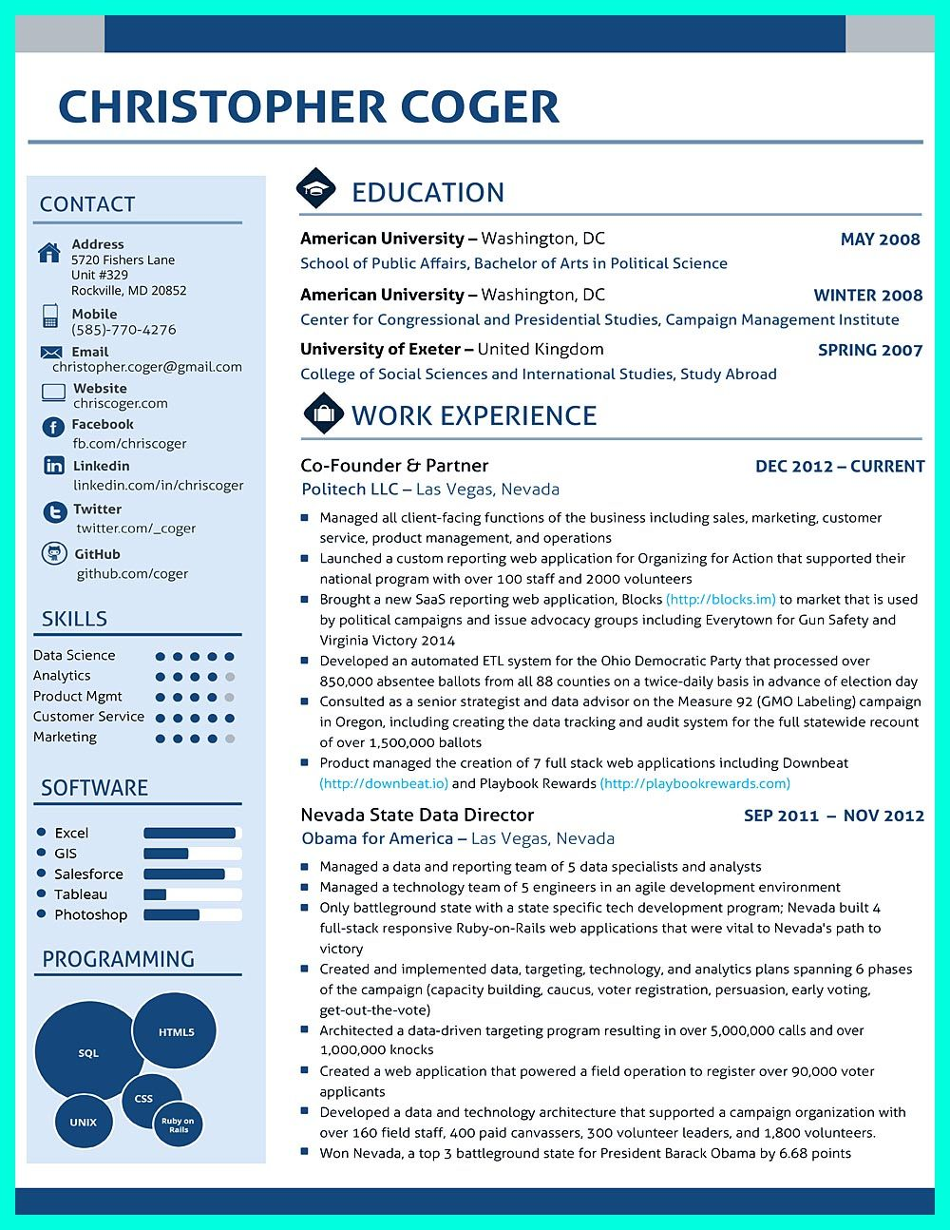

**CHRISTOPHER COGER**

CONTACT

**Address**

5720 Fishers Lane Unit #329

Rockville, MD 20852

Mobile

(585)-770-4276

Email

christopher.coger@gmail.com

EDUCATION

American University - Washington, DC

**MAY 2008**

School of Public Affairs, Bachelor of Arts in Political Science

**American University-Washington, DC**

**WINTER 2008**

Center for Congressional and Presidential Studies, Campaign Management Institute

**University of Exeter-United Kingdom**

**SPRING 2007**

College of Social Sciences and International Studies, Study Abroad

Website

chriscoger.com

**f Facebook**

WORK EXPERIENCE

fb.com/chriscoger

**in Linkedin**

Co-Founder & Partner

DEC 2012-CURRENT

linkedin.com/in/chriscoger

Politech LLC Las Vegas, Nevada

**Twitter**

twitter.com/_coger

**GitHub**

github.com/coger

SKILLS

Data Science

Analytics

Product Mgmt

Customer Service

Marketing

SOFTWARE

Excel GIS

Salesforce

Tableau Photoshop

PROGRAMMING

**SQL**

**UNIX**

**CSS**

**HTML5**

**Ruby on**

**Rails**

Managed all client-facing functions of the business including sales, marketing, customer service, product management, and operations

Launched a custom reporting web application for Organizing for Action that supported their national program with over 100 staff and 2000 volunteers

■Brought a new SaaS reporting web application, Blocks (http://blocks.im) to market that is used by political campaigns and issue advocacy groups including Everytown for Gun Safety and Virginia Victory 2014

■Developed an automated ETL system for the Ohio Democratic Party that processed over

850,000 absentee ballots from all 88 counties on a twice-daily basis in advance of election day Consulted as a senior strategist and data advisor on the Measure 92 (GMO Labeling) campaign in Oregon, including creating the data tracking and audit system for the full statewide recount of over 1,500,000 ballots

Product managed the creation of 7 full stack web applications including Downbeat (http://downbeat.io) and Playbook Rewards (http://playbookrewards.com)

Nevada State Data Director

Obama for America - Las Vegas, Nevada

**SEP 2011**

-

**NOV 2012**

■ Managed a data and reporting team of 5 data specialists and analysts ■Managed a technology team of 5 engineers in an agile development environment Only battleground state with a state specific tech development program; Nevada built 4 full-stack responsive Ruby-on-Rails web applications that were vital to Nevada's path to victory

Created and implemented data, targeting, technology, and analytics plans spanning 6 phases of the campaign (capacity building, caucus, voter registration, persuasion, early voting, get-out-the-vote)

■ Architected a data-driven targeting program resulting in over 5,000,000 calls and over 1,000,000 knocks

■Created a web application that powered a field operation to register over 90,000 voter applicants

■Developed a data and technology architecture that supported a campaign organization with over 160 field staff, 400 paid canvassers, 300 volunteer leaders, and 1,800 volunteers. ☐ Won Nevada, a top 3 battleground state for President Barack Obama by 6.68 points