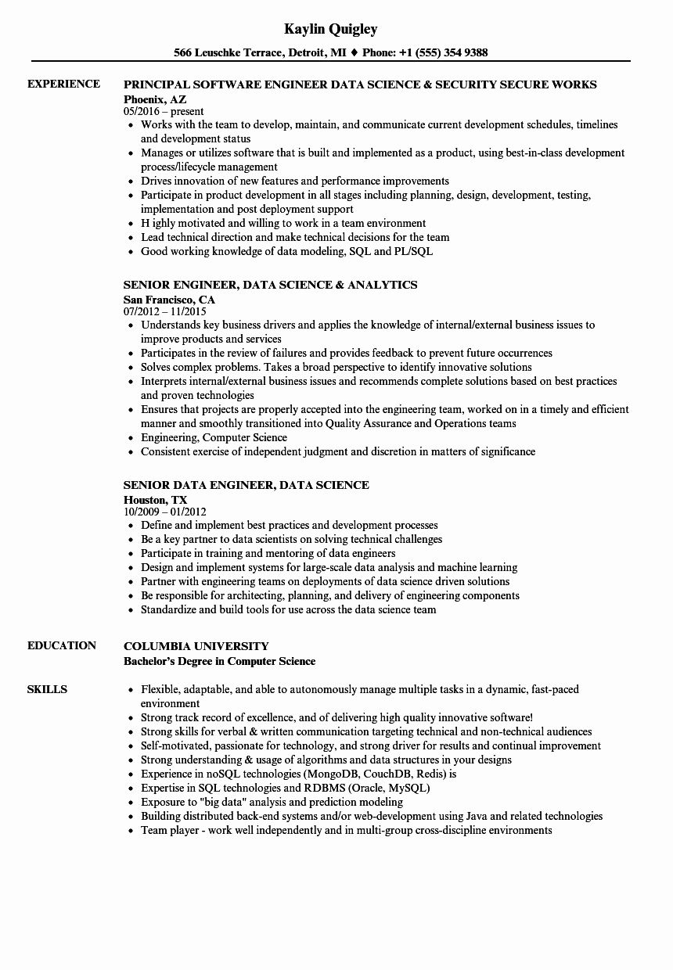

**EXPERIENCE**

**EDUCATION**

**SKILLS**

**Kaylin Quigley**

566 Leuschke Terrace, Detroit, MI ♦ Phone: +1 (555) 354 9388

**PRINCIPAL SOFTWARE ENGINEER DATA SCIENCE & SECURITY SECURE WORKS Phoenix, AZ**

05/2016-present

• Works with the team to develop, maintain, and communicate current development schedules, timelines and development status

• Manages or utilizes software that is built and implemented as a product, using best-in-class development process/lifecycle management

⚫ Drives innovation of new features and performance improvements

• Participate in product development in all stages including planning, design, development, testing, implementation and post deployment support

⚫ Highly motivated and willing to work in a team environment

• Lead technical direction and make technical decisions for the team

• Good working knowledge of data modeling, SQL and PL/SQL

**SENIOR ENGINEER, DATA SCIENCE & ANALYTICS**

San Francisco, CA

07/2012 11/2015

• Understands key business drivers and applies the knowledge of internal/external business issues to improve products and services

• Participates in the review of failures and provides feedback to prevent future occurrences

• Solves complex problems. Takes a broad perspective to identify innovative solutions

• Interprets internal/external business issues and recommends complete solutions based on best practices and proven technologies

• Ensures that projects are properly accepted into the engineering team, worked on in a timely and efficient manner and smoothly transitioned into Quality Assurance and Operations teams

• Engineering, Computer Science

• Consistent exercise of independent judgment and discretion in matters of significance

**SENIOR DATA ENGINEER, DATA SCIENCE**

**Houston, TX**

10/2009-01/2012

• Define and implement best practices and development processes

• Be a key partner to data scientists on solving technical challenges

• Participate in training and mentoring of data engineers

• Design and implement systems for large-scale data analysis and machine learning

• Partner with engineering teams on deployments of data science driven solutions

• Be responsible for architecting, planning, and delivery of engineering components

• Standardize and build tools for use across the data science team

**COLUMBIA UNIVERSITY**

Bachelor's Degree in Computer Science

• Flexible, adaptable, and able to autonomously manage multiple tasks in a dynamic, fast-paced environment

• Strong track record of excellence, and of delivering high quality innovative software!

• Strong skills for verbal & written communication targeting technical and non-technical audiences

⚫ Self-motivated, passionate for technology, and strong driver for results and continual improvement

• Strong understanding & usage of algorithms and data structures in your designs

• Experience in noSQL technologies (MongoDB, CouchDB, Redis) is

• Expertise in SQL technologies and RDBMS (Oracle, MySQL)

• Exposure to "big data" analysis and prediction modeling

• Building distributed back-end systems and/or web-development using Java and related technologies Team player - work well independently and in multi-group cross-discipline environments