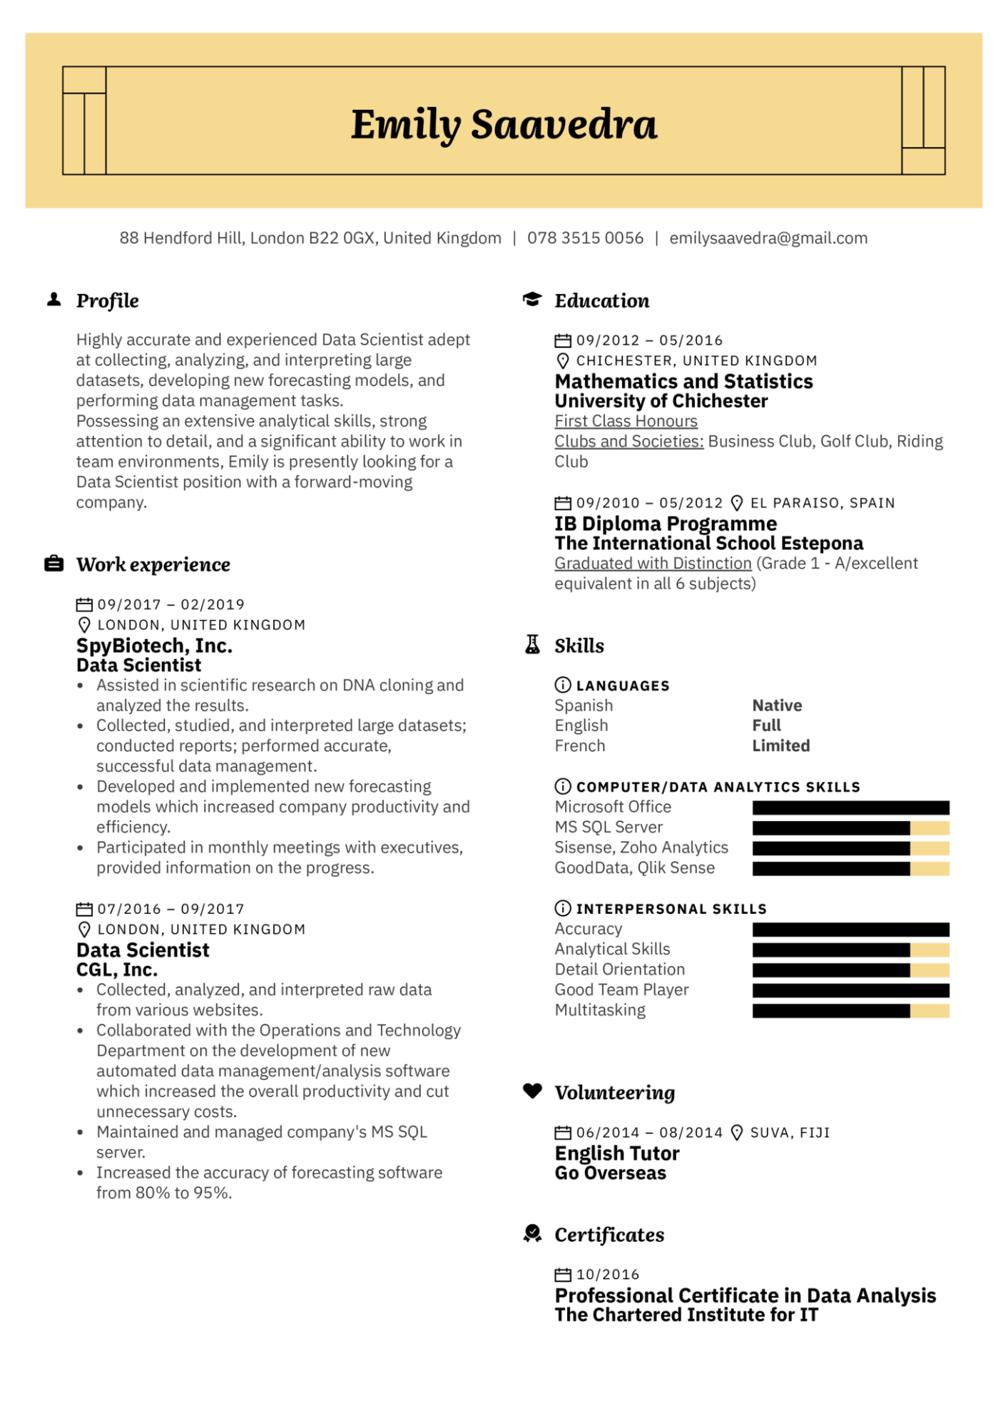

***Emily Saavedra***

88 Hendford Hill, London B22 OGX, United Kingdom | 078 3515 0056 | emilysaavedra@gmail.com

**▲ Profile**

Highly accurate and experienced Data Scientist adept at collecting, analyzing, and interpreting large datasets, developing new forecasting models, and performing data management tasks.

Possessing an extensive analytical skills, strong attention to detail, and a significant ability to work in team environments, Emily is presently looking for a Data Scientist position with a forward-moving company.

***Work experience***

09/2017 - 02/2019

LONDON, UNITED KINGDOM

**SpyBiotech, Inc.**

**Data Scientist**

• Assisted in scientific research on DNA cloning and

**Education**

09/2012 05/2016

**CHICHESTER, UNITED KINGDOM Mathematics and Statistics University of Chichester First Class Honours**

Clubs and Societies: Business Club, Golf Club, Riding Club

09/2010

05/2012 EL PARAISO, SPAIN

**IB Diploma Programme**

**The International School Estepona**

Graduated with Distinction (Grade 1 - A/excellent equivalent in all 6 subjects)

**A Skills**

analyzed the results.

•

Collected, studied, and interpreted large datasets; conducted reports; performed accurate,

**LANGUAGES**

Spanish

English

French

**Native Full Limited**

·

successful data management.

Developed and implemented new forecasting

models which increased company productivity and efficiency.

• Participated in monthly meetings with executives,

provided information on the progress.

07/2016 - 09/2017

LONDON, UNITED KINGDOM

**Data Scientist**

**CGL, Inc.**

Collected, analyzed, and interpreted raw data

from various websites.

• Collaborated with the Operations and Technology Department on the development of new

•

automated data management/analysis software which increased the overall productivity and cut unnecessary costs.

Maintained and managed company's MS SQL

server.

• Increased the accuracy of forecasting software from 80% to 95%.

→ COMPUTER/DATA ANALYTICS SKILLS Microsoft Office

MS SQL Server

Sisense, Zoho Analytics

GoodData, Qlik Sense

**INTERPERSONAL SKILLS**

Accuracy

Analytical Skills

Detail Orientation Good Team Player Multitasking

***Volunteering***

06/2014 08/2014 SUVA, FIJI

**English Tutor**

**Go Overseas**

***Certificates***

10/2016

**Professional Certificate in Data Analysis The Chartered Institute for IT**