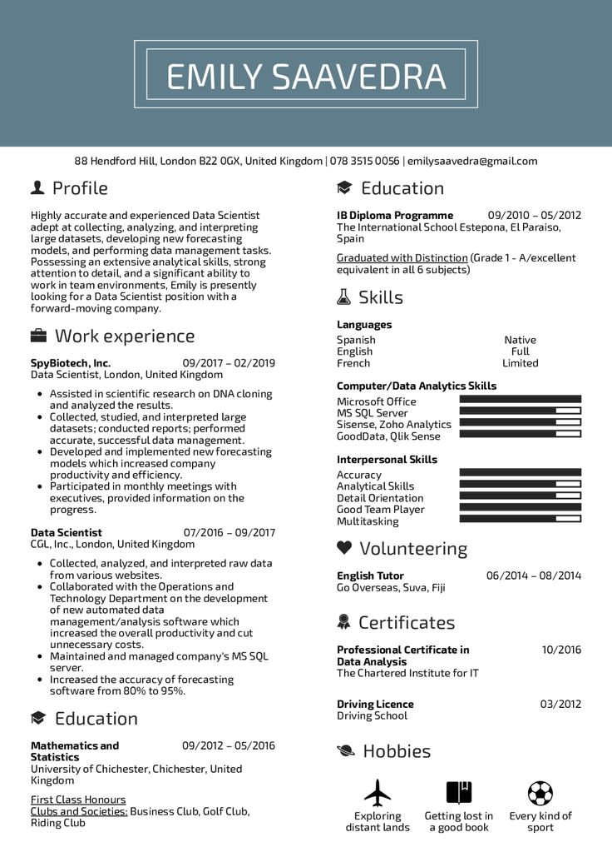

EMILY SAAVEDRA

88 Hendford Hill, London B22 OGX, United Kingdom | 078 3515 0056 | emilysaavedra@gmail.com

Profile

Highly accurate and experienced Data Scientist adept at collecting, analyzing, and interpreting large datasets, developing new forecasting models, and performing data management tasks. Possessing an extensive analytical skills, strong attention to detail, and a significant ability to work in team environments, Emily is presently looking for a Data Scientist position with a forward-moving company.

Work experience

**SpyBiotech, Inc.**

Education

**IB Diploma Programme**

09/2010 05/2012

The International School Estepona, El Paraiso, Spain

Graduated with Distinction (Grade 1 - A/excellent equivalent in all 6 subjects)

Skills

Languages

Spanish

English

09/2017 02/2019

French

Data Scientist, London, United Kingdom

Assisted in scientific research on DNA cloning and analyzed the results.

• Collected, studied, and interpreted large datasets; conducted reports; performed accurate, successful data management.

• Developed and implemented new forecasting models which increased company productivity and efficiency.

• Participated in monthly meetings with executives, provided information on the progress.

**Data Scientist**

07/2016-09/2017

CGL, Inc., London, United Kingdom

• Collected, analyzed, and interpreted raw data from various websites.

Collaborated with the Operations and

Technology Department on the development of new automated data

management/analysis software which increased the overall productivity and cut unnecessary costs.

• Maintained and managed company's MS SQL

server.

• Increased the accuracy of forecasting

software from 80% to 95%.

Education

Mathematics and

**Statistics**

09/2012-05/2016

University of Chichester, Chichester, United Kingdom

First Class Honours

Clubs and Societies: Business Club, Golf Club, Riding Club

**Computer/Data Analytics Skills**

Microsoft Office

MS SQL Server

Sisense, Zoho Analytics

GoodData, Qlik Sense

Interpersonal Skills Accuracy Analytical Skills Detail Orientation Good Team Player Multitasking

Volunteering

English Tutor

Go Overseas, Suva, Fiji

Certificates

**Professional Certificate in Data Analysis**

The Chartered Institute for IT

**Driving Licence Driving School**

• Hobbies

Native

Full

Limited

06/2014-08/2014

10/2016

03/2012

Exploring distant lands

Getting lost in a good book

Every kind of sport