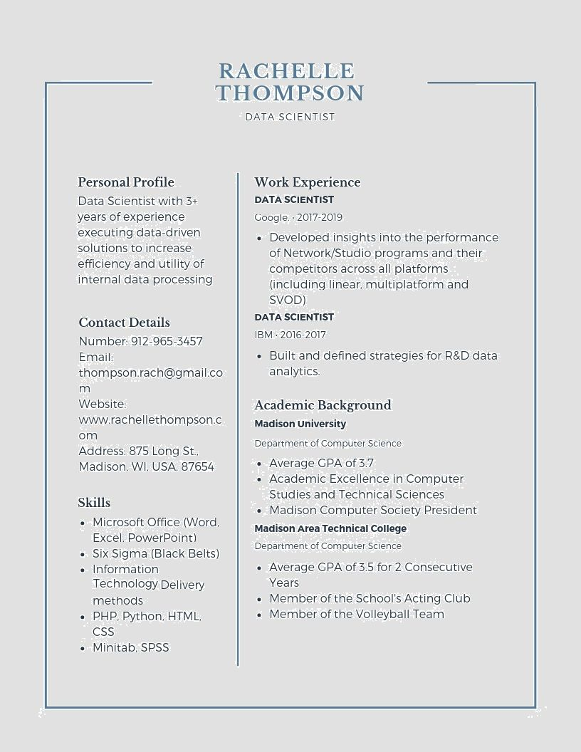

RACHELLE THOMPSON

DATA SCIENTIST

**Personal Profile**

Data Scientist with 3+ years of experience executing data-driven solutions to increase efficiency and utility of internal data processing

**Contact Details**

Number: 912-965-3457

Email:

thompson rach@gmail.co

m

Website:

www.rachellethompson.c

om

Address: 875 Long St.. Madison, WI. USA, 87654

**Skills**

Microsoft Office (Word, Excel, PowerPoint)

⚫ Six Sigma (Black Belts) • Information

Technology Delivery methods

⚫ PHP, Python, HTML,

CSS

Minitab, SPSS

**Work Experience**

**DATA SCIENTIST**

Google 2017-2019

• Developed insights into the performance of Network/Studio programs and their competitors across all platforms (including linear, multiplatform and SVOD)

**DATA SCIENTIST**

IBM. 2016-2017

• Built and defined strategies for R&D data analytics.

**Academic Background Madison University**

Department of Computer Science

Average GPA of 3.7

Academic Excellence in Computer Studies and Technical Sciences

Madison Computer Society President

**Madison Area Technical College**

Department of Computer Science

Average GPA of 3.5 for 2 Consecutive Years

Member of the School's Acting Club • Member of the Volleyball Team