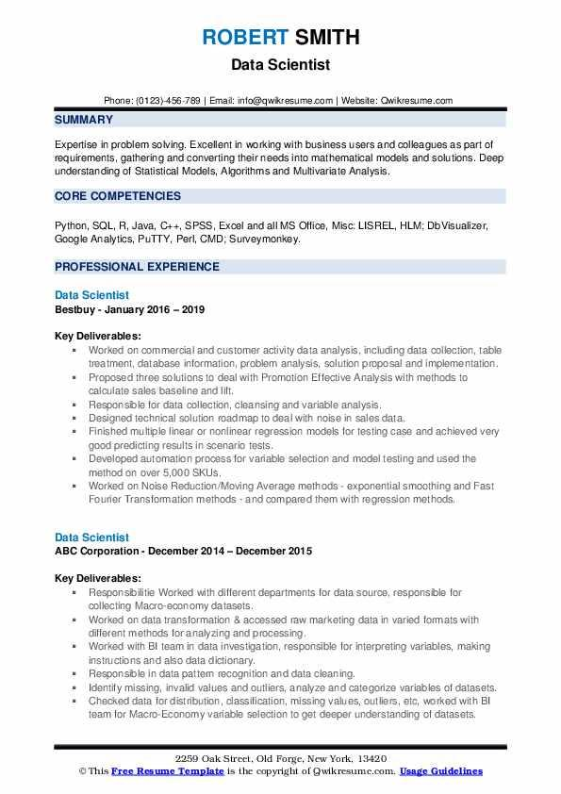

**ROBERT SMITH**

Data Scientist

Phone: (0123)-456-789 | Email: info@qwikresume.com | Website: Qwikresume.com

SUMMARY

Expertise in problem solving. Excellent in working with business users and colleagues as part of requirements, gathering and converting their needs into mathematical models and solutions. Deep understanding of Statistical Models, Algorithms and Multivariate Analysis.

CORE COMPETENCIES

Python, SQL, R, Java, C++, SPSS, Excel and all MS Office, Misc: LISREL, HLM; Db Visualizer, Google Analytics, PuTTY, Perl, CMD; Surveymonkey.

PROFESSIONAL EXPERIENCE

Data Scientist

Bestbuy - January 2016-2019

Key Deliverables:

• Worked on commercial and customer activity data analysis, including data collection, table treatment, database information, problem analysis, solution proposal and implementation.

⚫ Proposed three solutions to deal with Promotion Effective Analysis with methods to calculate sales baseline and lift.

• Responsible for data collection, cleansing and variable analysis.

•

Designed technical solution roadmap to deal with noise in sales data.

⚫ Finished multiple linear or nonlinear regression models for testing case and achieved very good predicting results in scenario tests.

•Developed automation process for variable selection and model testing and used the method on over 5,000 SKUS.

• Worked on Noise Reduction/Moving Average methods - exponential smoothing and Fast Fourier Transformation methods and compared them with regression methods.

Data Scientist

ABC Corporation - December 2014 - December 2015

Key Deliverables:

• Responsibilitie Worked with different departments for data source, responsible for collecting Macro-economy datasets.

• Worked on data transformation & accessed raw marketing data in varied formats with different methods for analyzing and processing.

•Worked with BI team in data investigation, responsible for interpreting variables, making instructions and also data dictionary.

• Responsible in data pattem recognition and data cleaning.

Identify missing, invalid values and outliers, analyze and categorize variables of datasets. ⚫ Checked data for distribution, classification, missing values, outliers, etc, worked with BI team for Macro-Economy variable selection to get deeper understanding of datasets.

2259 Oak Street, Old Forge, New York, 13420

This Free Resume Template is the copyright of Qwikresume.com. Usage Guidelines