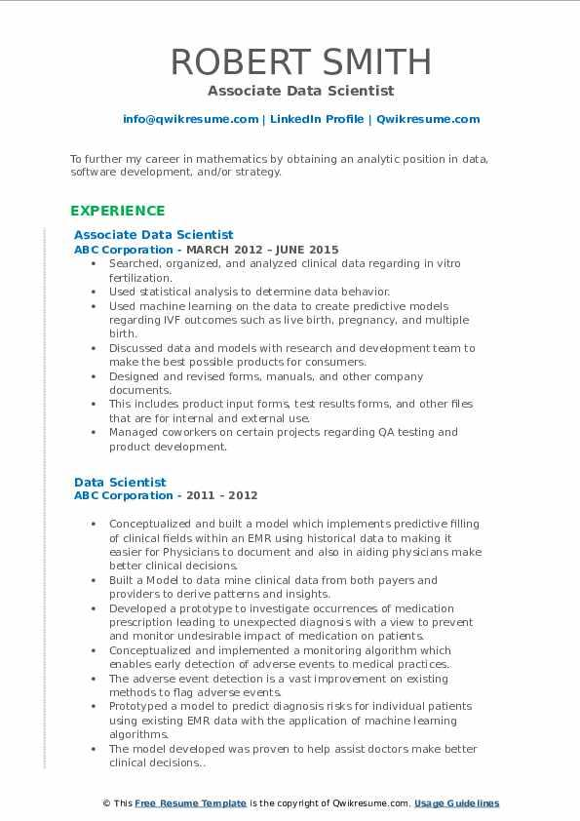

ROBERT SMITH

Associate Data Scientist

info@qwikresume.com | LinkedIn Profile | Qwikresume.com

To further my career in mathematics by obtaining an analytic position in data, software development, and/or strategy.

**EXPERIENCE**

Associate Data Scientist

ABC Corporation - MARCH 2012-JUNE 2015

Searched, organized, and analyzed clinical data regarding in vitro fertilization.

Used statistical analysis to determine data behavior.

• Used machine learning on the data to create predictive models regarding IVF outcomes such as live birth, pregnancy, and multiple birth.

• Discussed data and models with research and development team to make the best possible products for consumers.

Designed and revised forms, manuals, and other company. documents.

• This includes product input forms test results forms, and other files that are for internal and external use.

• Managed coworkers on certain projects regarding QA testing and product development.

Data Scientist

ABC Corporation - 2011 - 2012

• Conceptualized and built a model which implements predictive filling of clinical fields within an EMR using historical data to making it easier for Physicians to document and also in aiding physicians make better clinical decisions

• Built a Model to data mine clinical data from both payers and providers to derive patterns and insights.

• Developed a prototype to investigate occurrences of medication prescription leading to unexpected diagnosis with a view to prevent and monitor undesirable impact of medication on patients Conceptualized and implemented a monitoring algorithm which enables early detection of adverse events to medical practices. • The adverse event detection is a vast improvement on existing methods to flag adverse events

.

• Prototyped a model to predict diagnosis risks for individual patients using existing EMR data with the application of machine leaming algorithms

• The model developed was proven to help assist doctors make better clinical decisions...

This Free Resume Template is the copyright of Qwikresume.com, Usage Guidelines