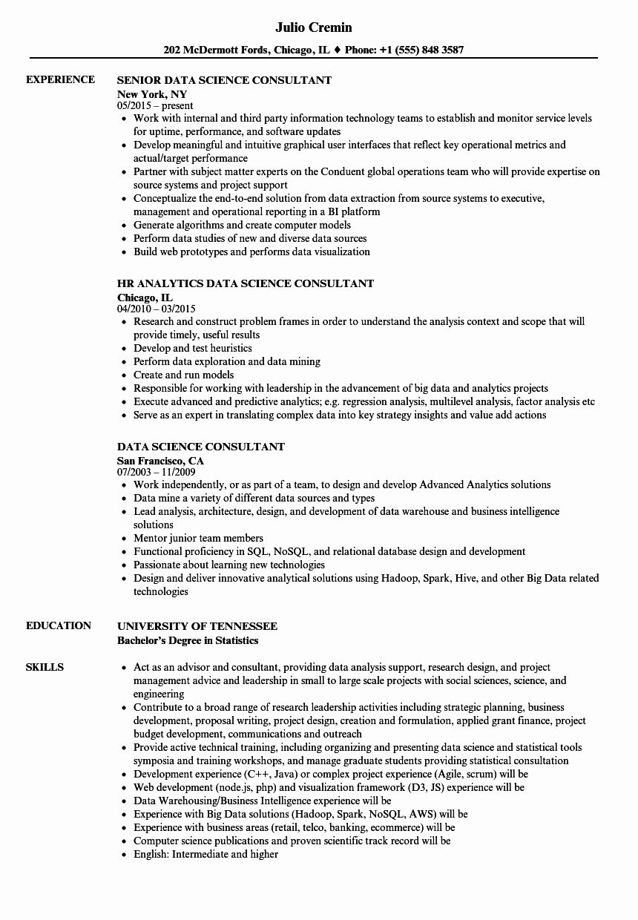

**EXPERIENCE**

Julio Cremin

**202 McDermott Fords, Chicago, IL ♦ Phone: +1 (555) 848 3587**

**SENIOR DATA SCIENCE CONSULTANT**

**New York, NY**

05/2015-present

• Work with internal and third party information technology teams to establish and monitor service levels for uptime, performance, and software updates

• Develop meaningful and intuitive graphical user interfaces that reflect key operational metrics and actual/target performance

• Partner with subject matter experts on the Conduent global operations team who will provide expertise on source systems and project support

• Conceptualize the end-to-end solution from data extraction from source systems to executive,

management and operational reporting in a BI platform

• Generate algorithms and create computer models • Perform data studies of new and diverse data sources

• Build web prototypes and performs data visualization

**HR ANALYTICS DATA SCIENCE CONSULTANT Chicago, IL**

04/2010-03/2015

⚫ Research and construct problem frames in order to understand the analysis context and scope that will provide timely, useful results

• Develop and test heuristics

• Perform data exploration and data mining

• Create and run models

• Responsible for working with leadership in the advancement of big data and analytics projects

• Execute advanced and predictive analytics; e.g. regression analysis, multilevel analysis, factor analysis etc

• Serve as an expert in translating complex data into key strategy insights and value add actions

**DATA SCIENCE CONSULTANT**

San Francisco, CA

07/2003 - 11/2009

• Work independently, or as part of a team, to design and develop Advanced Analytics solutions

⚫ Data mine a variety of different data sources and types

• Lead analysis, architecture, design, and development of data warehouse and business intelligence solutions

• Mentor junior team members

⚫ Functional proficiency in SQL, NOSQL, and relational database design and development

⚫ Passionate about learning new technologies

• Design and deliver innovative analytical solutions using Hadoop, Spark, Hive, and other Big Data related technologies

**EDUCATION**

**SKILLS**

**UNIVERSITY OF TENNESSEE**

**Bachelor's Degree in Statistics**

• Act as an advisor and consultant, providing data analysis support, research design, and project management advice and leadership in small to large scale projects with social sciences, science, and engineering

Contribute to a broad range of research leadership activities including strategic planning, business development, proposal writing, project design, creation and formulation, applied grant finance, project budget development, communications and outreach

• Provide active technical training, including organizing and presenting data science and statistical tools symposia and training workshops, and manage graduate students providing statistical consultation

• Development experience (C++, Java) or complex project experience (Agile, scrum) will be

⚫ Web development (node.js, php) and visualization framework (D3, JS) experience will be

• Data Warehousing/Business Intelligence experience will be

• Experience with Big Data solutions (Hadoop, Spark, NoSQL, AWS) will be

• Experience with business areas (retail, telco, banking, ecommerce) will be

⚫ Computer science publications and proven scientific track record will be

• English: Intermediate and higher