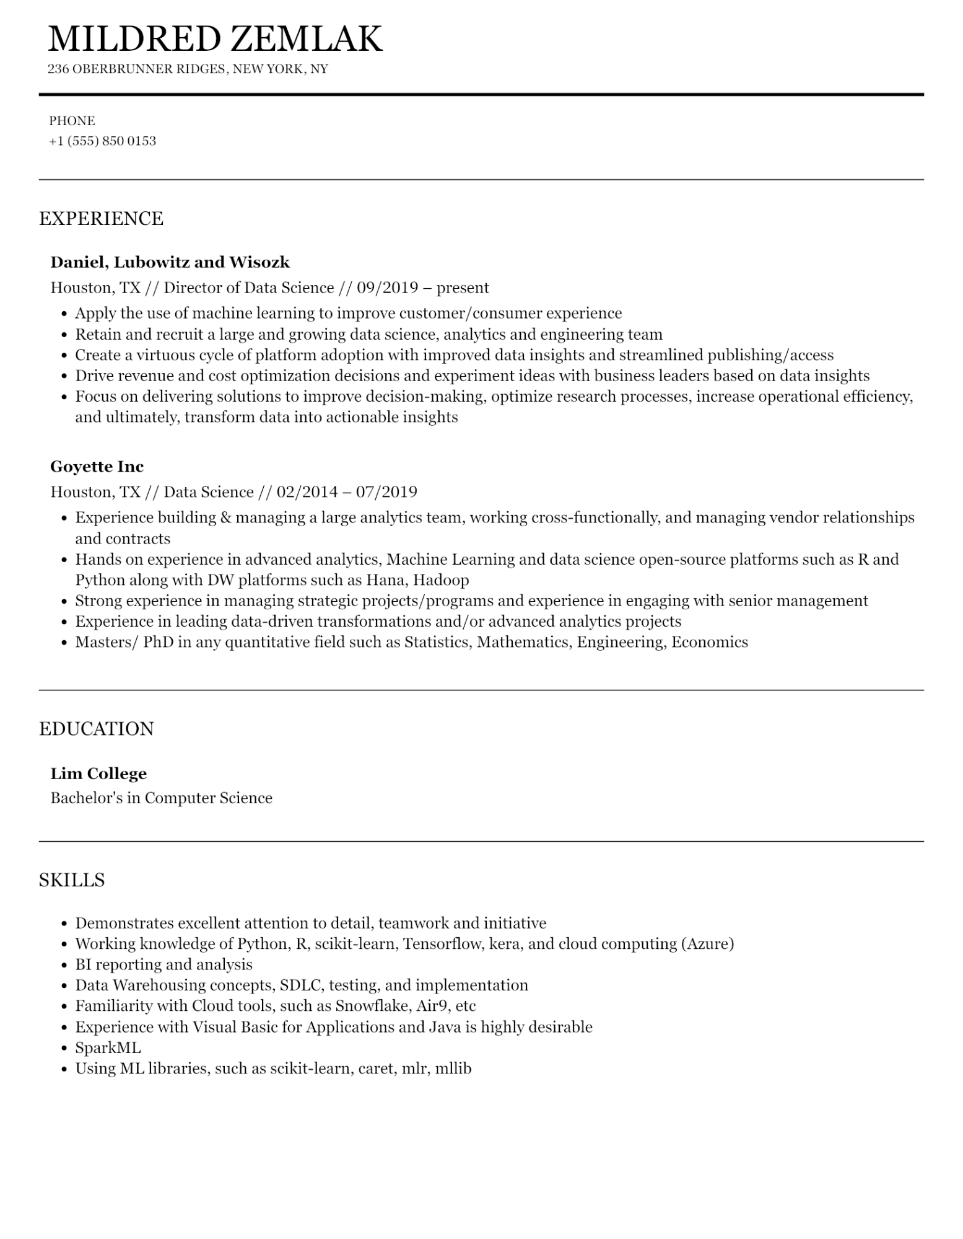

MILDRED ZEMLAK

236 OBERBRUNNER RIDGES, NEW YORK, NY

PHONE

+1 (555) 850 0153

EXPERIENCE

**Daniel, Lubowitz and Wisozk**

Houston, TX // Director of Data Science // 09/2019 – present

·

Apply the use of machine learning to improve customer/consumer experience

• Retain and recruit a large and growing data science, analytics and engineering team

• Create a virtuous cycle of platform adoption with improved data insights and streamlined publishing/access

• Drive revenue and cost optimization decisions and experiment ideas with business leaders based on data insights

• Focus on delivering solutions to improve decision-making, optimize research processes, increase operational efficiency, and ultimately, transform data into actionable insights

**Goyette Inc**

Houston, TX // Data Science // 02/2014 - 07/2019

•

Experience building & managing a large analytics team, working cross-functionally, and managing vendor relationships and contracts

• Hands on experience in advanced analytics, Machine Learning and data science open-source platforms such as R and Python along with DW platforms such as Hana, Hadoop

•

Strong experience in managing strategic projects/programs and experience in engaging with senior management Experience in leading data-driven transformations and/or advanced analytics projects

Masters/PhD in any quantitative field such as Statistics, Mathematics, Engineering, Economics

EDUCATION

**Lim College**

Bachelor's in Computer Science

SKILLS

• Demonstrates excellent attention to detail, teamwork and initiative

•

Working knowledge of Python, R, scikit-learn, Tensorflow, kera, and cloud computing (Azure)

• BI reporting and analysis

• Data Warehousing concepts, SDLC, testing, and implementation

•

·

Familiarity with Cloud tools, such as Snowflake, Air9, etc

Experience with Visual Basic for Applications and Java is highly desirable

·

SparkML

·

Using ML libraries, such as scikit-learn, caret, mlr, mllib