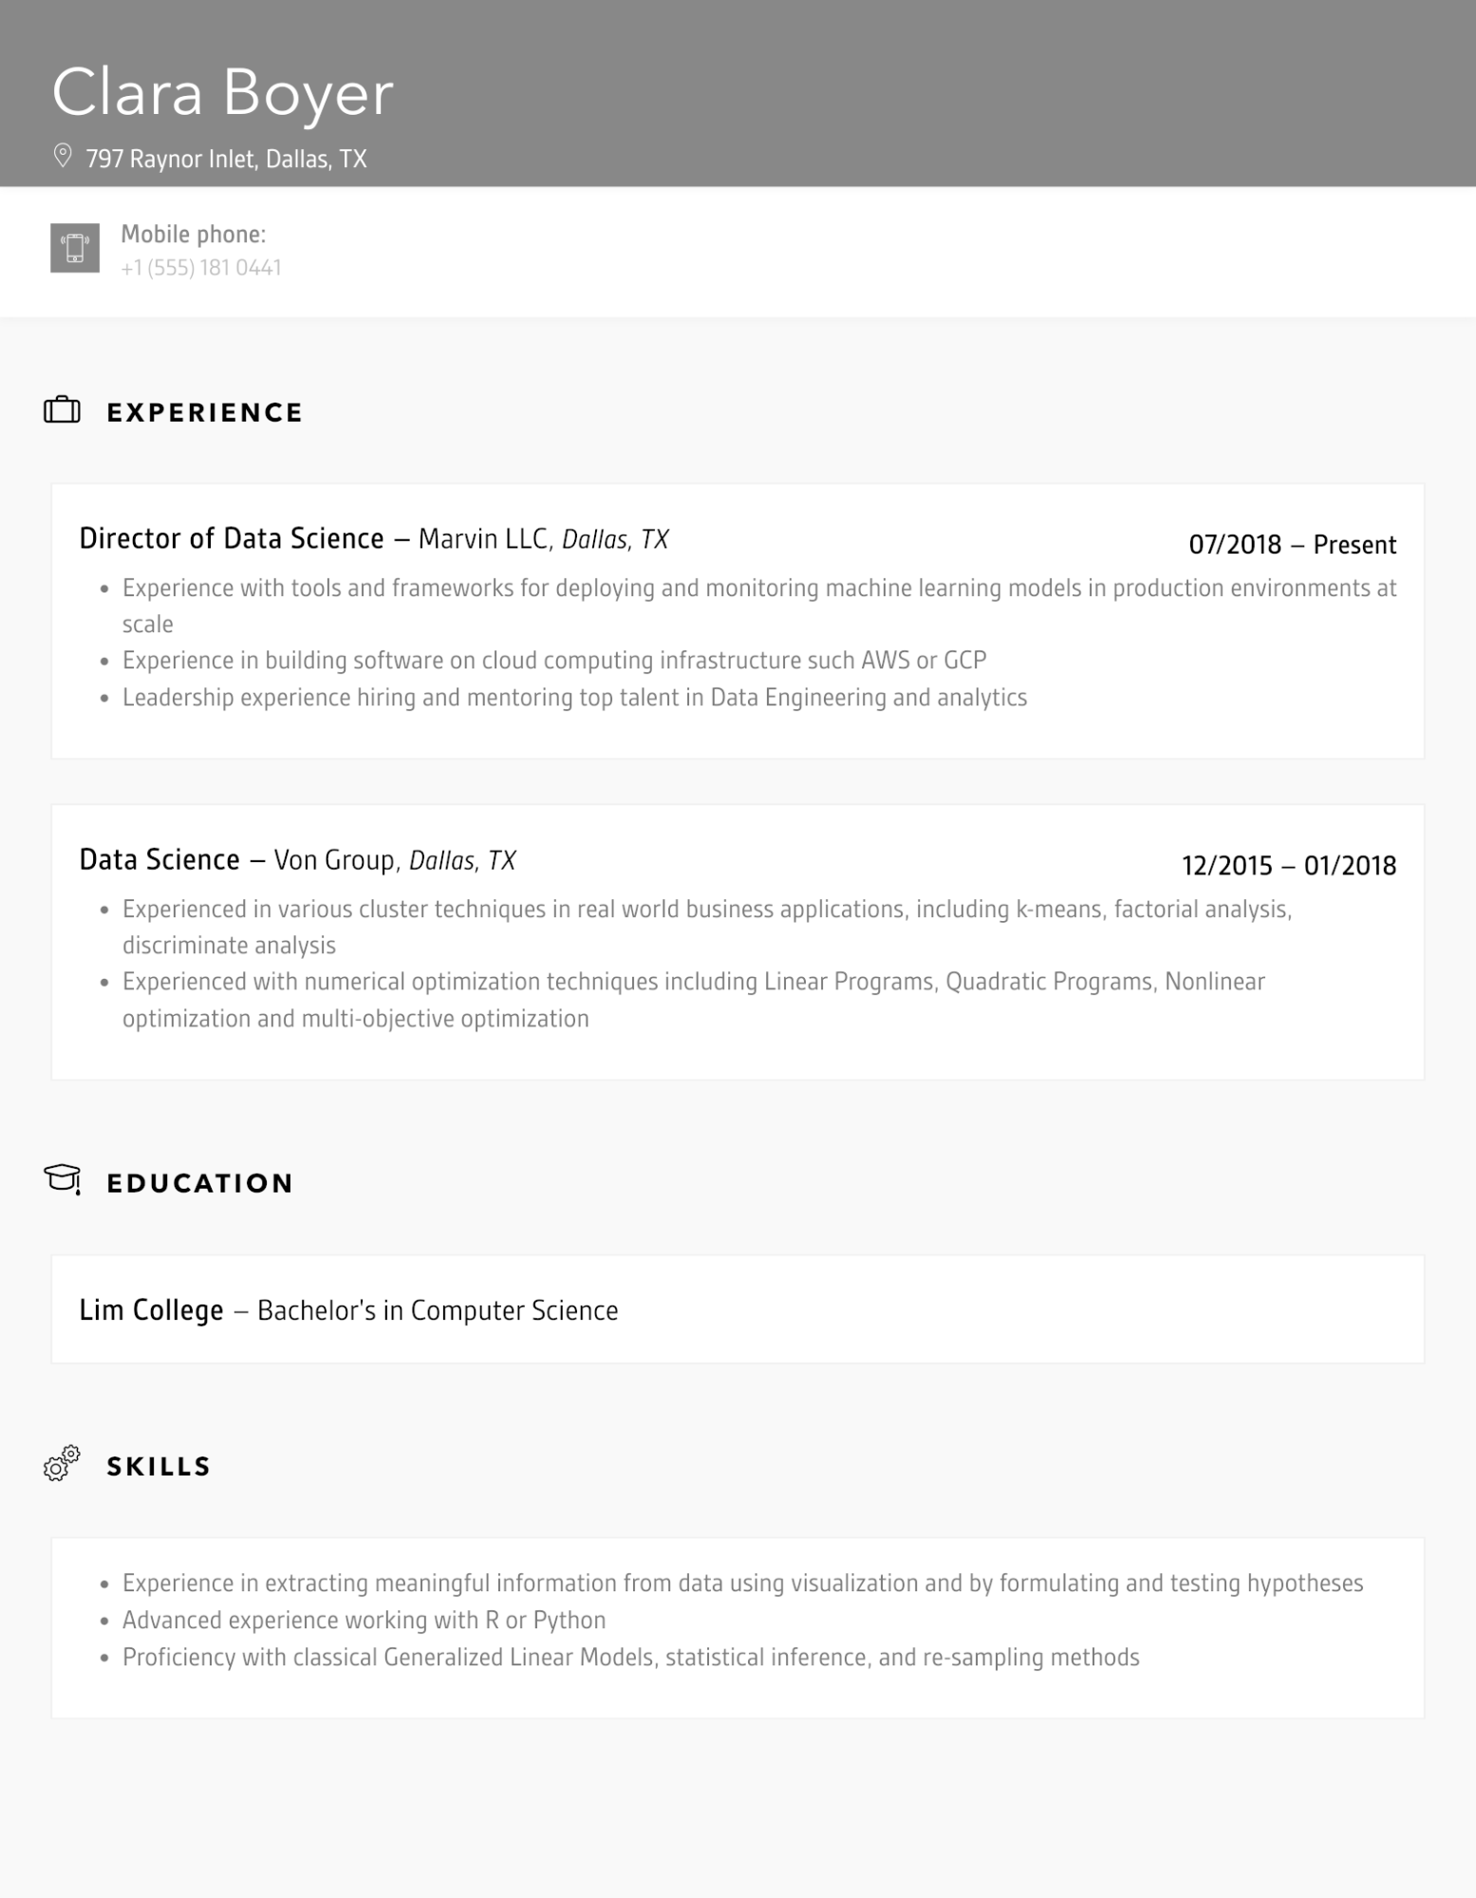

Clara Boyer

797 Raynor Inlet, Dallas, TX

Mobile phone:

+1 (555) 181 0441

**EXPERIENCE**

Director of Data Science - Marvin LLC, Dallas, TX

•

07/2018 - Present

Experience with tools and frameworks for deploying and monitoring machine learning models in production environments at scale

Experience in building software on cloud computing infrastructure such AWS or GCP Leadership experience hiring and mentoring top talent in Data Engineering and analytics

Data Science - Von Group, Dallas, TX

•

•

12/2015 01/2018

Experienced in various cluster techniques in real world business applications, including k-means, factorial analysis, discriminate analysis

Experienced with numerical optimization techniques including Linear Programs, Quadratic Programs, Nonlinear optimization and multi-objective optimization

**EDUCATION**

Lim College - Bachelor's in Computer Science

**SKILLS**

•

•

Experience in extracting meaningful information from data using visualization and by formulating and testing hypotheses Advanced experience working with R or Python

Proficiency with classical Generalized Linear Models, statistical inference, and re-sampling methods