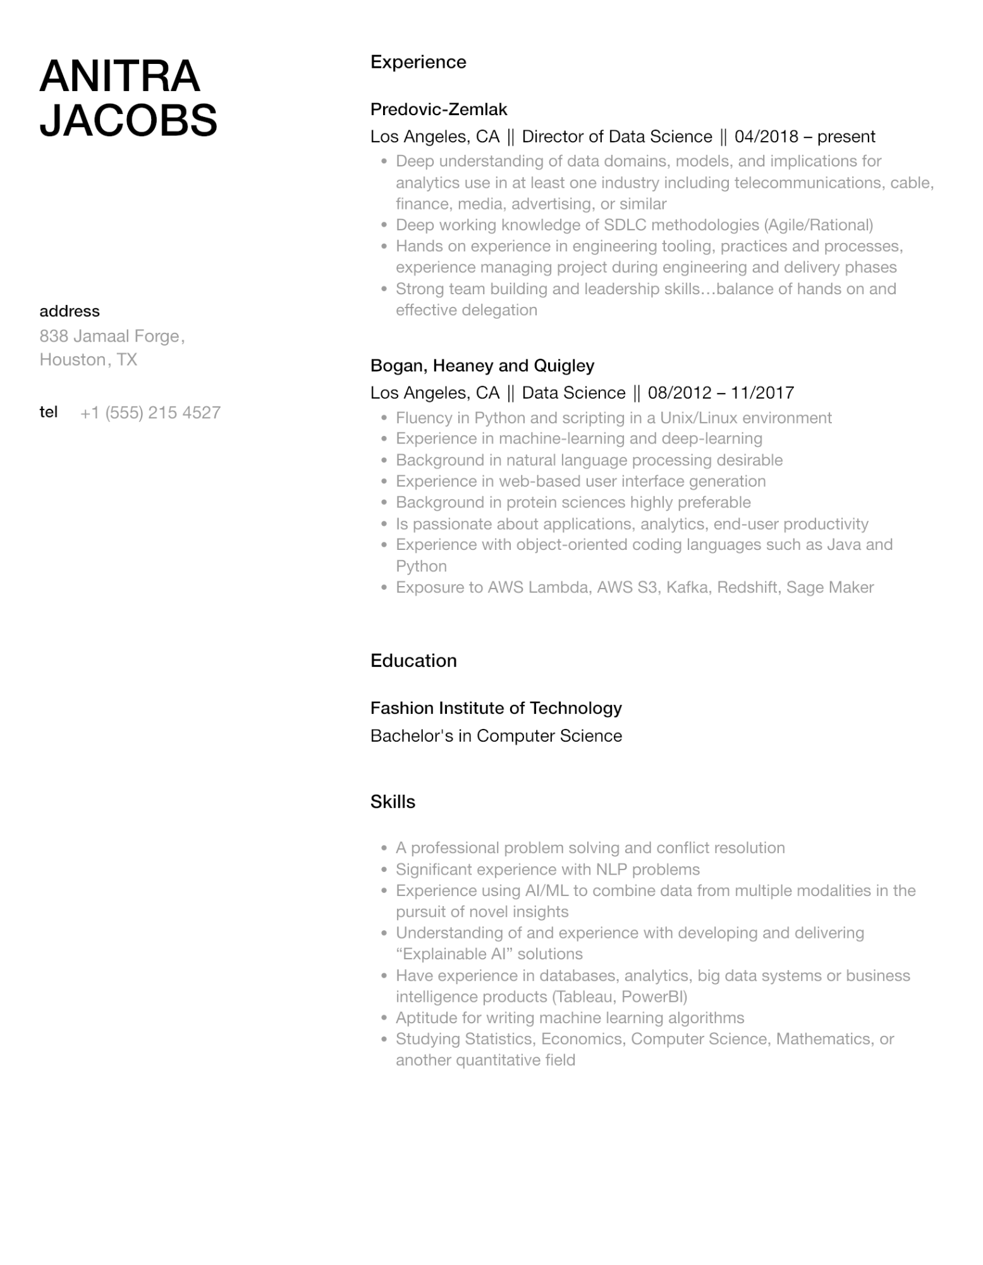

**ANITRA JACOBS**

address

838 Jamaal Forge, Houston, TX

Experience

Predovic-Zemlak

Los Angeles, CA || Director of Data Science || 04/2018 - present

•

•

Deep understanding of data domains, models, and implications for analytics use in at least one industry including telecommunications, cable, finance, media, advertising, or similar

Deep working knowledge of SDLC methodologies (Agile/Rational)

• Hands on experience in engineering tooling, practices and processes, experience managing project during engineering and delivery phases Strong team building and leadership skills...balance of hands on and effective delegation

•

Bogan, Heaney and Quigley

Los Angeles, CA || Data Science || 08/2012 - 11/2017

tel

+1 (555) 215 4527

•

•

•

·

•

•

•

•

Fluency in Python and scripting in a Unix/Linux environment

Experience in machine-learning and deep-learning

Background in natural language processing desirable

Experience in web-based user interface generation

Background in protein sciences highly preferable

Is passionate about applications, analytics, end-user productivity Experience with object-oriented coding languages such as Java and Python

Exposure to AWS Lambda, AWS S3, Kafka, Redshift, Sage Maker

Education

Fashion Institute of Technology

Bachelor's in Computer Science

Skills

•

A professional problem solving and conflict resolution

•

·

•

Significant experience with NLP problems

Experience using AI/ML to combine data from multiple modalities in the pursuit of novel insights

Understanding of and experience with developing and delivering "Explainable Al❞ solutions

• Have experience in databases, analytics, big data systems or business intelligence products (Tableau, PowerBI)

•

Aptitude for writing machine learning algorithms

•

Studying Statistics, Economics, Computer Science, Mathematics, or another quantitative field