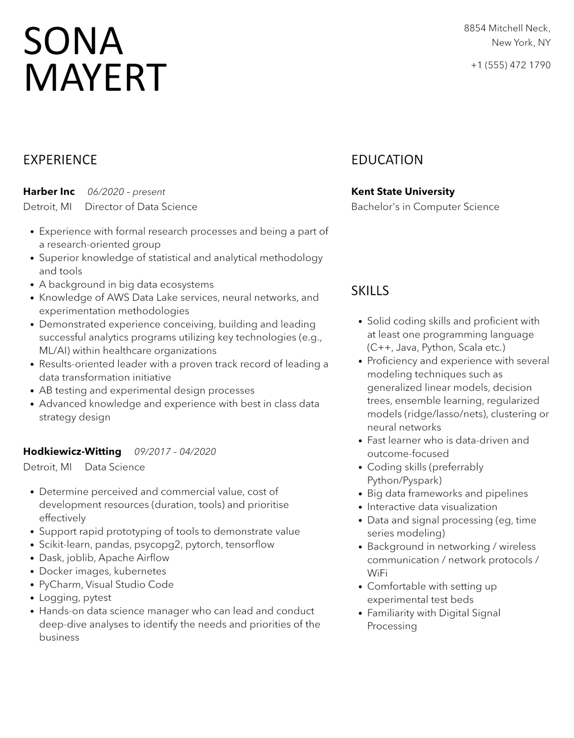

SONA MAYERT

8854 Mitchell Neck,

New York, NY

+1 (555) 472 1790

EXPERIENCE

**Harber Inc**

*06/2020 - present*

Detroit, MI

·

•

•

•

•

•

•

•

Director of Data Science

Experience with formal research processes and being a part of a research-oriented group

Superior knowledge of statistical and analytical methodology and tools

A background in big data ecosystems

Knowledge of AWS Data Lake services, neural networks, and experimentation methodologies

Demonstrated experience conceiving, building and leading successful analytics programs utilizing key technologies (e.g., ML/AI) within healthcare organizations

Results-oriented leader with a proven track record of leading a data transformation initiative

AB testing and experimental design processes

Advanced knowledge and experience with best in class data strategy design

**Hodkiewicz-Witting**

Detroit, MI

•

•

·

*09/2017-04/2020*

Data Science

Determine perceived and commercial value, cost of development resources (duration, tools) and prioritise effectively

Support rapid prototyping of tools to demonstrate value Scikit-learn, pandas, psycopg2, pytorch, tensorflow

•

Dask, joblib, Apache Airflow

•

Docker images, kubernetes

•

PyCharm, Visual Studio Code

•

Logging, pytest

Hands-on data science manager who can lead and conduct deep-dive analyses to identify the needs and priorities of the business

EDUCATION

**Kent State University**

Bachelor's in Computer Science

SKILLS

• Solid coding skills and proficient with at least one programming language (C++, Java, Python, Scala etc.) Proficiency and experience with several modeling techniques such as generalized linear models, decision trees, ensemble learning, regularized models (ridge/lasso/nets), clustering or neural networks

•

•

Fast learner who is data-driven and outcome-focused

Coding skills (preferrably Python/Pyspark)

Big data frameworks and pipelines

• Interactive data visualization

• Data and signal processing (eg, time series modeling)

Background in networking / wireless communication / network protocols/

WiFi

• Comfortable with setting up experimental test beds

Familiarity with Digital Signal Processing