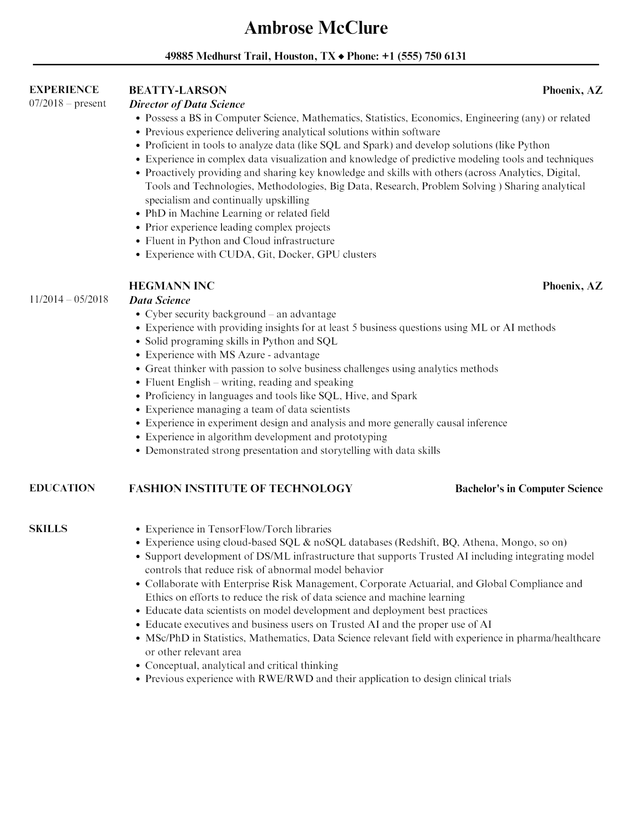

**Ambrose McClure**

**49885 Medhurst Trail, Houston, TX ◆ Phone: +1 (555) 750 6131**

**EXPERIENCE**

07/2018 - present

11/2014 - 05/2018

**BEATTY-LARSON**

***Director of Data Science***

**Phoenix, AZ**

• Possess a BS in Computer Science, Mathematics, Statistics, Economics, Engineering (any) or related • Previous experience delivering analytical solutions within software

• Proficient in tools to analyze data (like SQL and Spark) and develop solutions (like Python

•

•

Experience in complex data visualization and knowledge of predictive modeling tools and techniques Proactively providing and sharing key knowledge and skills with others (across Analytics, Digital, Tools and Technologies, Methodologies, Big Data, Research, Problem Solving) Sharing analytical specialism and continually upskilling

• PhD in Machine Learning or related field

• Prior experience leading complex projects

• Fluent in Python and Cloud infrastructure

•

Experience with CUDA, Git, Docker, GPU clusters

**HEGMANN INC**

***Data Science***

•

Cyber security background – an advantage

·

**Phoenix, AZ**

Experience with providing insights for at least 5 business questions using ML or AI methods

• Solid programing skills in Python and SQL

Experience with MS Azure - advantage

• Great thinker with passion to solve business challenges using analytics methods

• Fluent English – writing, reading and speaking

•

Proficiency in languages and tools like SQL, Hive, and Spark

•

Experience managing a team of data scientists

•

Experience in experiment design and analysis and more generally causal inference

Experience in algorithm development and prototyping

• Demonstrated strong presentation and storytelling with data skills

**EDUCATION**

**FASHION INSTITUTE OF TECHNOLOGY**

**SKILLS**

**Bachelor's in Computer Science**

•

Experience in TensorFlow/Torch libraries

Experience using cloud-based SQL & noSQL databases (Redshift, BQ, Athena, Mongo, so on)

Support development of DS/ML infrastructure that supports Trusted AI including integrating model controls that reduce risk of abnormal model behavior

• Collaborate with Enterprise Risk Management, Corporate Actuarial, and Global Compliance and Ethics on efforts to reduce the risk of data science and machine learning

• Educate data scientists on model development and deployment best practices

• Educate executives and business users on Trusted AI and the proper use of AI

• MSc/PhD in Statistics, Mathematics, Data Science relevant field with experience in pharma/healthcare or other relevant area

•

Conceptual, analytical and critical thinking

• Previous experience with RWE/RWD and their application to design clinical trials