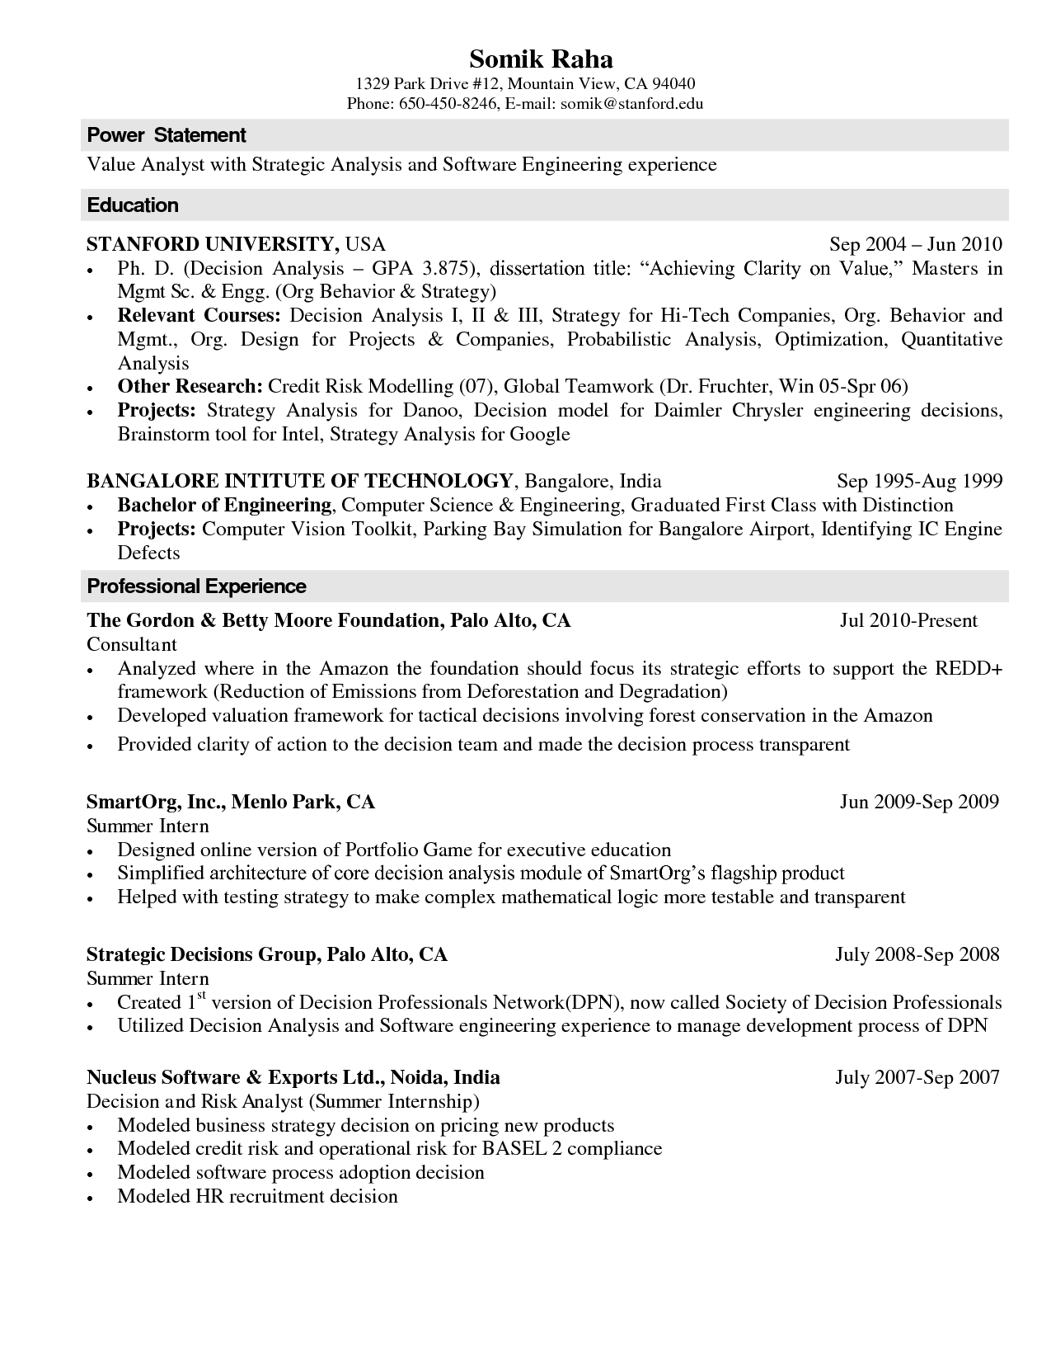

**Somik Raha**

1329 Park Drive #12, Mountain View, CA 94040

Phone: 650-450-8246, E-mail: somik@stanford.edu

**Power Statement**

Value Analyst with Strategic Analysis and Software Engineering experience

**Education**

**STANFORD UNIVERSITY, USA**

•

•

•

Sep 2004 - Jun 2010 Ph. D. (Decision Analysis - GPA 3.875), dissertation title: "Achieving Clarity on Value," Masters in Mgmt Sc. & Engg. (Org Behavior & Strategy)

Relevant Courses: Decision Analysis I, II & III, Strategy for Hi-Tech Companies, Org. Behavior and Mgmt., Org. Design for Projects & Companies, Probabilistic Analysis, Optimization, Quantitative Analysis

Other Research: Credit Risk Modelling (07), Global Teamwork (Dr. Fruchter, Win 05-Spr 06) Projects: Strategy Analysis for Danoo, Decision model for Daimler Chrysler engineering decisions, Brainstorm tool for Intel, Strategy Analysis for Google

**BANGALORE INTITUTE OF TECHNOLOGY, Bangalore, India**

•

•

Sep 1995-Aug 1999

Bachelor of Engineering, Computer Science & Engineering, Graduated First Class with Distinction Projects: Computer Vision Toolkit, Parking Bay Simulation for Bangalore Airport, Identifying IC Engine Defects

Professional Experience

**The Gordon & Betty Moore Foundation, Palo Alto, CA Consultant**

•

Jul 2010-Present

Analyzed where in the Amazon the foundation should focus its strategic efforts to support the REDD+ framework (Reduction of Emissions from Deforestation and Degradation)

•

•

Developed valuation framework for tactical decisions involving forest conservation in the Amazon Provided clarity of action to the decision team and made the decision process transparent

**SmartOrg, Inc., Menlo Park, CA**

Summer Intern

Jun 2009-Sep 2009

•

•

Designed online version of Portfolio Game for executive education Simplified architecture of core decision analysis module of SmartOrg's flagship product Helped with testing strategy to make complex mathematical logic more testable and transparent

July 2008-Sep 2008

**Strategic Decisions Group, Palo Alto, CA**

Summer Intern

·

Created 1st version of Decision Professionals Network(DPN), now called Society of Decision Professionals Utilized Decision Analysis and Software engineering experience to manage development process of DPN

**Nucleus Software & Exports Ltd., Noida, India**

Decision and Risk Analyst (Summer Internship)

July 2007-Sep 2007

•

Modeled business strategy decision on pricing new products

•

Modeled credit risk and operational risk for BASEL 2 compliance

Modeled software process adoption decision

•

Modeled HR recruitment decision