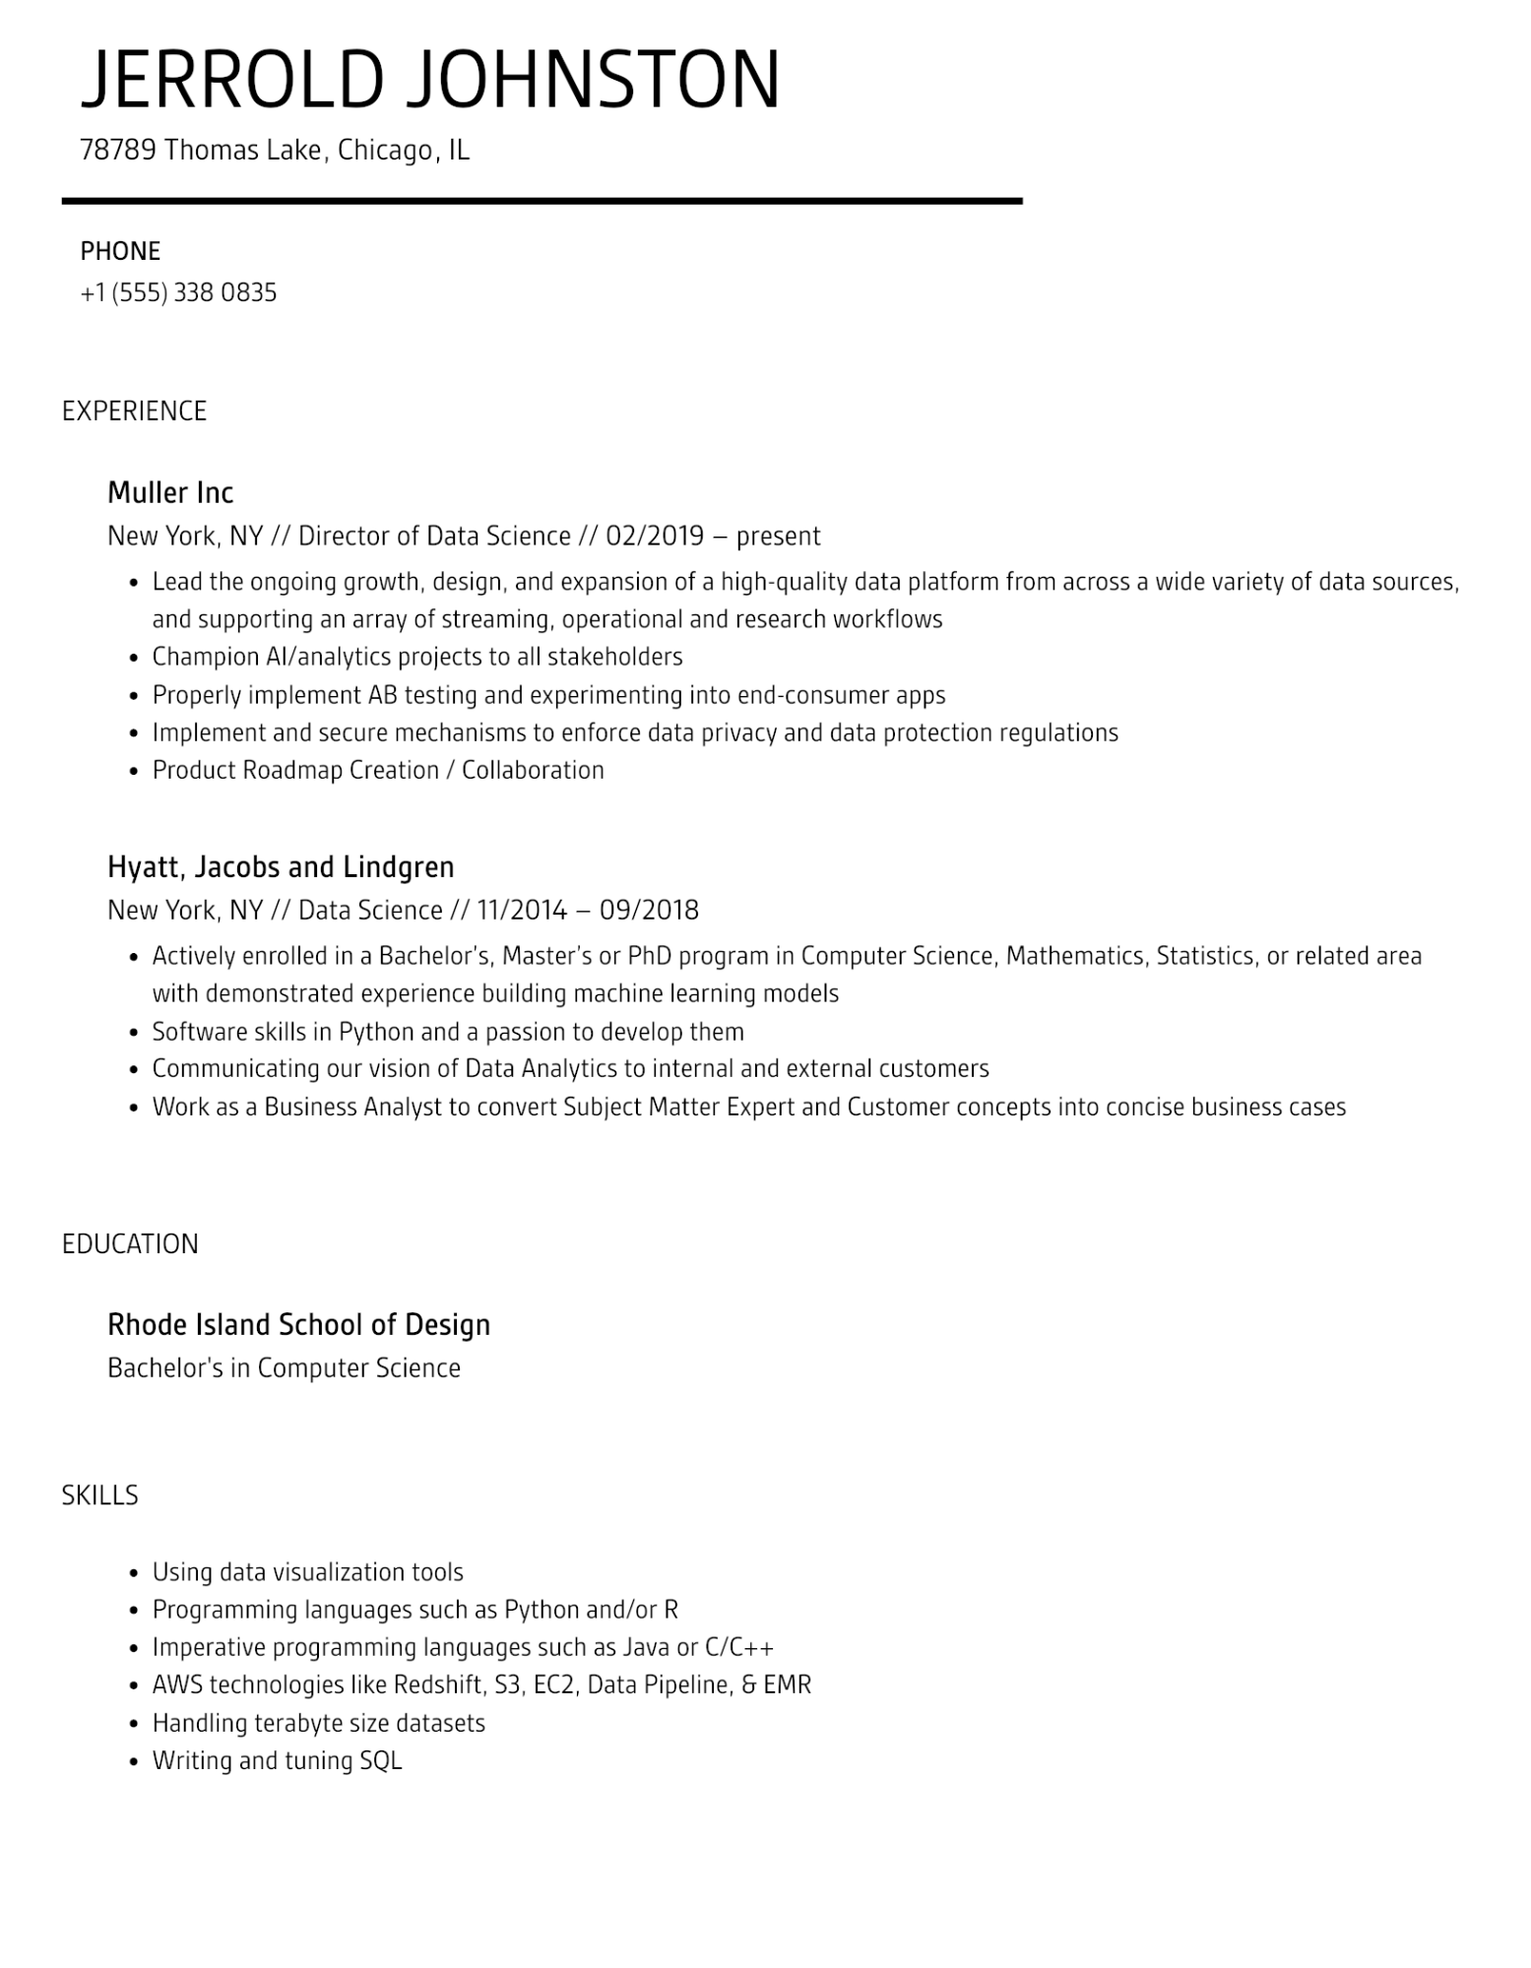

JERROLD JOHNSTON

78789 Thomas Lake, Chicago, IL

PHONE

+1 (555) 338 0835

EXPERIENCE

Muller Inc

New York, NY // Director of Data Science // 02/2019 - present

• Lead the ongoing growth, design, and expansion of a high-quality data platform from across a wide variety of data sources,

and supporting an array of streaming, operational and research workflows

•

Champion Al/analytics projects to all stakeholders

·

Properly implement AB testing and experimenting into end-consumer apps

·

Implement and secure mechanisms to enforce data privacy and data protection regulations

• Product Roadmap Creation / Collaboration

Hyatt, Jacobs and Lindgren

New York, NY // Data Science // 11/2014 - 09/2018

•

Actively enrolled in a Bachelor's, Master's or PhD program in Computer Science, Mathematics, Statistics, or related area with demonstrated experience building machine learning models

• Software skills in Python and a passion to develop them

·

Communicating our vision of Data Analytics to internal and external customers

• Work as a Business Analyst to convert Subject Matter Expert and Customer concepts into concise business cases

EDUCATION

Rhode Island School of Design

Bachelor's in Computer Science

SKILLS

•

Using data visualization tools

·

•

Programming languages such as Python and/or R

Imperative programming languages such as Java or C/C++

• AWS technologies like Redshift, S3, EC2, Data Pipeline, & EMR

·

Handling terabyte size datasets

•

Writing and tuning SQL