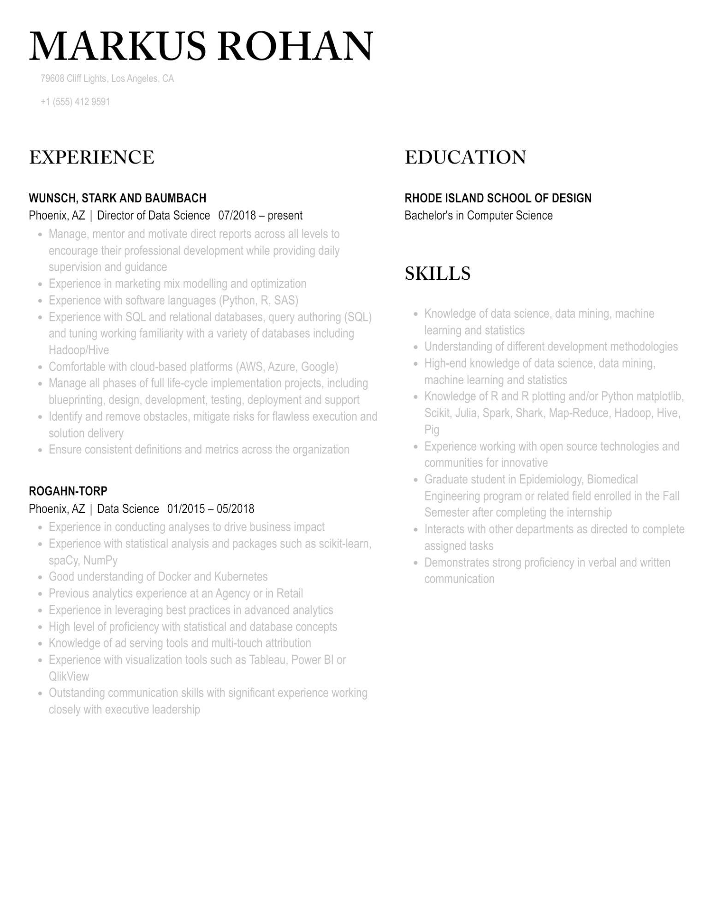

MARKUS ROHAN

79608 Cliff Lights, Los Angeles, CA +1 (555) 412 9591

EXPERIENCE

**WUNSCH, STARK AND BAUMBACH**

Phoenix, AZ | Director of Data Science 07/2018 - present

•

•

•

•

•

•

Manage, mentor and motivate direct reports across all levels to encourage their professional development while providing daily supervision and guidance

Experience in marketing mix modelling and optimization

Experience with software languages (Python, R, SAS)

Experience with SQL and relational databases, query authoring (SQL)

and tuning working familiarity with a variety of databases including Hadoop/Hive

Comfortable with cloud-based platforms (AWS, Azure, Google)

Manage all phases of full life-cycle implementation projects, including blueprinting, design, development, testing, deployment and support Identify and remove obstacles, mitigate risks for flawless execution and solution delivery

Ensure consistent definitions and metrics across the organization

**ROGAHN-TORP**

Phoenix, AZ | Data Science 01/2015-05/2018

•

Experience in conducting analyses to drive business impact

•

•

Experience with statistical analysis and packages such as scikit-learn, spacy, NumPy

Good understanding of Docker and Kubernetes

EDUCATION

**RHODE ISLAND SCHOOL OF DESIGN Bachelor's in Computer Science**

SKILLS

•

Knowledge of data science, data mining, machine learning and statistics

•

•

•

Understanding of different development methodologies High-end knowledge of data science, data mining,

machine learning and statistics

Knowledge of R and R plotting and/or Python matplotlib, Scikit, Julia, Spark, Shark, Map-Reduce, Hadoop, Hive, Pig

Experience working with open source technologies and communities for innovative

• Graduate student in Epidemiology, Biomedical Engineering program or related field enrolled in the Fall Semester after completing the internship

Interacts with other departments as directed to complete assigned tasks

Demonstrates strong proficiency in verbal and written communication

•

Previous analytics experience at an Agency or in Retail

•

•

•

Experience in leveraging best practices in advanced analytics

High level of proficiency with statistical and database concepts

Knowledge of ad serving tools and multi-touch attribution

Experience with visualization tools such as Tableau, Power BI or QlikView

Outstanding communication skills with significant experience working closely with executive leadership