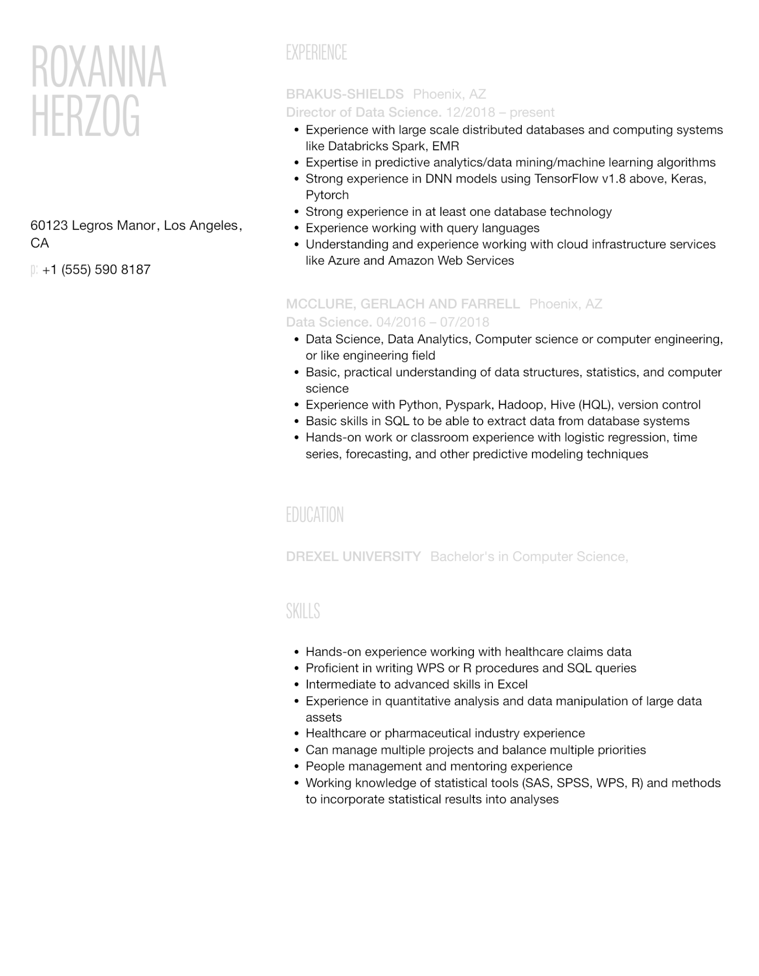

ROXANNA HERZOG

60123 Legros Manor, Los Angeles, CA

p: +1 (555) 590 8187

EXPERIENCE

BRAKUS-SHIELDS Phoenix, AZ

Director of Data Science. 12/2018 - present

• Experience with large scale distributed databases and computing systems like Databricks Spark, EMR

•

Expertise in predictive analytics/data mining/machine learning algorithms

• Strong experience in DNN models using TensorFlow v1.8 above, Keras, Pytorch

•

•

·

Strong experience in at least one database technology

Experience working with query languages

Understanding and experience working with cloud infrastructure services like Azure and Amazon Web Services

**MCCLURE, GERLACH AND FARRELL Phoenix, AZ**

Data Science. 04/2016 - 07/2018

• Data Science, Data Analytics, Computer science or computer engineering, or like engineering field

•

•

Basic, practical understanding of data structures, statistics, and computer science

Experience with Python, Pyspark, Hadoop, Hive (HQL), version control • Basic skills in SQL to be able to extract data from database systems

• Hands-on work or classroom experience with logistic regression, time series, forecasting, and other predictive modeling techniques

EDUCATION

DREXEL UNIVERSITY Bachelor's in Computer Science,

SKILLS

• Hands-on experience working with healthcare claims data

• Proficient in writing WPS or R procedures and SQL queries

• Intermediate to advanced skills in Excel

·

Experience in quantitative analysis and data manipulation of large data assets

• Healthcare or pharmaceutical industry experience

•

Can manage multiple projects and balance multiple priorities

•

People management and mentoring experience

·

Working knowledge of statistical tools (SAS, SPSS, WPS, R) and methods to incorporate statistical results into analyses